**MINISTRY OF EDUCATION AND TRAINING**

**FPT UNIVERSITY**

Capstone Project Document

The Traffic Sign Recognition and Training

|  |  |
| --- | --- |
| **Group 2** | |
| **Group member** | Mai Văn Tân – Team Leader – SE90061  Bùi Việt Phong – Team Member - SE60747  Hồ Đắc Nghĩa – Team Member - SE60628  Trần Lê Tuấn – Team Member - 60350 |
| **Supervisor** | Mr. Kiều Trọng Khánh |
| **Ext. Supervisor** | N/A |
| **Capstone Project code** | TSRT |

-Ho Chi Minh City, 01/2014-

*This page is intentionally left blank*

***ACKNOWLEDGEMENTS***

# Table of Contents

Table of Contents 4

List of Tables 8

List of Figures 10

Definitions, Acronyms, and Abbreviations 13

A. Introduction 14

1. Project Information 14

2. Introduction 14

3. Current System 14

4. Problem Definition 14

5. Proposed Solution 14

5.1 Feature functions 14

5.2 Advantage and disadvantage 15

6. Functional Requirement 15

6.1 Detect and recognize traffic sign 15

6.2 Account management 16

6.3 Traffic Sign Management 16

6.4 Report Management 16

7. Role and Responsibility 16

B. Software Project Management Plan 17

1. Problem Definition 17

1.1 Name of this Capstone Project 17

1.2 Problem Abstract 17

1.3 Project Overview 17

2. Project organization 19

2.1 Software Process Model 19

2.2 Roles and responsibilities 19

2.3 Tools and Techniques 20

3. Project Management Plan 21

3.1 Iteration 21

3.2 Iteration Detail 22

3.3 All Meeting Minutes 24

4. Coding Convention 24

C. Software Requirement Specification 28

1. User Requirement Specification 28

1.1 Guest Requirement 28

1.2 User Requirement 28

1.3 Staff Requirement 28

1.4 Admin Requirement 28

1.5 System Requirement 28

2. System Requirement Specification 28

2.1 External Interface Requirement 28

2.2 System Overview Use Case 30

2.3 List of Use Case 30

3. Software System Attribute 77

3.1 Usability 77

3.2 Reliability 77

3.3 Availability 77

3.4 Security 77

3.5 Maintainability 77

3.6 Portability 77

3.7 Performance 77

4. Conceptual Diagram 78

**Data Dictionary** 78

D. Software Design Description 79

1. Design Overview 79

2. System Architectural Design 80

3. Component Diagram 81

**Data Dictionary** 81

4. Detailed Description of Components 82

4.1 Class Diagram 82

4.2 Class Diagram Explanation 83

4.3 Sequence Diagram 86

5. User Interface Design 89

5.1 Instructor Interface Design 89

5.2 Admin Interface Design 95

5.3 Staff Interface Design 100

5.4 Mobile Interface Design 104

6. Database Design 111

6.1 Entity Relationship Diagram 111

6.2 Data Dictionary 112

7. Algorithms 115

7.1 Traffic sign detection 115

7.2 Traffic sign recognition 118

E. System Implementation & Test 122

1. Introduction 122

1.1 System Overview 122

1.2 Test Approach 122

2. Database Relationship Diagram 123

3. Performance measures 124

3.1 Traffic Sign Detection Performance 124

3.2 Traffic Sign Recognition Performance 124

4. Test Plan 125

4.1 Features to be tested 125

4.2 Features not to be tested 125

5. System Testing Test Case 126

6. Module Test Case 129

6.1 Manage RollCall 129

6.2 Manage Student Image 131

6.3 Check Attendance 134

6.4 Attendance Report 137

6.5 Manage Teaching Calendar 137

6.6 Manage Study Session 139

6.7 Check own Attendance Rate 141

F. Software User’s Manual 143

1. Installation Guide 143

1.1 Setting up environment at server site 143

1.2 Deployment at server side 143

1.3 Setting up the environment at client side 145

2. User Guide 147

2.1 Login 147

2.2 Admin 147

2.3 Staff 148

2.4 Instructor – Check Attendance (Mobile) 154

2.5 Instructor – Check Report 157

3. User Notice 159

3.1 Image Data Notice 159

3.2 Position & Angle Notice 160

3.3 Other Notice 161

G. Appendix 162

# List of Tables

Table 1: Roles and Responsibility 16

Table 2: Hardware Requirement for Server 18

Table 3: Hardware Requirement for Web User 18

Table 4: Hardware Requirement for Mobile User 19

Table 5: Roles and Responsibility Details 20

Table 6: Iteration 22

Table 7: Phase 1: Preliminary Investigation or Analysis 22

Table 8: Phase 2: Traffic Sign Detect & Recognize 23

Table 9: Phase 3: Account Management 23

Table 10: Phase 4: Traffic sign mange 23

Table 11: Phase 5: Search traffic sign 24

Table 12: Phase 6: History and report manage 24

Table 13: <Guest> Register account 33

Table 14: <Guest> Login 34

Table 15: <Guest, User> Search manually using web application 36

Table 16: <Guest, User> Search manually using mobile application 37

Table 17: <Guest, User> Search auto using web application 39

Table 18: <Guest, User> Search auto using web application 41

Table 19: <User, Staff, Admin> Logout 43

Table 20: <User> Report traffic sign wrong information 45

Table 21: <User> Report traffic sign wrong recognize 46

Table 22: <User> Delete history using web application 48

Table 23: <User> Delete history using mobile application 49

Table 24: <User> Add favorite using web application 52

Table 25: <User> Add favorite using mobile application 54

Table 26: <User> Remove favorite using web application 55

Table 27: <User> Remove favorite using mobile application 56

Table 28: <Staff> Add traffic sign 59

Table 29: <Staff> Edit traffic sign 61

Table 30: <Staff> Export to file 62

Table 31: <Staff> Import from file 64

Table 32: <Staff> View report 65

Table 33: <Staff> Delete report 67

Table 34: <Staff, Admin> Active Account 69

Table 35: <Staff, Admin> Deactivate Account 71

Table 36: <Staff, Admin> Make statistic 72

Table 37: <Admin> Configure system 74

Table 38: <Admin> Create staff account 76

Table 39: Data Dictionary 112

Table 40: Attribute Data Dictionary 114

**Table 41: Core Workflow Test Case** 129

**Table 42: Manage Roll Call Test Case** 131

**Table 43: Manage Student Image Test Case** 134

**Table 44: Check Attendance Test Case** 137

**Table 45: Attendance Report Test Case** 137

**Table 46: Manage Teaching Calendar Test Case** 139

**Table 47: Manage Study Session Test Case** 141

**Table 48: Check own Attendance Rate Test Case** 142

**Table 49: Login Step** 147

**Table 50: Set staff** 148

**Table 57: Login Step** 154

**Table 58: View Roll Call List Step** 154

**Table 59: Check Attendance Step** 155

**Table 60: View Roll Call Detail Step** 155

**Table 61: Take Attendance Manual Step** 156

**Table 62: View Teaching Roll Call Step** 157

**Table 63: View Roll Call Report Step** 157

# List of Figures

Figure 1: Agile Development Model 19

Figure 2: System Overview Use Case 30

Figure 3: <Guest> Overview Use Case 31

Figure 4: <Guest> Register account 31

Figure 5: <Guest> Login 33

Figure 6: <Guest, User> Search manually 34

Figure 7: <Guest, User> Search auto 38

Figure 8: <User> User over view 42

Figure 9: <User, Staff, Admin> Logout 42

Figure 10: <User> Report traffic sign wrong information 44

Figure 11: <User> Report traffic sign wrong recognize 45

Figure 12: <User> Delete history 47

Figure 13: <User> Add favorite 50

Figure 14: <User> Remove favorite 54

Figure 15: <Staff> Staff overview 57

Figure 16: <Staff> Add traffic sign 57

Figure 17: <Staff> Edit traffic sign 59

Figure 18: <Staff> Export to file 61

Figure 19: <Staff> Import from file 62

Figure 20: <Staff>View report 64

Figure 21: <Staff> Delete report 66

Figure 22: <Staff, Admin> Active Account 68

Figure 23: <Staff, Admin> Deactivate Account 69

Figure 24: <Staff, Admin> Make statistic 71

Figure 25: <Admin> Admin overview 73

Figure 26: <Admin> Configure system 73

Figure 27: <Admin> Create staff account 75

Figure 28: Conceptual Diagram 78

Figure 29: N-tier Architecture 80

Figure 30: Component Diagram 81

Figure 31: Class Diagram 82

Figure 32: Add Traffic Sign Sequence Diagram 86

Figure 33: Add Train Image Sequence Diagram 86

Figure 34: Import Data From File Sequence Diagram 87

Figure 35: Search Traffic Sign Auto Sequence Diagram 87

Figure 36: Search Traffic Sign Manual Sequence Diagram 88

Figure 37: Instructor Home Page 89

Figure 38: Instructor – Teaching Calendar 90

Figure 39: Instructor – Present Roll Call 91

Figure 40: Instructor – Roll Call Detail 92

Figure 41: Instructor – Check Attendance Manual 94

Figure 42: Admin - Home Page 95

Figure 43: Admin - Account Manager Page 97

Figure 44: Admin - Statistic Page 98

Figure 45: Admin - Configure Page 99

Figure 46: Staff – Traffic Sign Manager Page 100

Figure 47: Staff – Report Manager Page 102

Figure 48: Staff – Account Manager Page 103

Figure 52: Login Activity 105

Figure 53: Course Activity 106

Figure 54: Camera Activity 107

Figure 55: Roll Call Activity 108

Figure 56: Check Attendance Activity 109

Figure 57: Entity Relationship Diagram 111

Figure 58: Four basic types 116

Figure 59: Integral Image 116

Figure 60: Attentional Cascade 117

Figure 61: Viola-Jones flow chart 118

Figure 62: HOI features 120

Figure 63: SVM classifier 120

Figure 64: Classifier flow chart 121

Figure 65: Database Relationship Diagram 123

Figure 66: Traffic Sign Recognition Accuracy 124

**Figure 69: Core Workflow** 126

**Figure 70: Prepare deployment package** 144

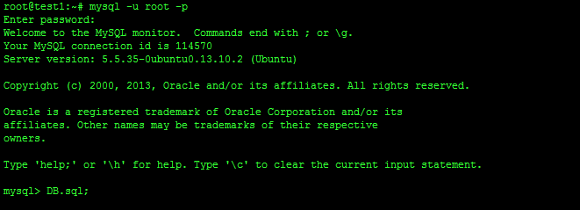**Figure 71: Deploy database** 144

**Figure 72: Run tomcat server** 144

**Figure 73: Copy war file to tomcat server** 144

**Figure 74: Set console application path** 144

**Figure 75: Restart tomcat** 145

**Figure 76: Change Settings** 145

**Figure 77: Download app** 146

**Figure 78: Install App** 146

**Figure 79: Login Page** 147

**Figure 80: Account Manage Page** 148

**Figure 80: Traffic Sign Manage Page** 149

**Figure 80: Add New Traffic Sign Modal** 150

**Figure 80: Report Manage Page** 151

**Figure 80: Report Detail Modal** 152

**Figure 80: Edit Wrong Recognition Page** 153

**Figure 87: Login Screen** 154

**Figure 88: Roll Call List Screen** 154

**Figure 89: Camera Screen** 155

**Figure 90: Roll Call Detail Screen** 155

**Figure 91: Take Attendance Screen** 156

**Figure 92: Instructor Home Page** 157

**Figure 93: Roll Call Detail Page** 157

**Figure 94: Report - Sheet 1** 158

**Figure 95: Report - Sheet 2** 158

# Definitions, Acronyms, and Abbreviations

|  |  |
| --- | --- |
| TSRT | Traffic Sign Recognition and Training |
| TS | Traffic sign |

# Introduction

## Project Information

* Project name: **The Traffic Sign Recognition and Training**
* Project Code: **TSRT**
* Product Type: **Website, Phone Application**
* Start Date: **January 6th, 2013**
* End Date: **April 19th, 2013**

## Introduction

Now a day, the traffic system is expand more than before. Beside that the traffic sign use to control traffic is developed to help people when join in the traffic. In Vietnam, we have more than 200 traffic signs, this may cause the difficult to people when meet a new traffic sign. On the other hand, internet and smartphone is more popular in Vietnam. Now it’s easy to have a smartphone with internet connection. That is the reason we want to build a system to help people find information about any traffic sign easily. So people can know more about the sign and traffic rule in each traffic sign, help them join in traffic easier and safer.

## Current System

Below are some current system:

* Search using book:

+ Advantages: clearly, accurate information.

+ Disadvantages: slow and not update regularly.

* Current application:

+ Advantage: update regularly, easy to use.

+ Disadvantages: few information (just have basic information about traffic sign), search slow.

* Using internet:

+ Advantages: provide updated information.

+ Disadvantages: search slowly, need internet connection, too many useless information.

## Problem Definition

The disadvantage of current system:

* Difficult to search the traffic sign (unknown the name or not remember the traffic sign).
* Provide few information, just has basic information, not have penalty fee.

## Proposed Solution

* Develop a recognition system that support auto detect and recognize traffic sign using smartphone’s camera.
* Support more information about the traffic sign: penalty fee, view history.
* Support user learn traffic sign.

### **Feature functions**

* + Admin

Admin can manage the system: update system, configure system.

Admin can manage account:

* + - Manage Staffs: provide permission role, set/unset staffs.
    - Manage users: active/deactivate users.
    - Make the statistic.
  + System
    - Detect and recognize traffic sign.
    - Provide information about traffic sign.
    - Support user learning traffic sign.
    - Support staff training new traffic sign.
  + Staff
    - Manage users: deactivate users, active users.
    - Training new traffic sign.
    - Add/update/delete traffic sign.
    - Make the statistic: statistic users by time, statistic search.
    - Import/export database.
    - Manage user’s report: check and statistic report.
  + Users
    - Search/view traffic sign.
    - Make report wrong traffic sign.
    - View/delete history traffic sign.
    - Add/view/remove favorite traffic sign.
  + Guest
    - Search/View traffic sign.

### Advantage and disadvantage

The advantage and disadvantage of the proposed solution:

* Advantage:

+ Easy to search traffic sign by take camera picture.

+ Provide more information about traffic sign like penalty fee.

+ Support user learn traffic sign.

* Disadvantage:

+ Must have internet connection.

+ Recognition accuracy not reach 100 percent.

## Functional Requirement

Function requirement of the system are listed as below:

### Detect and recognize traffic sign

* Detect candidate area from upload image.
* Recognize traffic sign from detected area.

### Account management

* Normal users can register new account.
* Staff accounts are set by admin.
* Admin can manage account: active/deactivate users.
* Staff can manage user account: active/deactivate users.

### Traffic Sign Management

* Staff can add/update/delete traffic sign.

### Report Management

* Users can send report about traffic sign.
* Staff can check/view report.

## Role and Responsibility

|  |  |  |  |  |
| --- | --- | --- | --- | --- |
| **No** | **Full Name** | **Role** | **Position** | **Contact** |
| 1 | Kiều Trọng Khánh | Project Manager | Instructor | khanhkt@fpt.edu.vn |
| 2 | Mai Văn Tân | Developer | Team Leader | tanmvse90061@fpt.edu.vn |
| 3 | Bùi Việt Phong | Developer | Team Member | phongbvse60747@fpt.edu.vn |
| 4 | Hồ Đắc Nghĩa | Developer | Team Member | nghiahdse60628@fpt.edu.vn |
| 5 | Trần Lê Tuấn | Developer | Team Member | tuantl60350@fpt.edu.vn |

Table 1: Roles and Responsibility

# Software Project Management Plan

## Problem Definition

### Name of this Capstone Project

The Traffic Sign Recognition and Training (TSRT)

### Problem Abstract

Now a day, the traffic system is expand more than before. Beside that the traffic sign use to control traffic is developed to help people when join in the traffic. In Vietnam, we have more than 200 traffic signs, this may cause the difficult to people when meet a new traffic sign. On the other hand, internet and smartphone is more popular in Vietnam. Now it’s easy to have a smartphone with internet connection. That is the reason we want to build a system to help people find information about any traffic sign easily. So people can know more about the sign and traffic rule in each traffic sign, help them join in traffic easier and safer.

### Project Overview

#### The Current System

Below are some current system:

* Search using book:

+ Advantages: clearly, accurate information.

+ Disadvantages: slow and not update regularly.

* Current application:

+ Advantage: update regularly, easy to use.

+ Disadvantages: few information (just have basic information about traffic sign), search slow.

* Using internet:

+ Advantages: provide updated information.

+ Disadvantages: search slowly, need internet connection, too many useless information.

#### The Proposed System

* Develop a recognition system that support auto detect and recognize traffic sign using smartphone’s camera.
* Support more information about the traffic sign: penalty fee, view history.
* Support user learn traffic sign.

##### Web

* The admin can manage information about system, staff and users.
* The system provides a method for admin to set permission for staff, select the user in the database to set permission.
* The system provides a method for admin configure system.
* The admin can make statistic about user account (user and staff).
* Staff cans manager traffic sign, add/edit/delete traffic sign.
* Staff cans manager report about traffic sign.
* The system will make a traffic sign take note for user. Support sticker used to learn for user.
* The system will provide a method for user upload image to website. Then, the system will recognize the image and give information for user.
* The system will provide a method for user view user’s history, user can send report if have any errors happen.

##### Mobile

* The mobile version also allow guest to register a new account.
* The user or guest can take a photo of traffic sign to make auto search about its information.
* In case the result is wrong, user or guest can send a report about this result.
* Allow user to add search result into favorite list for learning purpose.

#### Boundaries of the System

* The system is intended for almost Vietnam’s land traffic sign.
* Using in normal weather condition (sunny, cloudy...) and traffic sign must be in good state (In original shape, isn’t covered by other objects...)
* The system is intended for learning purpose only.
* The language of the system is Vietnamese
* The complete product includes:

+ The website, for admin, staff, user and guest to interactive with the system.

+ Mobile Application for user and guest.

+ All the process involved document.

#### Development Environment

##### Hardware requirements

**For server**

|  |  |  |
| --- | --- | --- |
| Windows | Minimum Requirements | Recommended |
| Internet Connection | 4Mbps | 8 Mbps |
| Operating System | Ubuntu 12 | Ubuntu 13.10 |
| Computer Processor | Intel® Core 2 Duo 2GHz | Intel® Core(TM) i5 CPU , M 460 @ 2.53GHz |
| Computer Memory | 512MB RAM | 3GB or more |

Table 2: Hardware Requirement for Server

**For Web User**

|  |  |  |
| --- | --- | --- |
| Web | Minimum Requirements | Recommended |
| Internet Connection | 2Mbps | 4Mbps |
| Web Browser | Firefox 20 | Firefox 27 |

Table 3: Hardware Requirement for Web User

**For Mobile User**

|  |  |  |
| --- | --- | --- |
| Mobile | Minimum Requirements | Recommended |
| Internet Connection | 2Mbps | 4Mbps |
| Operating System | Android 4.0 | Android 4.0 |
| Hardware | Touchscreen, Camera 5.0 MP or above | Touchscreen, Camera 8.0 MP or above |
| Memory | 512 MB or more | 1 GB or more |

Table 4: Hardware Requirement for Mobile User

##### Software requirements

* Microsoft Windows 7 Service Pack 1, Ubuntu 13.10: operating system and platform for development.
* MySql 5.5.20: use for database system.
* StarUML 5.0, Visio 2010: used to create models and diagrams
* Skype: used for communication and meeting
* Eclipse Juno 4.4, Android SDK 22.0.5, ADT 22.0.5 & JDK 7u25: used to implement mobile application.
* Eclipse Kepler: use to implement web application and web service.
* Netbean: use to implement console application in C++ (detect and recognize module).
* Google Code & TortoiseSVN: used for source control.

## Project organization

### Software Process Model

Project is developed under agile model.



Figure 1: Agile Development Model

[<http://masokotanzania.com/5-steps-to-making-agile-development-work>]

### Roles and responsibilities

|  |  |  |  |
| --- | --- | --- | --- |
| **No** | **Full name** | **Role in Group** | **Responsibilities** |
| **1** | Kiều Trọng Khánh | Project manager | * Specify user requirement * Control the development process * Give out technique and business analysis support |
| **2** | Mai Văn Tân | Team Leader, BA, DEV, Tester | * Managing process * Designing database * Clarifying requirements * Prepare documents * GUI Design * Create test plan * Coding * Testing |
| **3** | Bùi Việt Phong | Team Member, BA, DEV, Tester | * Designing database * Clarifying requirements * Prepare documents * GUI Design * Create test plan * Coding * Testing |
| **4** | Hồ Đắc Nghĩa | Team Member, BA, DEV, Tester | * Designing database * Clarifying requirements * Prepare documents * GUI Design * Create test plan * Coding * Testing |
| **5** | Trần Lê Tuấn | Team Member, BA, DEV, Tester | * Designing database * Clarifying requirements * Prepare documents * GUI Design * Create test plan * Coding * Testing |

Table 5: Roles and Responsibility Details

### Tools and Techniques

- Front-end technologies: HTML5, CSS3, JavaScript, jQuery, AJAX.

- Web application: Java servlet.

- Web Service: Jersey

- Mobile App: Android - Java.

- Web Server: Tomcat 7.0.

- Database Management System: MySql 5.5.20

## Project Management Plan

### Iteration

|  |  |  |  |  |  |
| --- | --- | --- | --- | --- | --- |
| **Phase**  **/Iteration** | **Description** | **Deliverables** | **Resource needed** | **Dependencies and Constrains** | **Risks** |
| **Preliminary Investigation or Analysis** | - Study similar existing systems.  -Identify and clarify requirements for the system in general. | -Introduction of proposed system.  -Main functions.  -Project Iteration Plan. | 30 man-days | N/A | Project may  not be feasible  for developing  because lack of technologies  and/or data |
| **Traffic Sign Detect & Recognize** | - Study traffic sign detect and recognize algorithm.  - Implement, testing and statistic result.  - Optimize algorithm. | Traffic sign detect and recognize console app. | 25 man-days | N/A | Lack of experience.  The implemented algorithm is not the best.  Lack of test data |
| **Account Manage** | Implement code for manage account | Account manage functions | 30 man-days | N/A |  |
| **Traffic sign manage** | Implement code for traffic sign manage | Traffic sign manage functions | 30 man-days | N/A |  |
| **Search traffic sign** | Implement code for search traffic sign | Traffic sign search functions (auto search and manually search) | 30 man-days | Traffic sign detect and recognize |  |
| **History, report manage** | Implement code for manage history and report manage | History and report manage functions | 30 man-days | Search traffic sign |  |

Table 6: Iteration

### Iteration Detail

#### Phase 1: Preliminary Investigation or Analysis

|  |  |  |
| --- | --- | --- |
| **Task** | **Description** | **Author** |
| **1. Identifying and studying existing systems** | Find which systems currently provide similar service, their strengths and weakness. | TanMV, PhongBV, NghiaHD, TuanTL |
| **2. Identifying and clarifying main functions** | Define which main functions system should provide. | TanMV, PhongBV, NghiaHD, TuanTL |
| **3. Introduction.** | Complete Introduction Report. | TanMV, PhongBV, NghiaHD, TuanTL |
| **4. Project Management**  **Plan.** | Prepare Project  Management Plan. | TanMV |
| **5. Website Prototype** | Build a prototype of proposed system (Website). | TuanTL |
| **6. Mobile Prototype** | Build a prototype of proposed system (Mobile App). | PhongBV |
| **7. Design diagram** | Design diagram. | TanMV, PhongBV, NghiaHD, TuanTL |
| **8. Document** | Add SRS, SDD | TanMV, PhongBV, NghiaHD, TuanTL |

Table 7: Phase 1: Preliminary Investigation or Analysis

#### Phase 2: Traffic Sign Detect & Recognize

|  |  |  |
| --- | --- | --- |
| **Task** | **Description** | **Author** |
| **1. Identifying Requirement and Planning** | Which feature this function should have and how to implement. | TanMV |
| **2. Studying Traffic Sign Detection & Recognition Algorithm** | Studying algorithm, implement by using library OpenCV | TanMV |
| **3. Extract candidate area from Image** | Find the candidate area in images, extract them for later use | TanMV |
| **4. Recognize traffic sign** | Recognize traffic sign from candidate area | TanMV |
| **5. Optimize** | Optimize the implement for more performance and accuracy | TanMV |
| **6. Implement API** | Create the interface for extracting and storing traffic sign | TanMV |
| **7. Testing** | Test system behavior and  performance | TanMV, PhongBV, NghiaHD, TuanTL |
| **8. Document** | Update SRS, SDD, Manual  Guide | TanMV, PhongBV, NghiaHD, TuanTL |

Table 8: Phase 2: Traffic Sign Detect & Recognize

#### Phase 3: Account manage

|  |  |  |
| --- | --- | --- |
| **Task** | **Description** | **Author** |
| 1. **Identifying Requirement and Planning** | Which feature this function should have and how to implement | TanMV, PhongBV, NghiaHD, TuanTL |
| 1. **Implement service for manage account** | Implement account functions | NghiaHD |
| 1. **Implement web app to manage account** | Implement account functions | TuanTL |
| 1. **Testing** | Test system behavior and  performance  Test user behavior and  performance | TanMV, PhongBV, NghiaHD, TuanTL |
| 1. **Document** | Update SRS, SDD, Manual  Guide | TanMV, PhongBV, NghiaHD, TuanTL |

Table 9: Phase 3: Account Management

#### Phase 4: Traffic sign manage

|  |  |  |
| --- | --- | --- |
| **Task** | **Description** | **Author** |
| 1. **Identifying Requirement and Planning** | Which feature this function should have and how to implement | TanMV, PhongBV, NghiaHD, TuanTL |
| 1. **Implement service for manage traffic sign** | Implement traffic sign mange functions | NghiaHD |
| 1. **Implement web app to manage traffic sign** | Implement traffic sign mange functions | TuanTL |
| 1. **Testing** | Test system behavior and  performance  Test user behavior and  performance | TanMV, PhongBV, NghiaHD, TuanTL |
| 1. **Document** | Update SRS, SDD, Manual  Guide | TanMV, PhongBV, NghiaHD, TuanTL |

Table 10: Phase 4: Traffic sign mange

#### Phase 5: Search traffic sign

|  |  |  |
| --- | --- | --- |
| **Task** | **Description** | **Author** |
| 1. **Identifying Requirement and Planning** | Which feature this function should have and how to implement | TanMV, PhongBV, NghiaHD, TuanTL |
| 1. **Implement service to search traffic sign** | Implement traffic sign search | NghiaHD |
| 1. **Implement web app to search traffic sign** | Implement traffic sign search | TuanTL |
| 1. **Implement mobile app to search traffic sign** | Implement traffic sign search | PhongBV |
| 1. **Testing** | Test system behavior and  performance  Test user behavior and  performance | TanMV, PhongBV, NghiaHD, TuanTL |
| 1. **Document** | Update SRS, SDD, Manual  Guide | TanMV, PhongBV, NghiaHD, TuanTL |

Table 11: Phase 5: Search traffic sign

#### Phase 6: History and report manage

|  |  |  |
| --- | --- | --- |
| **Task** | **Description** | **Author** |
| 1. **Identifying Requirement and Planning** | Which feature this function should have and how to implement. | TanMV, PhongBV, NghiaHD, TuanTL |
| 1. **Implement service to manage history and report** | Implement manage history and report functions | NghiaHD |
| 1. **Implement web app to manage history and report** | Implement manage history and report functions | TuanTL |
| 1. **Implement mobile app to view history, make report** | Implement manage history and make report | PhongBV |
| 1. **Testing** | Test system behavior and  performance  Test user behavior and  performance | TanMV, PhongBV, NghiaHD, TuanTL |
| 1. **Document** | Update SRS, SDD, Manual  Guide | TanMV, PhongBV, NghiaHD, TuanTL |

Table 12: Phase 6: History and report manage

### All Meeting Minutes

Refer to Meeting Minutes folder.

## Coding Convention

**Java: Using to develop Android App, Website and Web service.**

Summary:

* Naming conventions: Using Camel type for naming conventions.
* Commenting Convention: Using // for single line comment and /**/ for block comment

/**

* block comment

* …

* …

* …

*/

public static String getAbstractService()

{

//single line comment

if (abstractService == null)

{

throw new RuntimeException( "abstractService isn't initialized !");

}

return abstractService;

}

* Code formatting:

+ Blocks of code MUST be indented 4 characters, case statements aligned with their associated switch, and continuation lines 8 characters

+ Declarations and statements MUST NOT contain unnecessary white-space. A single-white space character is permitted between a comma and the following parameter in parameter lists, but that's all

+ There MUST be at most one statement per line

void foo()

{

while(bar > 0)

{

System.out.println();

bar--;

}

if(oatmeal == tasty)

{

System.out.println("Oatmeal is good and good for you");

}

else if(oatmeal == yak)

{

System.out.println("Oatmeal tastes like sawdust");

}

switch(suckFactor)

{

case 1:

System.out.println("This sucks");

break;

case 2:

System.out.println("This really sucks");

break;

default:

System.out.println("whatever");

break;

}

}

* Coding and class design

+ Empty blocks of code MUST be commented, e.g. empty uncommented catch clauses are not allowed

+ Strings MUST be checked for equality using equals

+ Utility classes MUST NOT have a public constructor

+ Interfaces MUST define a type. A utility class SHOULD be used for constants

**C++: Using to develop traffic sign detect and recognize console app.**

Summary:

* Naming Convention: using Pascal type
* Commenting Convention: Using // for single line comment and /**/ for block comment

/** Comments on function

...

...

*/

void classA::function_1( int variable1, //Comment on variable goes here.

float variable2, //Comment on variable goes here.

... ,

... )

{

...

* Code formatting:

+ Blocks of code MUST be indented 4 characters, case statements aligned with their associated switch, and continuation lines 8 characters

+ Declarations and statements MUST NOT contain unnecessary white-space. A single-white space character is permitted between a comma and the following parameter in parameter lists, but that's all

+ There MUST be at most one statement per line

vector<person> people;

//fill the vector somehow

int field_one_width = 0, field_two_width = 0;

//get the max widths

for ( vector<person>::iterator iter = people.begin(); iter != people.end();++iter )

{

if ( iter->firstname.length() > field_one_width )

{

field_one_width = iter->firstname.length();

}

if ( iter->lastname.length() > field_two_width )

{

field_two_width = iter->lastname.length();

}

}

//print the elements of the vector

for ( vector<person>::iterator iter = people.begin(); iter != people.end();++iter )

{

cout<<setw(field_one_width)<<left<<iter->firstname;

cout<<" ";

cout<<setw(field_two_width)<<left<<iter->lastname;

}

# Software Requirement Specification

## User Requirement Specification

### Guest Requirement

Guest, who is not have account or not login system. Guest can use the basic functions of system like search auto and search manually

### User Requirement

Use is normal user of the system. When login system, use can search auto, search manually beside that use have favorite, store favorite traffic sign and history store old requests. When view traffic sign information and search auto use also can report to help system work more accurate.

### Staff Requirement

Staff is the main manager of the system. Staff’s account is set by admin. Staff can use system with these functions:

* Manage user account: Active/Inactive account
* Manage traffic sign: add/delete/edit/import/export traffic sign
* Manage report that use submit: view/remove report

### Admin Requirement

Admin is highest manage in system. Admin can do functions:

* Manage account: set/unset staff account/active/inactive
* Manage system: configure system

### System Requirement

System is also an important part. System can do functions:

* Detect traffic sign
* Recognize traffic sign
* Store user history
* Store user favorite

## System Requirement Specification

### External Interface Requirement

#### User Interface

* + - The interface of website is clear.
    - The interface of mobile app must be clear, compatible with touch screen. The size of controls must be big enough to touch on smartphone.
    - The error, warning messages must be make clear, easy to understand. Hardware Interface
* The system will use the standard hardware and data communications resources of a standard computer.

#### Software Interface

* Firefox with Resolution (1280*800) or bigger and support JavaScript and HTML5
* Smartphone with Android 4.0. Screen size (60 x 120 mm) or bigger.

#### Communication Protocol

* Website using HTTP protocol for communication between the web browser and the web server.
* Mobile app using HTTP protocol for communicating between app and web service.

### System Overview Use Case



Figure 2: System Overview Use Case

### List of Use Case

#### <Guest>Overview Use Case



Figure 3: <Guest> Overview Use Case

##### <Guest>Register account

Use Case Diagram



Figure 4: <Guest> Register account

Use Case Specification

|  |  |  |  |
| --- | --- | --- | --- |
| **USE CASE – GU001** | | | |
| **Use Case No.** | GU001 | **Use Case Version** | 2.0 |
| **Use Case Name** | Register | | |
| **Author** | Tran Le Tuan | | |
| **Date** | 15/01/2014 | **Priority** | Normal |
| **Actor:** Guest  **Summary:**  Guest uses this case to register account into system.  **Goal:**  Allow guest register account into system.  **Triggers:**   * Guest wants to register account. * To register: Guest go to the register page, guest enter username, password, email, address then click on “Đăng ký” button to register.   **Preconditions:** N/A  **Post Conditions:**   * **Success:** System will show success message on current page * **Fail:** System will show error message on current page   **Main Success Scenario:**   |  |  |  | | --- | --- | --- | | Step | Actor Action | System Response | | 1 | Guest click on “Đăng ký” button | System redirect to register page, contain a register form:   * “Tên đăng nhập”: Textbox * “Mật khẩu”: Textbox * “Nhập lại mật khẩu”: Textbox * “Email”: Textbox   - In format: ^([a-zA-Z0-9_\-\.]+)@((\[[0-9]{1,3}\.[0-9]{1,3}\.[0-9]{1,3}\.)|(([a-zA-Z0-9\-]+\.)+))([a-zA-Z]{2,4}|[0-9]{1,3})(\]?)$   * “Đăng ký”: Button | | 2 | Guest enters register information.  Press “Đăng ký” button. | System send verify email and show the success message: “Bạn đã đăng ký thành công, vui lòng xác nhận email để kích hoạt tài khoản”.  [Exception 1, 2, 3, 4, 5] | | 3 | Guest verify account | System show message “Chúc mừng bạn kích hoạt thành công” and redirect to homepage  [Exception 6] |   **Alternative Scenario:** N/A  **Exceptions:**   |  |  |  | | --- | --- | --- | | No | Actor Action | System Response | | 1 | Missing information | Show error message: “Vui lòng nhập đầy đủ thông tin”. | | 2 | Username/Password not in range [5,30] | Show error message: “Tên đăng nhập và mật khẩu phải từ 5-30 ký tự”. | | 3 | Input invalid retype password. | Show error message: “Thông tin nhập vào không đúng”. | | 4 | Input invalid email. | Show error message: “Email không hợp lệ” | | 5 | Existed username/email | Show error message: “Tên đăng nhập hoặc email đã được sử dụng” | | 6 | Verify link is expired | Show error message: “Đã hết hạn kích hoạt. Liên lạc với admin để có thêm thông tin” |   **Relationships:** N/A  **Business Rules:**   * Each user can register one account. * Password use MD5 code type when save in database. | | | |

Table 13: <Guest> Register account

##### <Guest> Login

Use Case Diagram



Figure 5: <Guest> Login

Use Case Specification

|  |  |  |  |
| --- | --- | --- | --- |
| **USE CASE – GU002** | | | |
| **Use Case No.** | GU002 | **Use Case Version** | 2.0 |
| **Use Case Name** | Login | | |
| **Author** | Tran Le Tuan | | |
| **Date** | 15/01/2014 | **Priority** | Normal |
| **Actor:** Guest  **Summary:**  Guest uses this case to login into system.  **Goal:**  Allow authentication and authorization of the system.  **Triggers:**   * Guest want to login into system * To login: Guest go to the login page, guest enters username and password, then click on “Đăng Nhập” button to login.   **Preconditions:** N/A  **Post Conditions:**   * **Success:** Guest login successful, redirect to corresponding page * **Fail:** System will show error on current page   **Main Success Scenario:**   |  |  |  | | --- | --- | --- | | Step | Actor Action | System Response | | 1 | Guest click on “Đăng nhập” button | System show a login form, includes:   * Tên đăng nhập: Textbox * Mật khẩu: Textbox * Đăng nhập: Button | | 1 | Guess enter username and password into textboxes.  Press “Đăng nhập” button. | Guest log into system, authorized with corresponding role. Redirect to home page.  [Exception 1,2] |   **Alternative Scenario:** N/A  **Exceptions:**   |  |  |  | | --- | --- | --- | | No | Actor Action | System Response | | 1 | No input in “Tên đăng nhập” or “Mật khẩu” textboxs | Show error message: “Vui lòng nhập thông tin đăng nhập”. | | 2 | Input invalid username or password | Show error message: “Tên đăng nhập hoặc mật khẩu không đúng”. |   **Relationships:** N/A  **Business Rules:**   * Each user, staff, admin has an account. * Only active account can log in. | | | |

Table 14: <Guest> Login

##### <Guest, User>Search manually

Use Case Diagram



Figure 6: <Guest, User> Search manually

Use Case Specification

|  |  |  |  |
| --- | --- | --- | --- |
| **USE CASE – GU003** | | | |
| **Use Case No.** | GU003 | **Use Case Version** | 2.0 |
| **Use Case Name** | Search manually using web application | | |
| **Author** | Mai Van Tan | | |
| **Date** | 15/01/2014 | **Priority** | Normal |
| **Actor:** Guest, User  **Summary:**   * User use this case to search manually   **Goal:**   * Allow user to search a traffic sign   **Triggers:**   * User want to search traffic sign in manually * User can search manually by input a key work or view a list and choice the traffic sign. * User select “Tìm kiếm biển báo” in menu bar, input keyword in “Từ khóa” textbox then press “Tìm kiếm”. The system will return a list of traffic sign, guest select the traffic sign to view information.   **Preconditions:** N/A  **Post Conditions:**   * **Success**: System will show the information of the traffic sign * **Fail:** Show the error to user   **Main Success Scenario:**   |  |  |  | | --- | --- | --- | | Step | Actor Action | System Response | | 1 | User select “Tìm kiếm biển báo” in menu bar | System redirect to search traffic sign page, contain:   * Tìm kiếm tự động: * Tìm kiếm bằng tay:   + “Từ khóa”: Textbox   + “Tìm kiếm”: Button   + List of main type traffic sign | | 2 | User input keyword in “Từ khóa” and press “Tìm kiếm”  [Alternative 1] | System receives the input, process. After done, system return a list of traffic sign match with the input keyword  [Exception 1] | | 3 | User select a traffic sign in list | System redirect to traffic sign information contain:   * Tên biển báo: Label * Hình ảnh: Image * Nội dung biển báo: Label * Mức phạt: Label |   **Alternative Scenario:**  **1.**   |  |  |  | | --- | --- | --- | | Step | Actor Action | System Response | | 1 | User select a type in list main traffic sign type | Show the list of traffic sign of type that user selected. | | 2 | User select a traffic sign in list | System redirect to traffic sign information contain:   * Tên biển báo: Label * Hình ảnh: Image * Nội dung biển báo: Label * Mức phạt: Label |   **Exceptions:**   |  |  |  | | --- | --- | --- | | No | Actor Action | System Response | | 1 | No result match with keyword | Show message: “Không tìm thấy” |   **Relationships: N/A**  **Business Rules:**   * Search result is listed in alphabet order * Search accept Vietnamese without accent marks | | | |

Table 15: <Guest, User> Search manually using web application

|  |  |  |  |
| --- | --- | --- | --- |
| **USE CASE – GU004** | | | |
| **Use Case No.** | GU004 | **Use Case Version** | 2.0 |
| **Use Case Name** | Search manually using mobile application | | |
| **Author** | Mai Van Tan | | |
| **Date** | 15/01/2014 | **Priority** | Normal |
| **Actor:** Guest, User  **Summary:**   * User use this case to search manually   **Goal:**   * Allow user to search a traffic sign   **Triggers:**   * User want to search traffic sign in manually * User can search manually by input a key work or view a list and choice the traffic sign. * User select search traffic sign in manually item [image], input keyword in “Từ khóa” textbox then press “Tìm kiếm”. The system will return a list of traffic sign, guest select the traffic sign to view information.   **Preconditions:** N/A  **Post Conditions:**   * **Success**: System will show the information of the traffic sign * **Fail:** Show the error to user   **Main Success Scenario:**   |  |  |  | | --- | --- | --- | | Step | Actor Action | System Response | | 1 | User select search traffic sign in manually item [image] | System redirect to search traffic in manually screen, contain:   * “Từ khóa”: Textbox * “Tìm kiếm”: Button * List of main type traffic sign | | 2 | User input keyword in “Từ khóa” and press “Tìm kiếm”  [Alternative 1] | System receives the input, process. After done, system return a list of traffic sign match with the input keyword  [Exception 1] | | 3 | User select a traffic sign in list | System redirect to traffic sign information contain:   * Tên biển báo: Label * Hình ảnh: Image * Nội dung biển báo: Label * Mức phạt: Label |   **Alternative Scenario:**  **1.**   |  |  |  | | --- | --- | --- | | Step | Actor Action | System Response | | 1 | User select a type in list main traffic sign type | Show the list of traffic sign of type that user selected. | | 2 | User select a traffic sign in list | System redirect to traffic sign information contain:   * Tên biển báo: Label * Hình ảnh: Image * Nội dung biển báo: Label * Mức phạt: Label |   **Exceptions:**   |  |  |  | | --- | --- | --- | | No | Actor Action | System Response | | 1 | No result match with keyword | Show message: “Không tìm thấy” |   **Relationships: N/A**  **Business Rules:**   * Search result is listed in alphabet order * Search accept Vietnamese without accent marks | | | |

Table 16: <Guest, User> Search manually using mobile application

##### <Guest, User> Search auto

Use Case Diagram



Figure 7: <Guest, User> Search auto

Use Case Specification

|  |  |  |  |
| --- | --- | --- | --- |
| **USE CASE – GU005** | | | |
| **Use Case No.** | GU005 | **Use Case Version** | 2.0 |
| **Use Case Name** | Search auto using web application | | |
| **Author** | Mai Van Tan | | |
| **Date** | 15/01/2014 | **Priority** | Normal |
| **Actor:** Guest, User  **Summary:**   * User use this case to auto search traffic sign   **Goal:**   * Allow user to search traffic sign automatically   **Triggers:**   * User want to search traffic sign automatically * User select “Tìm kiếm biển báo” in menu bar, select an image and press “Tải lên và tìm kiếm”. System will return a list of result. Guest selects a traffic sign to view information of it.   **Preconditions:** N/A  **Post Conditions:**   * **Success**: System will show the information of the traffic sign * **Fail:** Show the error to user.   **Main Success Scenario:**   |  |  |  | | --- | --- | --- | | Step | Actor Action | System Response | | 1 | User click on “Tìm kiếm biển báo” in menu bar | System redirect to search traffic sign page, contain:   * “Tìm kiếm tự động”   + File picker   + “Tải lên và tìm kiếm”: Button * “Tìm kiếm bằng tay”   + “Từ khóa”: Textbox   + “Tìm kiếm”: Button   + List of main type traffic sign | | 2 | User select an image and press “Tải lên và tìm kiếm” | System receives the image, process. After done, redirect to result page contain:   * Image uploaded * List of traffic sign recognized   [Exception 1][Exception 2] | | 3 | User select an traffic sign to view detail | System redirect to view traffic sign information page, contain:   * Tên biển báo: Label * Hình ảnh: Image * Nội dung biển báo: Label * Mức phạt: Label |   **Alternative Scenario:** N/A  **Exceptions:**   |  |  |  | | --- | --- | --- | | No | Actor Action | System Response | | 1 | No result match with keyword | Show message: “Không tìm thấy” | | 2 | Image is not matches format or size | Show message: “Chỉ chấp nhận ảnh jpg, pgn, bmp có kích thước nhỏ hơn 1MB” |   **Relationships: N/A**  **Business Rules:**   * The image is only in jpg, png, bmp format with the size less than 1MB | | | |

Table 17: <Guest, User> Search auto using web application

|  |  |  |  |
| --- | --- | --- | --- |
| **USE CASE – GU006** | | | |
| **Use Case No.** | GU006 | **Use Case Version** | 2.0 |
| **Use Case Name** | Search auto using mobile application | | |
| **Author** | Mai Van Tan | | |
| **Date** | 15/01/2014 | **Priority** | Normal |
| **Actor:** Guest, User  **Summary:**   * User use this case to auto search traffic sign in mobile   **Goal:**   * Allow user to search traffic sign automatically   **Triggers:**   * User want to search traffic sign automatically * User select search auto item [image], system opens a camera screen. User takes a photo and submits to server. System will return a list of result. User selects a traffic sign to view information of it.   **Preconditions:** N/A  **Post Conditions:**   * **Success**: System will show the information of the traffic sign * **Fail:** Show the error to user.   **Main Success Scenario:**   |  |  |  | | --- | --- | --- | | Step | Actor Action | System Response | | 1 | User select search auto item [image] | System show the screen contain:   * Chụp ảnh biển báo: Link * Chọn ảnh có sẵn: Link | | 2 | User select “Chụp ảnh biển báo” | System will open camera screen,   * Preview image screen * Button [image]: take and submit the image | | 3 | User take a photo and submit to the server  [Alternative 1][Alternative 2] | System receive the photo, after process system redirect to result page contain a list of traffic sign  [Exception 1] | | 4 | User select a traffic sign to view information | System redirect to traffic sign information page contain:   * Tên biển báo: Label * Hình ảnh: Image * Nội dung biển báo: Label * Mức phạt: Label |   **Alternative Scenario:**  **1.**   |  |  |  | | --- | --- | --- | | Step | Actor Action | System Response | | 1 | User select “Chọn ảnh có sẳn” and select an image  [Alternative 2] | System receive the photo, after process system redirect to result page contain a list of traffic sign  [Exception 1] | | 2 | User select a traffic sign to view information | System redirect to traffic sign information page contain:   * Tên biển báo: Label * Hình ảnh: Image * Nội dung biển báo: Label * Mức phạt: Label |   **2.**   |  |  |  | | --- | --- | --- | | Step | Actor Action | System Response | | 1 | No internet connection | Show message: “Không có kết nối internet, chương trình sẽ tự động tìm kiếm khi có internet” | | 2 | When internet available | System receive the photo, after process system notify user | | 3 | User view the notification | System show the list result  [Exception 1][Exception 2] | | 4 | User select a traffic sign to view information | System redirect to traffic sign information screen contain:   * Tên biển báo: Label * Hình ảnh: Image * Nội dung biển báo: Label * Mức phạt: Label |   **Exceptions:**   |  |  |  | | --- | --- | --- | | No | Actor Action | System Response | | 1 | No result match with keyword | Show message: “Không tìm thấy” | | 2 | Image is not matches format or size | Show message: “Chỉ chấp nhận ảnh jpg, pgn, bmp có kích thước nhỏ hơn 1MB” |   **Relationships: N/A**  **Business Rules:**   * The image is only in jpg, png, bmp format with the size less than 1MB | | | |

Table 18: <Guest, User> Search auto using web application

#### <User> User over view

Use Case Diagram



Figure 8: <User> User over view

##### <User, Staff, Admin> Logout

Use Case Diagram



Figure 9: <User, Staff, Admin> Logout

Use Case Specification

|  |  |  |  |
| --- | --- | --- | --- |
| **USE CASE – UU001** | | | |
| **Use Case No.** | UU001 | **Use Case Version** | 2.0 |
| **Use Case Name** | Logout | | |
| **Author** | Mai Van Tan | | |
| **Date** | 15/01/2014 | **Priority** | Normal |
| **Actor:** User, Staff, Admin  **Summary:**  User use this case to logout  **Goal:**  Allow user to logout  **Triggers:**  User want to logout  User click on “Thoát” button  **Preconditions:**   * Guest must logged in the system with the role is user, staff, or admin   **Post Conditions:**  **Success:** User logout and redirect to home  **Fail:** System show the error  **Main Success Scenario:**   |  |  |  | | --- | --- | --- | | Step | Actor Action | System Response | | 1 | User click on “Thoát” button | System delete user session and redirect to home page  [Exception 1] |   **Alternative Scenario:** N/A  **Exceptions:**   |  |  |  | | --- | --- | --- | | No | Actor Action | System Response | | 1 | Session timeout | System show message “Bạn chưa đăng nhập”, redirect to login page |   **Relationships:** N/A  **Business Rules:**   * Session timeout: 30mins | | | |

Table 19: <User, Staff, Admin> Logout

##### <User> Report traffic sign wrong information

Use Case Diagram



Figure 10: <User> Report traffic sign wrong information

Use Case Specification

|  |  |  |  |
| --- | --- | --- | --- |
| **USE CASE – UU002** | | | |
| **Use Case No.** | UU002 | **Use Case Version** | 2.0 |
| **Use Case Name** | Report wrong information | | |
| **Author** | Ho Dac Nghia | | |
| **Date** | 15/01/2014 | **Priority** | Normal |
| **Actor:** User  **Summary:**  User uses this case to report traffic sign  **Goal:**  Allow user to report traffic sign  **Triggers:**   * User want to report wrong traffic sign(wrong information) * When user view search result and think that result is wrong then user can click on report item on traffic sign information page   **Preconditions:**   * User must log in the system with role user.   **Post Conditions:**  **Success:** The report of a traffic sign will be save on server  **Fail:** Report isn’t send  **Main Success Scenario:**   |  |  |  | | --- | --- | --- | | Step | Actor Action | System Response | | 1 | While view search result, user click on the report item | System redirect to report page:   * “Nội dung phản hồi”: Textbox – Min length: 50, Max length: 200. * “Hủy”: Button * “Gửi”: Button | | 2 | User input report content and click on “Gửi” button [Alternative 1] | System send report to server and show message “Cám ơn bạn đã gửi phản hồi” and go back to search page |   **Alternative Scenario:**   |  |  |  | | --- | --- | --- | | No | Actor Action | System Response | | 1 | User click on “Hủy” button | System back to search page |   **Exceptions:** N/A  **Relationships:** N/A  **Business Rules:**   * The text box must not be empty. * The report sent to server have pending status. | | | |

Table 20: <User> Report traffic sign wrong information

##### <User> Report traffic sign wrong recognize

Use Case Diagram



Figure 11: <User> Report traffic sign wrong recognize

Use Case Specification

|  |  |  |  |
| --- | --- | --- | --- |
| **USE CASE – UU003** | | | |
| **Use Case No.** | UU003 | **Use Case Version** | 2.0 |
| **Use Case Name** | Report Wrong Recognize | | |
| **Author** | Ho Dac Nghia | | |
| **Date** | 15/01/2014 | **Priority** | Normal |
| **Actor:** User  **Summary:**  User uses this case to report traffic sign recognize  **Goal:**  Allow user to report traffic sign recognize.  **Triggers:**   * User want to report wrong traffic sign(wrong recognize traffic sign) * When user wants to recognize a traffic sign but the system cannot show the result of that traffic sign. * User can click report item on auto search result page   **Preconditions:**  User must logged in the system with the role is user  **Post Conditions:**  **Success:** The report of a traffic sign will be save on server  **Fail:** Report isn’t send  **Main Success Scenario:**   |  |  |  | | --- | --- | --- | | Step | Actor Action | System Response | | 1 | In the recognize page, user can click “Phản hồi” item. | System redirect to report page:   * “Nội dung phản hồi”: Textbox – Min length:50, Max length: 200 * “Hủy”: Button * “Gửi”: Button | | 2 | User input report content and click on “Gửi” button [Alternative 1] | System send report to server and show message “Cám ơn bạn đã gửi phản hồi” and go back to result page |   **Alternative Scenario:**   |  |  |  | | --- | --- | --- | | No | Actor Action | System Response | | 1 | User click on “Hủy” button | System back to result page | | | | |
| **Exception:** N/A  **Relationships:** N/A  **Business Rules:**   * The text box must not be empty. * The report sent to server have pending status. | | | |

Table 21: <User> Report traffic sign wrong recognize

##### <User> Delete history

Use Case Diagram



Figure 12: <User> Delete history

Use Case Specification

|  |  |  |  |
| --- | --- | --- | --- |
| **USE CASE – UU004** | | | |
| **Use Case No.** | UU004 | **Use Case Version** | 2.0 |
| **Use Case Name** | Delete history using web application | | |
| **Author** | Mai Van Tan | | |
| **Date** | 15/01/2014 | **Priority** | Normal |
| **Actor:** User  **Summary:**   * User use this case to delete search history in web application   **Goal:**   * Allow user delete their search history   **Triggers:**   * User want to delete history of search result * User view list of history or view history detail then select “Xóa” button. Confirm to delete by press “Đồng ý”   **Preconditions:**   * Guest must log in the system with role user   **Post Conditions:**   * **Success**: The history will be deleted from system * **Fail:** Show the error to user   **Main Success Scenario:**   |  |  |  | | --- | --- | --- | | Step | Actor Action | System Response | | 1 | User select “Xem lịch sử tìm kiếm” | System redirect to history page contain a list of search history   * List of search history * “Xóa”: Button - on each row | | 2 | User select “Xóa” button  [Alternative 1] | System shows message: “Bạn có chắc chắn muốn xóa?” | | 3 | User select “Đồng ý” | System delete the history and refresh the list  [Exception 1] |   **Alternative Scenario:**   |  |  |  | | --- | --- | --- | | No | Actor Action | System Response | | 1 | User select to view history detail | System redirect to view history detail page, like result page when make search auto [reference to Use case GU005]   * “Xóa”: Button | | 2 | User select “Xóa” button | System shows message: “Bạn có chắc chắn muốn xóa?” | | 3 | User select “Đồng ý” | System delete the history and refresh the list  [Exception 1] |   **Exceptions:**   |  |  |  | | --- | --- | --- | | No | Actor Action | System Response | | 1 | Cannot delete history | Show message: “Xóa không thành công”. |   **Relationships: Search auto in web application use case**  **Business Rules:**   * When delete history, only change history’s active into false | | | |

Table 22: <User> Delete history using web application

|  |  |  |  |
| --- | --- | --- | --- |
| **USE CASE – UU005** | | | |
| **Use Case No.** | UU005 | **Use Case Version** | 2.0 |
| **Use Case Name** | Delete history using mobile application | | |
| **Author** | Mai Van Tan | | |
| **Date** | 15/01/2014 | **Priority** | Normal |
| **Actor:** User  **Summary:**   * User use this case to delete search history in mobile application   **Goal:**   * Allow user deletes their search history.   **Triggers:**   * User want to delete history of search result * User view list of history or view history detail then select “Xóa” button. Confirm to delete by press “Đồng ý”.   **Preconditions:**   * Guest must log in the system with role user   **Post Conditions:**   * **Success**: The history will be deleted from system * **Fail:** Show the error to user.   **Main Success Scenario:**   |  |  |  | | --- | --- | --- | | Step | Actor Action | System Response | | 1 | User select “Xem lịch sử tìm kiếm” | System redirect to history screen contain a list of search history   * List of search history | | 2 | User press and hold for 1s in a history item, then select “Xóa”  [Alternative 1] | System shows message: “Bạn có chắc chắn muốn xóa?” | | 3 | User select “Đồng ý” | System delete the history and refresh the list  [Exception 1] |   **Alternative Scenario:**   |  |  |  | | --- | --- | --- | | Step | Actor Action | System Response | | 1 | User select to view history detail | System redirect to view history detail screen, like result screen when make search auto [reference to Use case GU006]   * “Xóa”: Button | | 2 | User select “Xóa” button | System shows message: “Bạn có chắc chắn muốn xóa?” | | 3 | User select “Đồng ý” | System delete the history and refresh the list  [Exception 1] |   **Exceptions:**   |  |  |  | | --- | --- | --- | | No | Actor Action | System Response | | 1 | Cannot delete history | Show message: “Xóa không thành công”. |   **Relationships: Search auto in mobile application use case**  **Business Rules:**   * When delete history, only change history’s active into false | | | |

Table 23: <User> Delete history using mobile application

##### <User> Add favorite

Use Case Diagram



Figure 13: <User> Add favorite

Use Case Specification

|  |  |  |  |
| --- | --- | --- | --- |
| **USE CASE – UU006** | | | |
| **Use Case No.** | UU006 | **Use Case Version** | 2.0 |
| **Use Case Name** | Add favorite (Using web application) | | |
| **Author** | Bui Viet Phong | | |
| **Date** | 15/01/2014 | **Priority** | Normal |
| **Actor:** User  **Summary:**  This use case allows user to add a traffic sign into favorite list  **Goal:**  Add a traffic sign into favorite list  **Triggers:**   * In our system, each user has a favorite list to bookmark traffic signs for viewing later again * To add a traffic sign into favorite list, user must: * View traffic sign details by auto search or manually search * On the traffic sign details screen, click button “Thêm vào danh sách yêu thích”   **Preconditions:**   * Guest must log in the system with role user   **Post Conditions:**   * **Success:** The popup inform that the traffic sign has been added to favorite list * **Fail:** No traffic sign is added to favorite list   **Main Success Scenario:**   |  |  |  | | --- | --- | --- | | Step | Actor Action | System Response | | 1 | Click one type off traffic sign in category  [Alternative 1] [Alternative 2] | Get the list traffic sign from the database, matching with the category was chosen by user  Show the list of traffic signs, each row include:   * Traffic image * Traffic’s name | | 2 | Click on one traffic sign in the list. | Show the Traffic details screen, contains detail of traffic sign, include:   * Traffic sign Image * Traffic sign content * Penalize fee. * “Thêm vào danh sách yêu thích”: Button | | 3 | Click button “Thêm vào danh sách yêu thích” | Add the traffic sign to favorite list and show the notice with message:  “Biển báo đã được thêm vào danh sách yêu thích” |   **Alternative Scenario 1:**   |  |  |  | | --- | --- | --- | | Step | Actor Action | System Response | | 1 | Enter traffic sign’s name then click “Tìm kiếm” | Get the list traffic sign from the database, matching with the keyword was entered by user  Show the list of traffic signs, each row include:   * Traffic sign image * Traffic sign name | | 2 | Click on one traffic sign in the list. | Show the Traffic details screen, contains detail of traffic sign, include:   * Traffic sign Image * Traffic sign content * Penalize fee. * “Thêm vào danh sách yêu thích”: Button | | 3 | Click button “Thêm vào danh sách yêu thích” | Add the traffic sign to favorite list and show the notice with message:  “Biển báo đã được thêm vào danh sách yêu thích” |   **Alternative Scenario 2:**   |  |  |  | | --- | --- | --- | | Step | Actor Action | System Response | | 1 | View a traffic sign details by search auto on web in Use case **GU005** | System make auto search and redirect to Traffic details screen, contains detail of traffic sign, include:   * Traffic sign Image * Traffic sign content * Penalize fee. * “Thêm vào danh sách yêu thích”: Button   [reference to Use case **GU005** for details] | | 2 | Click button “Thêm vào danh sách yêu thích” | Add the traffic sign to favorite list and show the notice with message:  “Biển báo đã được thêm vào danh sách yêu thích” |   **Exceptions:** N/A  **Relationships:** Manage favorite  **Business Rules:** - The favorite list cannot contain more than one traffic signs have same ID. | | | |

Table 24: <User> Add favorite using web application

|  |  |  |  |
| --- | --- | --- | --- |
| **USE CASE – UU007** | | | |
| **Use Case No.** | UU007 | **Use Case Version** | 2.0 |
| **Use Case Name** | Add to favorite (Using mobile application) | | |
| **Author** | Bui Viet Phong | | |
| **Date** | 15/01/2014 | **Priority** | Normal |
| **Actor:** User  **Summary:**  This user case allow user to add a traffic sign into favorite list  **Goal:**  Add a traffic sign into favorite list  **Triggers:**   * In our system, each user has a favorite list to bookmark traffic signs for viewing later again * To add a traffic sign into favorite list, user must: * View traffic sign details by auto search or manually search * On the traffic sign details screen, select favorite item   **Preconditions:**   * Guest must log in the system with role user.   **Post Conditions:**   * **Success:** The popup inform that the traffic sign has been added to favorite list * **Fail:** No traffic sign is added to favorite list   **Main Success Scenario:**   |  |  |  | | --- | --- | --- | | Step | Actor Action | System Response | | 1 | - Choose ‘Tra cứu biển báo’  - Choose one item in category.  [Alternative 1] | Get the list traffic sign from the database, matching with the category was chosen by user  Show the list of traffic signs, each row include:   * Traffic sign image * Traffic sign name | | 2 | Choose one traffic sign in the list. | Show the Traffic details screen, contains detail of traffic sign, include:   * Traffic sign Image * Traffic sign content * Penalize fee. * “Favorite item”: button – “star” shape | | 3 | Click on favorite item at the top-right corner of the screen. | Add the traffic sign to favorite list and show the message:  “Biển báo đã được thêm vào danh sách yêu thích” |   **Alternative Scenario 1:**   |  |  |  | | --- | --- | --- | | Step | Actor Action | System Response | | 1 | View a traffic sign details by search auto on mobile in Use case **GU006** | System make auto search and redirect to traffic details screen, contains detail of traffic sign, include:   * Traffic sign Image * Traffic sign content * Penalize fee. * “Favorite item”: button – “star” shape   [reference to Use case **GU006** for details] | | 2 | Click on favorite item at the top-right corner of the screen. | Add the traffic sign to favorite list and show the message:  “Biển báo đã được thêm vào danh sách yêu thích” |   **Exceptions:** N/A  **Relationships:** Manage favorite  **Business Rules:** - The favorite list cannot contain more than one traffic signs have same ID. | | | |

Table 25: <User> Add favorite using mobile application

##### <User> Remove favorite

Use Case Diagram



Figure 14: <User> Remove favorite

Use Case Specification

|  |  |  |  |
| --- | --- | --- | --- |
| **USE CASE – UU008** | | | |
| **Use Case No.** | UU008 | **Use Case Version** | 2.0 |
| **Use Case Name** | Remove favorite (Using web application) | | |
| **Author** | Bui Viet Phong | | |
| **Date** | 15/01/2014 | **Priority** | Normal |
| **Actor:** User  **Summary:**  This user case allow user to remove a traffic sign from favorite list  **Goal:**  Remove a traffic sign from favorite list  **Triggers:**   * In our system, each user has a favorite list to bookmark traffic signs for viewing later again * To remove a traffic sign from favorite list, user must: * Select ‘Danh sách yêu thích’ to view favorite list * Select ‘Xóa’   **Preconditions:**   * Guest must log in the system with role user.   **Post Conditions:**   * **Success:** The traffic sign has been remove from favorite list * **Fail:** No traffic sign has been remove from favorite list   **Main Success Scenario:**   |  |  |  | | --- | --- | --- | | Step | Actor Action | System Response | | 1 | - Click ‘Danh sách yêu thích’ | Redirect to favorite page, include:   * List of traffic signs in the favorite list * Each row in the list include:   + Traffic sign name   + Traffic sign image   + “Xóa”: Button | | 2 | Click button “Xóa” in the row contain the traffic sign tend to remove | Remove the traffic sign from favorite list |   **Alternative Scenario:** N/A  **Exceptions:** N/A  **Relationships:** Manage favorite  **Business Rules: -** When the traffic sign is removed from favorite list, it is also removed from database | | | |

Table 26: <User> Remove favorite using web application

|  |  |  |  |
| --- | --- | --- | --- |
| **USE CASE – UU009** | | | |
| **Use Case No.** | UU009 | **Use Case Version** | 2.0 |
| **Use Case Name** | Remove favorite (Using mobile application) | | |
| **Author** | Bui Viet Phong | | |
| **Date** | 15/01/2014 | **Priority** | Normal |
| **Actor:** User  **Summary:**  This user case allow user to remove a traffic sign from favorite list  **Goal:**  Remove a traffic sign from favorite list  **Triggers:**   * In our system, each user has a favorite list to bookmark traffic signs for viewing later again. * To remove a traffic sign from favorite list, user must: * Select ‘Danh sách yêu thích’ to view favorite list * Select and hold on the traffic sign for 1 second * Select ‘Xóa’   **Preconditions:**   * Guest must log in the system   **Post Conditions:**   * **Success:** The traffic sign has been remove from favorite list * **Fail:** No traffic signs has been remove from favorite list   **Main Success Scenario:**   |  |  |  | | --- | --- | --- | | Step | Actor Action | System Response | | 1 | - Click ‘Danh sách yêu thích’  [Alternative 1] | * Show the list of traffic signs in the favorite list. * Each row in the list include:   + Traffic sign’s name   + Traffic sign image | | 2 | Select and hold on one traffic sign in the list for 1 second. | Show the menu, contains below items:   * Chuyển lên trên * Chuyển xuống dưới * Xóa | | 3 | Select ‘Xóa’ | Remove the traffic sign from favorite list. |   **Alternative 1:**   |  |  |  | | --- | --- | --- | | Step | Actor Action | System Response | | 1 | View a traffic sign details by search auto in Use case **GU006** or by search manually on mobile in Use case **GU004** | System make auto search or search manually then redirect to traffic details screen, contains detail of traffic sign, include:   * Traffic sign Image * Traffic sign content * Penalize fee. * “Favorite item”: button – “star” shape   [reference to Use case **GU004** or **GU006** for details] | | 2 | Select the “Yellow star” on the top-right screen | Remove the traffic sign from favorite list. |   **Exceptions:** N/A  **Relationships:** Manage favorite  **Business Rules: -** When the traffic sign is removed from favorite list, it is also removed from database | | | |

Table 27: <User> Remove favorite using mobile application

#### <Staff> Staff overview

Use Case Diagram

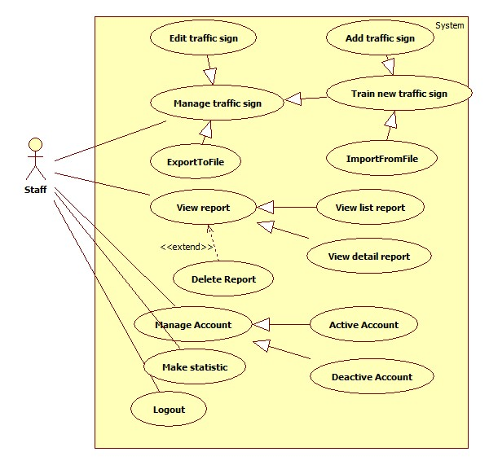

Figure 15: <Staff> Staff overview

##### <Staff> Add Traffic sign

Use Case Diagram



Figure 16: <Staff> Add traffic sign

Use Case Specification

|  |  |  |  |
| --- | --- | --- | --- |
| **USE CASE SU001** | | | |
| **Use Case No.** | SU001 | **Use Case Version** | 2.0 |
| **Use Case Name** | Add traffic sign | | |
| **Author** | Tran Le Tuan | | |
| **Date** | 15/01/2014 | **Priority** | Normal |
| **Actor:** Staff  **Summary:**  Staff use this case to add new traffic sign  **Goal:**  New traffic sign will be added into database  **Triggers:**   * We want to add a new traffic sign into database * To add new sign, staff must: * From the staff Home Page, click the menu item “Quản lí biển báo” * Select “Thêm biển báo” button   **Preconditions:**   * Guest must login as role Staff.   **Post Conditions:**   * **Success:** The sign will be added * **Fail:** No sign added. Transfer to error page   **Main Success Scenario:**   |  |  |  | | --- | --- | --- | | Step | Actor Action | System Response | | 1 | Click menu item “Quản lí biển báo”. | Redirect to Sign Manager Page, includes a panel with 2 tabs:   * Danh sách biển báo. * Thêm biển báo.   Current tab is Account List. This tab includes:   * Table with 2 column:   + Hình: Label   + Thông tin: Label * Thêm: Button * Hủy: Button | | 2 | Fill information of the sign and press “Thêm” button.  [Alternative 1] | The new sign will be added. System shows message “Đã Thêm Biển Báo Thành Công”  [Exception 1, 2] |   **Alternative Scenario:**   |  |  |  | | --- | --- | --- | | No | Actor Action | System Response | | 1 | Click on “Hủy” button | The form is emptied |   **Exceptions:**   |  |  |  | | --- | --- | --- | | No | Actor Action | System Response | | 1 | Not enter enough require information. | Display error message: “Thông tin khai báo chưa đầy đủ.” | | 2 | Traffic sign name existed in database | Display error message:  “Biển báo đã tồn tại.” |   **Relationships:** Manage Account  **Business Rules:**   * Added traffic sign must difference with other traffic sign in database. | | | |

Table 28: <Staff> Add traffic sign

##### <Staff> Edit traffic sign

Use Case Diagram



Figure 17: <Staff> Edit traffic sign

Use Case Specification

|  |  |  |  |
| --- | --- | --- | --- |
| **USE CASE – SU002** | | | |
| **Use Case No.** | SU002 | **Use Case Version** | 2.0 |
| **Use Case Name** | Edit traffic sign | | |
| **Author** | Bui Viet Phong | | |
| **Date** | 15/01/2014 | **Priority** | Normal |
| **Actor:** Staff  **Summary:**  This use case allow staff to edit traffic sign information or traffic images  **Goal:**  Edit traffic sign information or traffic images**.**  **Triggers:**   * For recognize or view traffic signs details, the system must store traffic signs information and images for recognition * To edit traffic signs, staff must: * Select ‘Quản lý biển báo’ * Click “Chỉnh sửa” * Edit information or add image then click “Hoàn tất”   **Preconditions:**   * Guest must log in the system with role staff   **Post Conditions:**   * **Success:** The new traffic sign’s information or image will be updated * **Fail: T**raffic sign’s information or image will not be updated   **Main Success Scenario:**   |  |  |  | | --- | --- | --- | | Step | Actor Action | System Response | | 1 | - Click ‘Quản lý biển báo’ | Redirect to Traffic management page, contains:   * “Tạo mới biển báo”: Button. * “Thêm biển báo từ tập tin” : Button. * List of the current traffic signs, each row include:   + Traffic name   + Traffic image   + “Chỉnh sửa” : Button | | 2 | Click “Chỉnh sửa” button | Redirect to edit traffic sign page, contains:   * Text field: Traffic sign name * Text field: Traffic sign number * Text field: Traffic sign content * Text field: Penalize fee * File Upload Control: file type “.jpeg” – Maximum size: 1mB * “Hoàn tất”: Button * “Hủy” : Button | | 3 | Edit information in text box or select file to upload from File Upload Control to add more image then click “Hoàn tất”.  [Alternative 1] | * Update traffic sign information or images. * Redirect to Traffic management page.   [Exception 1] |   **Alternative Scenario:**   |  |  |  | | --- | --- | --- | | No | Actor Action | System Response | | 1 | [Alternative 1]  - Click “Hủy” button | Redirect to Traffic management page. |   **Exceptions:**   |  |  |  | | --- | --- | --- | | No | Actor Action | System Response | | 1 | Select wrong file. | Display error message: “ Tập tin không đúng định dạng” | | 2 | File structure is wrong. | Display error message: “ Tập tin không đúng cấu trúc” | | 3 | File size is more than 1mB | Display error message: “ Kích thước tập tin phải nhỏ hơn 1mB” |   **Relationships:** Manage traffic signs  **Business Rules:**   * Staff can add many images in one time. * Traffic ID and traffic’s name is not null. | | | |

Table 29: <Staff> Edit traffic sign

##### <Staff> Export to file

Use Case Diagram



Figure 18: <Staff> Export to file

Use Case Specification

|  |  |  |  |
| --- | --- | --- | --- |
| **USE CASE – SU003** | | | |
| **Use Case No.** | SU003 | **Use Case Version** | 2.0 |
| **Use Case Name** | Export To File. | | |
| **Author** | Tran Le Tuan | | |
| **Date** | 15/01/2014 | **Priority** | Normal |
| **Actor:** Staff  **Summary:**  Staff uses this case to export to file  **Goal:**  Allow staff to export to file  **Triggers:**   * Staff wants to export to file. * To export file, we must :   + Staff login system  + On manage traffic sign page, click on button “Xuất tập tin” to export  **Preconditions:**   * Guest must login with role Staff.   **Post Conditions:**   * **Success**: Staff can export to file * **Fail:** Show message error alert   **Main Success Scenario:**   |  |  |  | | --- | --- | --- | | Step | Actor Action | System Response | | 1 | Click on “Xuất tập tin” to request export on “quản lí” page | System will export report to file excel.  Show message “Xuất tập tin thành công”  [Exception 1] |   **Alternative Scenario:** N/A  **Exceptions:**   |  |  |  | | --- | --- | --- | | No | Actor Action | System Response | | 1 | Cannot export file | Display error message: “Xuất tập tin thất bại.” |   **Relationships:** N/A  **Business Rules:**   * The export file will be a excel file with the structure like the sample file in … | | | |

Table 30: <Staff> Export to file

##### <Staff> Import from file

Use Case Diagram



Figure 19: <Staff> Import from file

Use Case Specification

|  |  |  |  |
| --- | --- | --- | --- |
| **USE CASE – SU004** | | | |
| **Use Case No.** | SU004 | **Use Case Version** | 2.0 |
| **Use Case Name** | Import traffic sign from file | | |
| **Author** | Bui Viet Phong | | |
| **Date** | 15/01/2014 | **Priority** | Normal |
| **Actor:** Staff  **Summary:**  This use case allow staff to train new traffic signs from existing file  **Goal:**  Train new traffic signs from existing file  **Triggers:**   * For recognize or view traffic signs details, the system must store traffic signs information and images for recognition * To train new traffic signs from existing file, staff must: * Select ‘Quản lý biển báo’ * Click “Thêm biển báo từ tập tin” * Select file to upload then click “Tải lên”   **Preconditions:**   * Guest must log in the system with role staff * Staff has the file to upload   **Post Conditions:**   * **Success:** The new traffic sign has been added to database * **Fail:** No traffic sign has been has been added to database   **Main Success Scenario:**   |  |  |  | | --- | --- | --- | | Step | Actor Action | System Response | | 1 | - Click ‘Quản lý biển báo’ | Redirect to Traffic management page, contains:   * “Tạo mới biển báo”: Button * “Thêm biển báo từ tập tin” : Button. * List of the current traffic signs, each row include:   + Traffic name   + Traffic image   + “Chỉnh sửa” : Button | | 2 | Click “Thêm biển báo từ tập tin” button | Redirect to Import traffic sign page, contains:   * File Upload Control. * “Tải lên”: Button. * “Hủy” : Button | | 3 | Select file to upload from File Upload Control then click “Tải lên” button.  [Alternative 1] | Upload file and add new traffic signs to database.  Redirect to Traffic management page  [Exception 1][Exception 2] |   **Alternative Scenario 1:**   |  |  |  | | --- | --- | --- | | Step | Actor Action | System Response | | 1 | [Alternative 1]  - Click “Hủy” button | Redirect to Traffic management page. |   **Exceptions:**   |  |  |  | | --- | --- | --- | | No | Actor Action | System Response | | 1 | Not select file, click “Tải lên” button | Display error message: “Vui lòng chọn file để tải lên” | | 2 | Upload wrong file. | Display error message: “ Tập tin không đúng định dạng” |   **Relationships:** Manage traffic signs  **Business Rules:** N/A | | | |

Table 31: <Staff> Import from file

##### <Staff> View report

Use Case Diagram



Figure 20: <Staff>View report

Use Case Specification

|  |  |  |  |
| --- | --- | --- | --- |
| **USE CASE – SU005** | | | |
| **Use Case No.** | SU005 | **Use Case Version** | 2.0 |
| **Use Case Name** | View Report | | |
| **Author** | Ho Dac Nghia | | |
| **Date** | 15/01/2014 | **Priority** | Normal |
| **Actor:** Staff  **Summary:**  Staff use this case to view report  **Goal:**   * Allow staff to view list of report or detail of report   **Triggers:**   * Click menu item “Quản lý phản hồi” on menu bar. * System redirect to Report Page * The list of report will show * Click “Chi tiết” link to view details of report   **Preconditions:**   * User must login system with role Staff.   **Post Conditions:**   * **Success:** The list of report will show. Staff can view details of report. * **Fail:** No report list displayed. Staff cannot view details of report.   **Main Success Scenario:**   |  |  |  | | --- | --- | --- | | Step | Actor Action | System Response | | 1 | Click menu item “Quản lí phản hồi” on menu bar. | Redirect to Report List Page, contains:  Table with 4 columns, record of 20 latest report:  - Mã số: label  - Tên người phản hồi: label  - Thời gian: label  - Nội dung: label  - Xem chi tiết: link  - Xóa: link | | 2 | For report’s detail view  Staff click “Chi tiết” link beside each report.  [Alternative 1] | System redirect Report Details Page  The details of report will show |   **Alternative Scenario:**   |  |  |  | | --- | --- | --- | | Step | Actor Action | System Response | | 1 | [Alternative 1]  - Click “Xóa” link | Reference to Usecase- SU006. |   **Exception**: N/A  **Relationships:** N/A  **Business Rules:** N/A | | | |

Table 32: <Staff> View report

##### <Staff> Delete report

Use Case Diagram



Figure 21: <Staff> Delete report

Use Case Specification

|  |  |  |  |
| --- | --- | --- | --- |
| **USE CASE – SU006** | | | |
| **Use Case No.** | SU006 | **Use Case Version** | 2.0 |
| **Use Case Name** | Delete Report | | |
| **Author** | Ho Dac Nghia | | |
| **Date** | 15/01/2014 | **Priority** | Normal |
| **Actor:** Staff  **Summary:**  Staff uses this case to delete report  **Goal:**  Allow staff to delete report.  **Triggers:**   * Click menu item "Quản lí phản hồi" on menu bar. * On the report list, click report item to view details of report * Click "Xóa" to delete report * Click “Đồng ý”   **Preconditions:**   * User must log in the system with role Staff. * There must be at least one report in the report list   **Post Conditions:**   * **Success:** The report of a traffic sign will be removed from server and database * **Fail:** Report isn’t removed   **Main Success Scenario:**   |  |  |  | | --- | --- | --- | | Step | Actor Action | System Response | | 1 | Click menu item “Quản lí phản hồi” on menu bar. | Redirect to Report List Page, contains:  Table with 4 columns, record of 20 latest report:   * Mã số: Label * Tên người phản hồi: Label * Thời gian: Label * Nội dung: Label * Xem chi tiết: Link * Xóa: Link | | 2 | Click on the “Xóa” link  [Alternative1] | Show confirms windows with message:  “Bạn có muốn xóa phản hồi này?” | | 3 | Click “Đồng ý” button.  [Alternative 2] | The selected report will be inactive. System display a message: “Phản hồi đã được xóa” |   **Alternative Scenario:**  1.   |  |  |  | | --- | --- | --- | | Step | Actor Action | System Response | | 1 | Click on “Xem chi tiết” link | Redirect to Report Detail Page, contains detail of User’s Report, include:  Mã số: label  -Tên người phản hồi: label  -Thời gian: label  -Nội dung: label  -Hình ảnh kết quả nhận diện: label  -Xóa: button | | 2 | Click on the “Xóa” button | Show confirms windows with message:  “Bạn có muốn xóa phản hồi này?” | | 3 | Click “Đồng ý” button.  [Alternative 2] | The selected report will be inactive.  System display a message: “Phản hồi đã được xóa”. |   2.   |  |  |  | | --- | --- | --- | | Step | Actor Action | System Response | | 1 | Click “Hủy” | System will close the message box. |   **Exceptions:** N/A **Relationships:** View Report  **Business Rules:** N/A | | | |

Table 33: <Staff> Delete report

##### <Staff, Admin> Active Account

Use Case Diagram



Figure 22: <Staff, Admin> Active Account

Use Case Specification

|  |  |  |  |
| --- | --- | --- | --- |
| **USE CASE – SU007** | | | |
| **Use Case No.** | SU007 | **Use Case Version** | 2.0 |
| **Use Case Name** | Active Account | | |
| **Author** | Tran Le Tuan | | |
| **Date** | 15/01/2014 | **Priority** | Normal |
| **Actor:** Admin, Staff  **Summary:**  This use case allow admin to active an account  **Goal:**  An inactive account will be activated  **Triggers:**   * In our system, when we do not want user to login, we inactive his/her account. We can active the inactivated account so they can login again. * To active an account, admin must: * From the admin Home Page, click the menu item “Quản lí tài khoản”. * Check the Select checkbox of the account record, then select “Kích hoạt” on the drop down list, and press “Đồng ý” button   **Preconditions:**   * User must log in the system with the role admin * There must be at least one inactive account in database   **Post Conditions:**   * **Success:** The selected accounts will be activated * **Fail:** No account activated.Transfer to error page   **Main Success Scenario:**   |  |  |  | | --- | --- | --- | | Step | Actor Action | System Response | | 1 | Click menu item“Quản lí tài khoản”. | Redirect to Account Manager Page, includes a panel with 2 tabs:   * Danh sách tài khoản * Tạo tài khoản   Current tab is Account List. This tab includes:   * Table with 4 column:   + Mã số: Label   + Tên tài khoản: Label   + Email: Label   + Chức vụ: Label   + Tình Trạng: Label * Action: dropdownlist: Khóa, Kích hoạt * Đồng ý: Button | | 2 | Check the checkboxs of the account(s), select “Kích hoạt” on the drop down list, and press “Đồng ý” button | The selected account(s) will be activated  [Exception 1,2] |   **Alternative Scenario:** N/A  **Exceptions:**   |  |  |  | | --- | --- | --- | | No | Actor Action | System Response | | 1 | The account has already been activated by another admin | Nothing happen, the account(s) status is active | | 2 | Check no checkbox, press “Đồng ý” button | Display error message:  “Chưa chọn tài khoản để kích hoạt.” |   **Relationships:** Manage Account  **Business Rules:**   * Admin cannot active/inactive account of themselves or other admin * Staff cannot active/inactive account of themselves, other Staff or Admin | | | |

Table 34: <Staff, Admin> Active Account

##### <Staff, Admin> Deactivate Account

Use Case Diagram



Figure 23: <Staff, Admin> Deactivate Account

Use Case Specification

|  |  |  |  |
| --- | --- | --- | --- |
| **USE CASE – SU008** | | | |
| **Use Case No.** | SU008 | **Use Case Version** | 2.0 |
| **Use Case Name** | Inactive Account | | |
| **Author** | Tran Le Tuan | | |
| **Date** | 15/01/2014 | **Priority** | Normal |
| **Actor:** Admin  **Summary:**  This use case allow admin to active an account  **Goal:**  A active account will be inactivated  **Triggers:**   * In our system, when we do not want a user to login, we inactive his/her account. The account can be activated later * To active an account, admin must: * From the admin Home Page, click the menu item “Quản lí tài khoản” * Check the Select checkbox of the account record, select “Kích hoạt” on the drop down list, and press “Process” button   **Preconditions:**   * User must logged in the system with the role is admin * There must be at least 1 active account in database   **Post Conditions:**   * **Success:** The selected account(s) will be inactivated * **Fail:** No account inactivated.Transfer to error page   **Main Success Scenario:**   |  |  |  | | --- | --- | --- | | Step | Actor Action | System Response | | 1 | Click menu item“Quản lí tài khoản”. | Redirect to Account Manager Page, includes a panel with 2 tabs:   * Danh sách tài khoản * Tạo tài khoản   Current tab is Account List. This tab includes:   * Table with 5 columns:   + Mã số: Label   + Tên tài khoản: Label   + Email: Label   + Chức vụ: Label   + Tình Trạng : Label * Action: dropdownlist: Khóa, kích hoạt. * Đồng ý: Button | | 2 | Check the checkboxs of the account, select “Khóa” on the drop down list, and press “Đồng ý” button. | The selected account(s) will be inactivated.  [Exception 1,2] |   **Alternative Scenario:** N/A  **Exceptions:**   |  |  |  | | --- | --- | --- | | No | Actor Action | System Response | | 1 | The account have been inactivated by another admin | Nothing happen, the account(s) status is inactive | | 2 | Check no checkbox, press “Đồng ý” button. | Display error message:  “Chưa chọn tài khoản khóa” |   **Relationships:** Manage Account  **Business Rules:**   * Admin cannot active/inactive account of themselves or other admin * Staff cannot active/inactive account of themselves, other Staff or Admin | | | |

Table 35: <Staff, Admin> Deactivate Account

##### <Staff, Admin> Make statistic

Use Case Diagram



Figure 24: <Staff, Admin> Make statistic

Use Case Specification

|  |  |  |  |
| --- | --- | --- | --- |
| **USE CASE – SU008** | | | |
| **Use Case No.** | SU008 | **Use Case Version** | 2.0 |
| **Use Case Name** | Make statistic | | |
| **Author** | Ho Dac Nghia | | |
| **Date** | 15/01/2014 | **Priority** | Normal |
| **Actor:** Staff  **Summary:**  This use case allow staff to make Statistics about User and Report  **Goal:**   * Make Statistics information about user or report   **Triggers:**   * Click menu item “Thống Kê” -> “Drop down list” have 2 item “Thống kê người dùng” and “Thống kê phản hồi” * Click on “Thống kê người dùng” -> Statistics info of User * Click on “Thống kê phản hồi” -> Statistics info of Report   **Preconditions:**   * User must logged in the system with the role is staff   **Post Conditions:**   * **Success:** Statistics info of User or Report were displayed * **Fail:** No statistics info displayed   **Main Success Scenario:**   |  |  |  | | --- | --- | --- | | Step | Actor Action | System Response | | 1 | Click menu item“Thống Kê” | Dropdown list, contains :   * Thống kê người dùng * Thống kê phản hồi | | 1 | Click item “Thống kê người dùng”  [Alternative 1] | System redirect to Statistic Page contains:   * Thời gian bắt đầu: Time Picker * Thời gian kết thúc: Time Picker * Submit: Button | | 2 | Staff input value of time start and value of time end. Click “Submit” button | System will show the graph for User Statistic |   **Alternative Scenario:**  1.   |  |  |  | | --- | --- | --- | | Step | Actor Action | System Response | | 1 | Click item “Thống kê phản hồi” | System redirect to Statistic Page contains:   * Thời gian bắt đầu: Time Picker * Thời gian kết thúc: Time Picker * Submit: Button | | 2 | Staff input value of time start and value of time end. Click “Submit” button | System will show the graph for Report Statistic. |   **Exceptions:**   |  |  |  | | --- | --- | --- | | No | Actor Action | System Response | | 1 | The time start more than end time. | Display error message: “Ngày bắt đầu phải nhỏ hơn ngày kết thúc” | | 2 | The time start does not pick. | Display error message:”Vui lòng chọn ngày bắt đầu” |   **Relationships:** N/A  **Business Rules:**   * User statistic based on the number of users who use the system in 1 day * Report statistic based on the number of report that sent to the system in 1 day | | | |

Table 36: <Staff, Admin> Make statistic

#### <Admin> Admin overview

Use Case Diagram

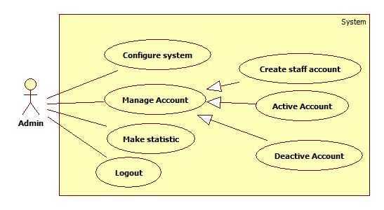

Figure 25: <Admin> Admin overview

##### <Admin> Configure system

Use Case Diagram



Figure 26: <Admin> Configure system

Use Case Specification

|  |  |  |  |
| --- | --- | --- | --- |
| **USE CASE – AD001** | | | |
| **Use Case No.** | AD001 | **Use Case Version** | 2.0 |
| **Use Case Name** | Configure system | | |
| **Author** | Mai Van Tan | | |
| **Date** | 15/01/2014 | **Priority** | Normal |
| **Actor:** Admin  **Summary:**  Admin use this case configure system  **Goal:**  Allow to configure system  **Triggers:**   * When admin want to configure system * Admin click on “Quản lý cấu hình” in menu   **Preconditions:**   * Guest must log in the system with role admin   **Post Conditions:**   * **Success:** The new configuration is applied to system * **Fail:** System show the message   **Main Success Scenario:**   |  |  |  | | --- | --- | --- | | Step | Actor Action | System Response | | 1 | Click menu item “Quản lý cấu hình”. | System redirect to configure system page:   * Thông số 1: Textbox * Thông số 2: Textbox * …… (Will be update later) * Xác nhận: Button | | 2 | Admin input the information and click “Xác nhận” | System apply new configuration  [Exception 1, 2] |   **Alternative Scenario:** N/A  **Exceptions:**   |  |  |  | | --- | --- | --- | | No | Actor Action | System Response | | 1 | Not valid information | System show message “Thông số nhập vào không hợp lệ” | | 2 | Cannot apply new configuration | System show message “Có lỗi, thiết lập cấu hình thất bại” |   **Relationships:** N/A  **Business Rules:** N/A | | | |

Table 37: <Admin> Configure system

##### <Admin> Create staff account

Use Case Diagram

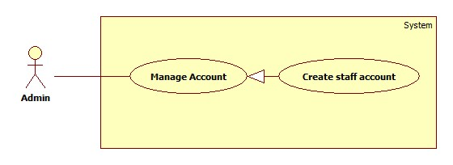

Figure 27: <Admin> Create staff account

Use Case Specification

|  |  |  |  |
| --- | --- | --- | --- |
| **USE CASE – AD002** | | | |
| **Use Case No.** | AD002 | **Use Case Version** | 2.0 |
| **Use Case Name** | Create Staff Account | | |
| **Author** | Tran Le Tuan | | |
| **Date** | 15/01/2014 | **Priority** | Normal |
| **Actor:** Admin  **Summary:**  Admin use this case to create account for staff  **Goal:**  A new account staff will be added to database  **Triggers:**   * In our system, the account of a staff will be added only by admin * To create a new account, admin must: * From the admin Home Page, click the menu item “Quản lí tài khoản” * In the Account Manager Page, click on the Tab “Tạo tài khoản” * Input new account information, click “Đồng ý” to finish.   **Preconditions:**   * Admin must login system   **Post Conditions:**   * **Success:** A new account will be created. The account will be displayed on account list * **Fail:** No account created.Transfer to error page or still in current page   **Main Success Scenario:**   |  |  |  | | --- | --- | --- | | Step | Actor Action | System Response | | 1 | Click menu item “Quản lí tài khoản”. | Redirect to Account Manager Page, includes a panel with 2 tabs:   * Danh sách tài khoản * Tạo tài khoản   Current tab is Account List. This tab includes:   * Table with 5 columns:   + Mã số: Label   + Tên: Label   + Email: Label   + Chức vụ: Label   + Tình trạng: Checkbox * Dropdownlist: Khóa, Đã kích hoạt * Đồng ý: Button | | 2 | Click Tab “Tạo tài khoản”. | Display a tab panel includes:   * Tên Tài Khoản: Textbox (min length: 5, max length: 30, required). * Mật mã: Textbox (password box, min length: 5, max length: 30, required). * Chức vụ: dropdownlist: Nhân viên, Thành viên. * Đồng ý: Button * Hủy: Button | | 3 | Input new account information.  Click “Đồng ý” button.  [Alternative 1] | System will add the account to database.  Show the tab panel “Danh sách tài khoản”  [Exception 1,2,3,4] |   **Alternative Scenario:**   |  |  |  | | --- | --- | --- | | No | Actor Action | System Response | | 1 | Click on “Hủy” button | The form is emptied |   **Exceptions:**   |  |  |  | | --- | --- | --- | | No | Actor Action | System Response | | 1 | Not enter enough require information. | Display error message: “Thông tin khai báo chưa đầy đủ.” | | 2 | Username/password is not in range [5,30] | Display error message: “Tên tài khoản/Mật mã phải từ 5 đến 30 kí tự” | | 3 | Confirm password is not equal password | Display error message:  “Mật mã nhập lại không trùng khớp.” | | 4 | Username or email existed in database | Display error message:  “Tài khoản hoặc Email đã tồn tại.” |   **Relationships:** Manage Account  **Business Rules:**   * Each account is active when added to database. * The “Nhập lại mật khẩu” value must match “Mật khẩu” value. | | | |

Table 38: <Admin> Create staff account

## Software System Attribute

### Usability

#### Graphic User Interface

* All the text, label and image should be in Vietnamese.

#### Usability

* Website admin, staff should need only two days of training to use the system.
* The guest, user can use the system easily without training.

#### Installation

* The system must be easy to deploy. Customer can deploy successfully and learn to configure, maintain the system within one day of training.
* The mobile app must be easy to install. Compatible with Android OS 4.0.
* The attached manual guide must be clear.

### Reliability

* N/A

### Availability

* N/A

### Security

* Privacy: Each role of user has a specific permission to interact with system.
* Only admin can grant permission to staff.

### Maintainability

* N/A

### Portability

* N/A

### Performance

* N/A

## Conceptual Diagram

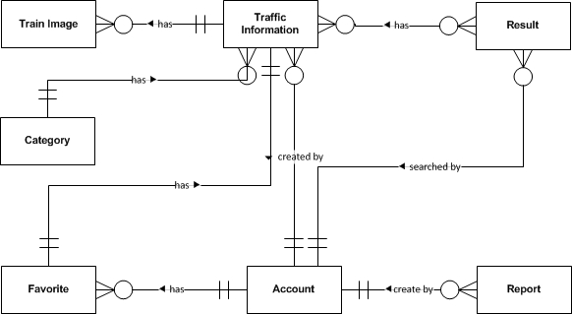

Figure 28: Conceptual Diagram

**Data Dictionary**

|  |  |
| --- | --- |
| **Entity Data dictionary: describe content of all entities** | |
| **Entity Name** | **Description** |
| Traffic Information | Describe information about traffic sign |
| Train Image | Describe information about image to support recognize traffic sign |
| Category | Describe all type of traffic sign |
| Report | Describe information about report of user. Contain content when user though the search result or traffic information wrong. |
| Account | Describe all information about user in the system |
| Result | Describe information about search auto result (user’s history) |
| Favorite | Describe information about favorite traffic sign of user |

# Software Design Description

## Design Overview

* This document describes the technical and user interface design of TSRT using mobile device. It includes the architectural design, the detailed design of common functions and business functions and the design of database model.
* The architectural design describes the overall architecture of the system and the architecture of each main component and subsystem.
* The detailed design describes static and dynamic structure for each component and functions. It includes class diagrams, class explanations and sequence diagrams for each Use Cases.
* The database design describes the relationships between entities and details of each entity.
* Document overview:
* Section 2: gives an overall description of the system architecture design.
* Section 3: gives component diagrams that describe the connection and integration of the system.
* Section 4: gives the detail design description include class diagram, class explanation, and sequence diagram to details the application functions.
* Section 5: describe an ERD with logical diagram.

## System Architectural Design



Figure 29: N-tier Architecture

<http://www.cardisoft.gr/frontend/article.php?aid=87&cid=96>

* **Client Tier**: The client tier interacts with the users for the solution. Since the application conforms to a three layered services application it hosts the presentation layer components.
* **Application Tier**: The servers used in the application tier are responsible for host­ing all the application's business components and, in the case of Web applications, the Web servers as well.
* **Data Tier**: The servers in the data tier host the databases that the application requires; it is within this tier that the data layer is hosted.

## Component Diagram



Figure 30: Component Diagram

**Data Dictionary**

|  |  |
| --- | --- |
| **Name** | **Description** |
| TS Detect And Recognize | Provide functions to detect and recognize traffic sign |
| Traffic | Provide functions about traffic sign: manage, search |
| Manage | Provide functions to manage account, favorite |
| Statistic And Configure | Provide functions to statistic and configure server |
| Web service | Provide service interface using http protocol |
| Mobile client | Provide functions in mobile |
| Web Module | Provide functions in web |

## Detailed Description of Components

### Class Diagram

–

Figure 31: Class Diagram

### Class Diagram Explanation

#### TrafficInfo

Attribute

|  |  |  |  |
| --- | --- | --- | --- |
| **Attribute** | **Type** | **Visibility** | **Description** |
| trafficID | String | Private | Traffic sign no |
| name | String | Private | Name of traffic sign |
| image | String | Private | Traffic sign image link |
| categoryID | Int | Private | Category ID of traffic sign |
| information | String | Private | Content of traffic sign |
| penaltyfee | String | Private | Penalty fee of traffic sign |
| creator | String | Private | Creator of traffic sign |
| createDate | Date | Private | Create date |
| modifyDate | Date | Private | Modify date |
| isActive | Boolean | Private | Status of traffic sign |

Method

|  |  |  |  |
| --- | --- | --- | --- |
| **Method** | **Return Type** | **Visibility** | **Description** |
| searchTraffic() | ArrayList<TrafficInfo> | Public | Search traffic by input parameter: name, cateID, limit |
| getDetail() | TrafficInfo | Public | Get traffic sign detail |

#### Account

Attribute

|  |  |  |  |
| --- | --- | --- | --- |
| **Attribute** | **Type** | **Visibility** | **Description** |
| userID | String | Private | UserID |
| password | String | Private | User’s password in MD5 form |
| email | String | Private | User’s email |
| name | String | Private | User’s name |
| role | String | Private | Role in system |
| createDate | Date | Private | Create date |
| isActive | Boolean | Private | Status |

Method

|  |  |  |  |
| --- | --- | --- | --- |
| **Method** | **Return Type** | **Visibility** | **Description** |
| getAccount() | Account | Public | Get user information |

#### Category

Attribute

|  |  |  |  |
| --- | --- | --- | --- |
| **Attribute** | **Type** | **Visibility** | **Description** |
| categoryID | Int | Private | ID of category |
| categoryName | String | Private | Name of category |

Method

|  |  |  |  |
| --- | --- | --- | --- |
| **Method** | **Return Type** | **Visibility** | **Description** |
| listAllCategory() | ArrayList<Category> | Public | Get list all category |

#### TrainImage

Attribute

|  |  |  |  |
| --- | --- | --- | --- |
| **Attribute** | **Type** | **Visibility** | **Description** |
| trafficID | String | Private | TrafficID of Image |
| imageID | String | Private | ID of image |
| imageName | String | Private | Name of image |

Method

|  |  |  |  |
| --- | --- | --- | --- |
| **Method** | **Return Type** | **Visibility** | **Description** |
| add() | Boolean | Public | Add a train image |
| listByTrafficID() | ArrayList<TrainImage> | Public | List all train image of a traffic sign |

#### Favorite

Attribute

|  |  |  |  |
| --- | --- | --- | --- |
| **Attribute** | **Type** | **Visibility** | **Description** |
| creator | String | Private | Creator of favorite |
| trafficID | String | Private | Traffic ID of favorite |
| createDate | Date | Private | Create date |
| modifyDate | Date | Private | Modify date |
| isActive | Boolean | Private | Status |

Method

|  |  |  |  |
| --- | --- | --- | --- |
| **Method** | **Return Type** | **Visibility** | **Description** |
| listFavorite() | ArrayList<Favorite> | Public | List all favorite of an user |

#### Result

Attribute

|  |  |  |  |
| --- | --- | --- | --- |
| **Attribute** | **Type** | **Visibility** | **Description** |
| resultID | Int | Private | Unique ID for result |
| uploadedImage | String | Private | Image link of result |
| listTraffic | String | Private | List result contain trafficID and their location in image |
| creator | String | Private | Creator of result |
| createDate | Date | Private | Create date |
| isActive | Boolean | Private | Status of result |

Method

|  |  |  |  |
| --- | --- | --- | --- |
| **Method** | **Return Type** | **Visibility** | **Description** |
| getResultByID() | Result | Public | Get result detail by ID |
| getResultByCreator() | ArrayList<Result> | Public | Get all result of an user |

#### Report

Attribute

|  |  |  |  |
| --- | --- | --- | --- |
| **Attribute** | **Type** | **Visibility** | **Description** |
| reportID | Int | Private | Unique id for report |
| referenceID | String | Private | Reference Id of report, this ID reference to TrafficInfo or Result depend on type of report |
| content | String | Private | Content of report |
| creator | String | Private | Creator of report |
| type | Int | Private | Type of report. 1 for wrong recognize, 2 for wrong traffic information |
| createDate | Date | Private | Create date |
| isActive | Boolean | Private | Status |

Method

|  |  |  |  |
| --- | --- | --- | --- |
| **Method** | **Return Type** | **Visibility** | **Description** |
| getReportDetail() | Report | Public | Get detail of report |
| getReportByType | ArrayList<Report> | Public | Get all report by type |

### Sequence Diagram

#### Add Traffic Sign

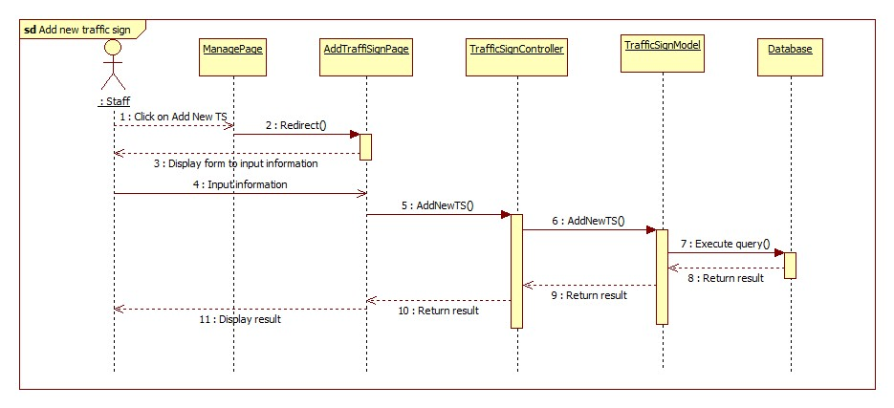

Figure 32: Add Traffic Sign Sequence Diagram

#### Add Train Image

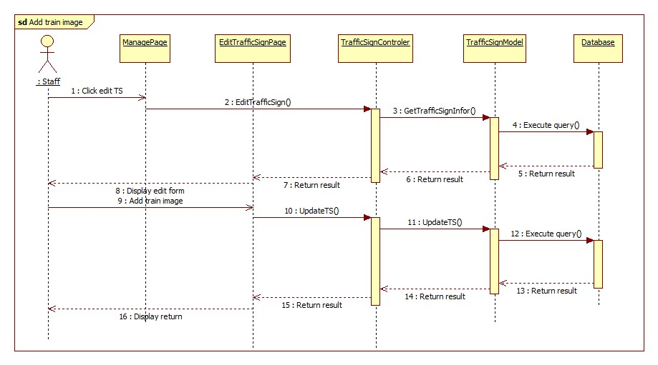

Figure 33: Add Train Image Sequence Diagram

#### Import Data From File

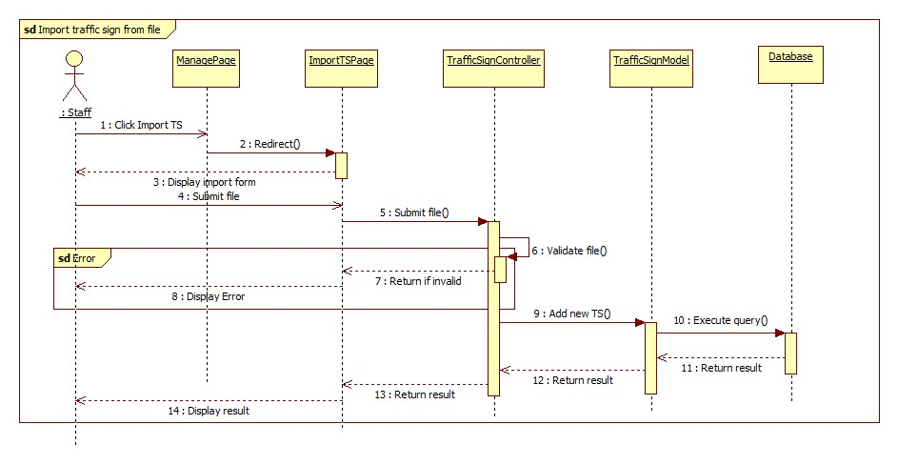

Figure 34: Import Data From File Sequence Diagram

#### Search Traffic Sign Auto

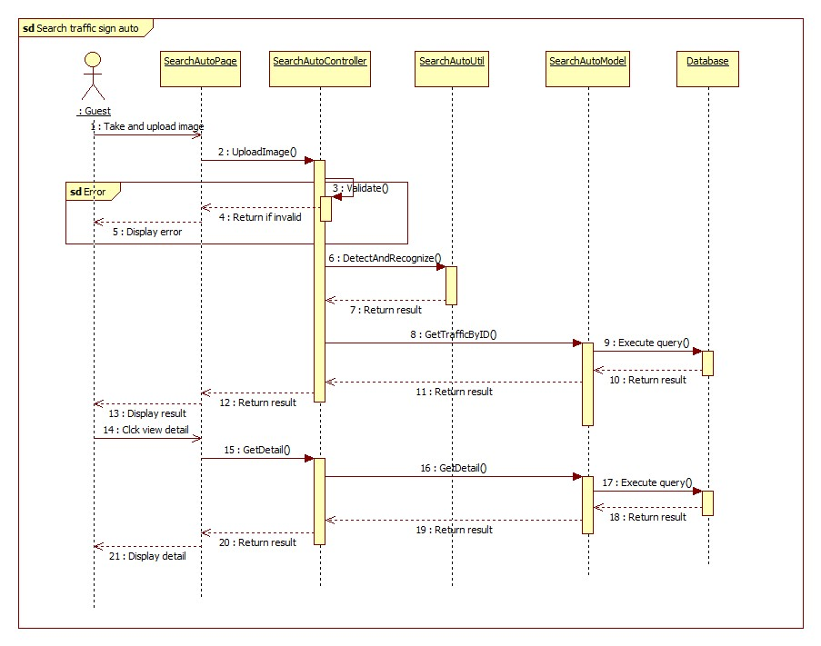

Figure 35: Search Traffic Sign Auto Sequence Diagram

#### Search Traffic Sign Manual

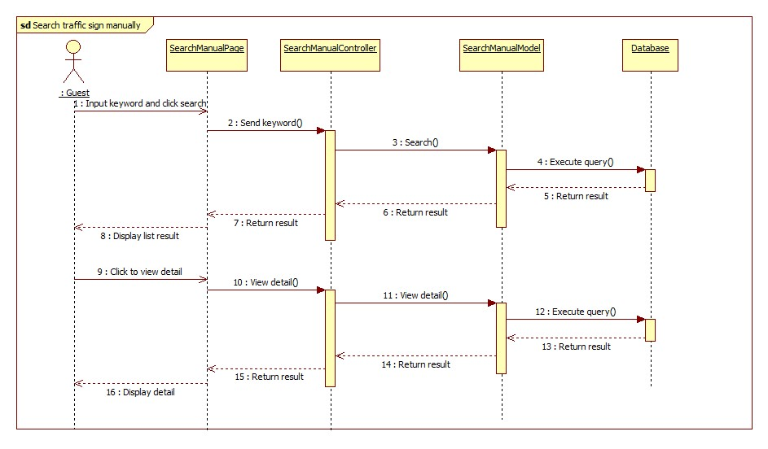

Figure 36: Search Traffic Sign Manual Sequence Diagram

## User Interface Design

### User Interface Design

#### User Home Page

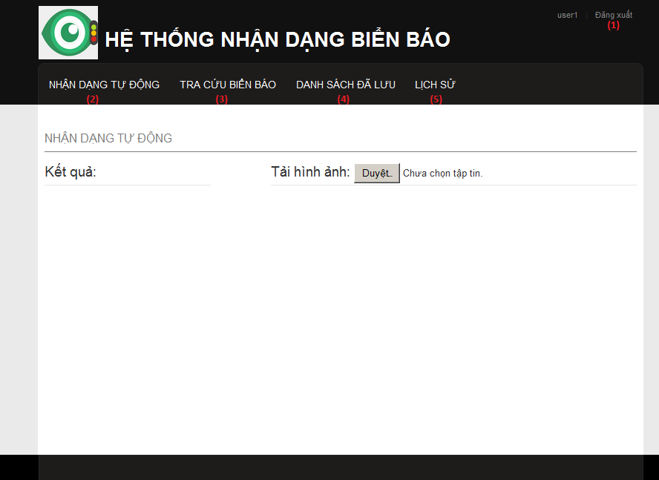

Figure 37: User Home Page

**Button/ Hyperlink**

|  |  |  |  |  |
| --- | --- | --- | --- | --- |
| **No** | **Function** | **Description** | **Validation** | **Outcome** |
| 1 | Logout | Click to logout | No | Delete session and return to Home page |
| 2 | Search auto | Click to go to search auto page | No | Search auto Page |
| 3 | Search manual | Click to go to search manual page | No | Search manual page |
| 4 | Favorite | Click to View favorite list | No | Get the favorite list from service and return to Favorite page |
| 5 | History | Click to view history list | No | Get the history list from service and return to history page |

#### User – Search auto

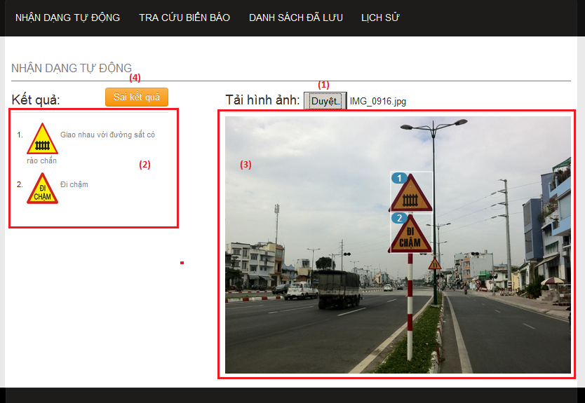

Figure 38: User – Search auto

**Fields**

|  |  |  |  |  |  |  |  |
| --- | --- | --- | --- | --- | --- | --- | --- |
| **No** | **Field Name** | **Description** | **Read only** | **Mand-atory** | **Control Type** | **Data Type** | **Length** |
| 3 | Image preview | Show image was upload by user. | Y | Y | Image tag | N/A | N/A |

**Button/ Hyperlink**

|  |  |  |  |  |
| --- | --- | --- | --- | --- |
| **No** | **Function** | **Description** | **Validation** | **Outcome** |
| 1 | Select image for upload | Click to select an image to upload for search traffic signs | No | Upload image to service and show the result |
| 2 | ist result | Show list result matching with number in the image. Click one item to view traffic sign detail | No | Show popup to view traffic sign details |
| 4 | Send report | Click to show popup to send report | No | Show popup to send report |

#### User – Search manual

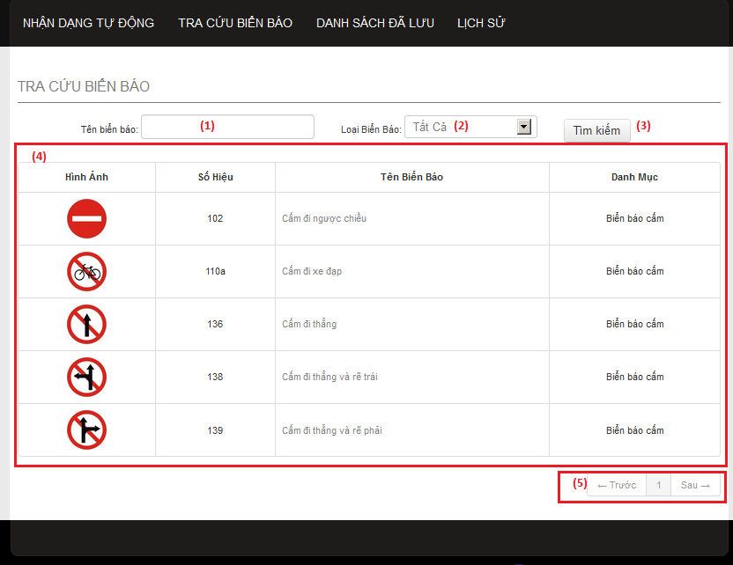

Figure 39: User – Search manual

**Fields**

|  |  |  |  |  |  |  |  |
| --- | --- | --- | --- | --- | --- | --- | --- |
| **No** | **Field Name** | **Description** | **Read only** | **Mand-atory** | **Control Type** | **Data Type** | **Length** |
| 1 | Search key | Enter traffic name to search. | N | N | Input tag | Strin-g | N/A |
| 2 | Category | Select one category type to search | N | Y | Select tag | N/A | N/A |
| 4 | List result | Display result after search manual | Y | Y | Table | N/A | N/A |

**Button/ Hyperlink**

|  |  |  |  |  |
| --- | --- | --- | --- | --- |
| **No** | **Function** | **Description** | **Validation** | **Outcome** |
| 3 | Search manual | Click to search traffic sign by traffic sign’s name and category. | No | Show list result to the table below. |
| 4 | Paging | Select number or “Trước”, “Sau” to view others records in the table. | No | Change page in the table |

**Table List Result includes**

|  |  |  |  |  |  |
| --- | --- | --- | --- | --- | --- |
| **Field Name** | **Description** | **Read only** | **Control Type** | **Data Type** | **Length** |
| “Hình ảnh” | Traffic sign’s image. Click to view traffic sign detail | Y | Image | N/A | N/A |
| “Số hiệu” | Traffic sign’s ID number | Y | Label | String | N/A |
| “Tên biển báo” | Traffic sign’s name. Click to view traffic sign detail | Y | Label | String | N/A |
| “Danh mục” | Traffic sign’s category | Y | Label | String | N/A |

#### User – Favorite list

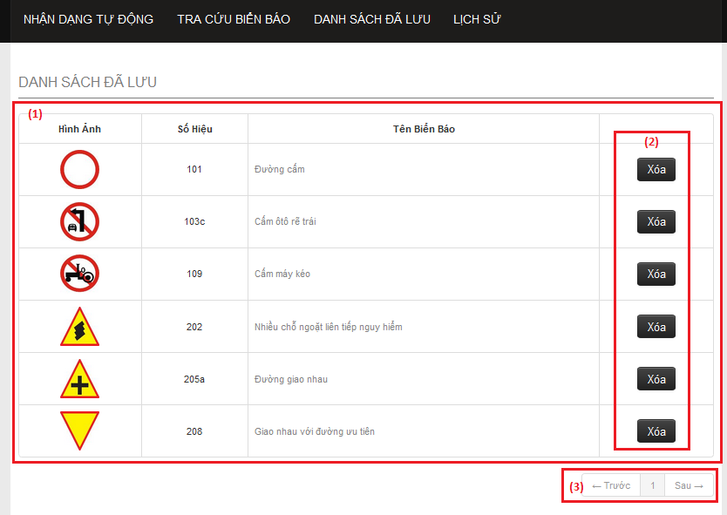

Figure 40: User – Favorite list

**Fields**

|  |  |  |  |  |  |  |  |
| --- | --- | --- | --- | --- | --- | --- | --- |
| **No** | **Field Name** | **Description** | **Read only** | **Mandatory** | **Control Type** | **Data Type** | **Length** |
| 1 | Favorite List Table | The list of traffic signs in the favorite. | N | Y | Table | N/A | N/A |

**Button/ Hyperlink**

|  |  |  |  |  |
| --- | --- | --- | --- | --- |
| **No** | **Function** | **Description** | **Validation** | **Outcome** |
| 2 | Delete favorite | Click to delete traffic sign from favorite list. | No | Send delete request to service and delete a row in table. |
| 3 | Paging | Select number or “Trước”, “Sau” to view others records in the table. | No | Change page in the table |

**Table Favorite list includes**

|  |  |  |  |  |  |
| --- | --- | --- | --- | --- | --- |
| **Field Name** | **Description** | **Read only** | **Control Type** | **Data Type** | **Length** |
| “Hình ảnh” | Traffic sign’s image. Click to view traffic sign detail | Y | Image | N/A | N/A |
| “Số hiệu” | Traffic sign’s ID number | Y | Label | String | N/A |
| “Tên biển báo” | Traffic sign’s name. Click to view traffic sign detail | Y | Label | String | N/A |
| Action | Button to delete traffic sign from favorite list. | Y | Button | N/A | N/A |

#### User – History list

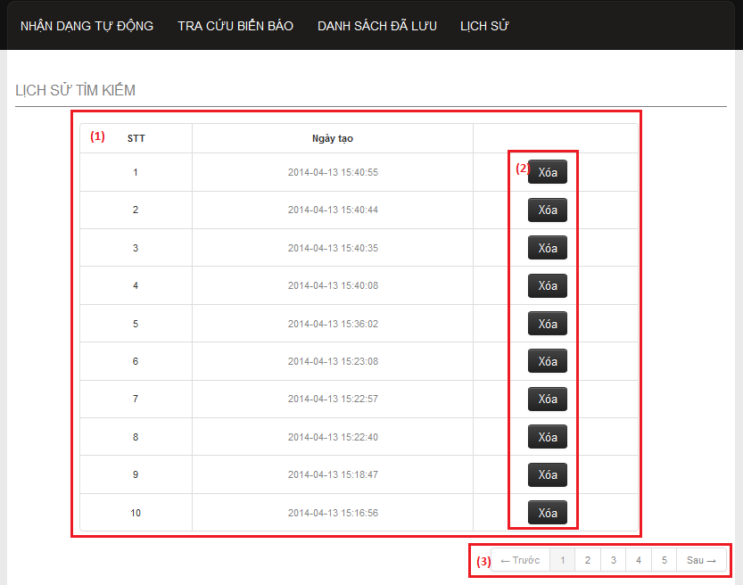

Figure 41: User – History list

**Fields**

|  |  |  |  |  |  |  |  |
| --- | --- | --- | --- | --- | --- | --- | --- |
| **No** | **Field Name** | **Description** | **Read only** | **Mandatory** | **Control Type** | **Data Type** | **Length** |
| 1 | History list | The list history. | N | Y | Table | N/A | N/A |

**Button/ Hyperlink**

|  |  |  |  |  |
| --- | --- | --- | --- | --- |
| **No** | **Function** | **Description** | **Validation** | **Outcome** |
| 2 | Delete history | Click to delete one history record in the table. | No | Send delete request to service and delete a row in table. |
| 3 | Paging | Select number or “Trước”, “Sau” to view others records in the table. | No | Change page in the table |

**Table History list includes**

|  |  |  |  |  |  |
| --- | --- | --- | --- | --- | --- |
| **Field Name** | **Description** | **Read only** | **Control Type** | **Data Type** | **Length** |
| “STT” | Display row’s position in table. | Y | Label | String | N/A |
| “Ngày tạo” | Display history ‘s create time | Y | Label | String | N/A |
| Action | Button to delete history. | Y | Button | N/A | N/A |

#### User – Traffic sign detail

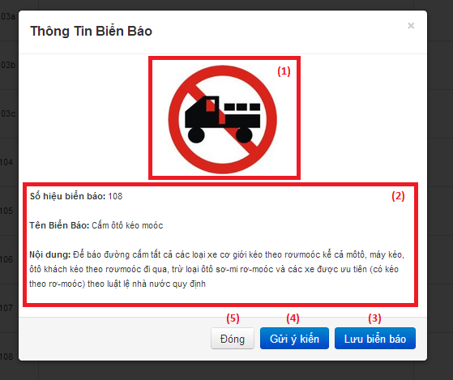

Figure 42: User – Traffic sign detail

**Fields**

|  |  |  |  |  |  |  |  |
| --- | --- | --- | --- | --- | --- | --- | --- |
| **No** | **Field Name** | **Description** | **Read only** | **Mandatory** | **Control Type** | **Data Type** | **Length** |
| 1 | Traffic sign’s image | Display traffic sign’s image. | Y | Y | Image tag | N/A | N/A |
| 2 | Traffic sign information | Display traffic sign detail information | Y | Y | Label | String | N/A |

**Button/ Hyperlink**

|  |  |  |  |  |
| --- | --- | --- | --- | --- |
| **No** | **Function** | **Description** | **Validation** | **Outcome** |
| 3 | Add favorite | Click to add traffic sign to favorite list. | No | Send add favorite request to service and change button to “Xóa biển báo”. |
| 4 | Send report | Click to show popup for send report. | No | Show popup send report |
| 5 | Close popup | Click to close popup | No | Popup close. |

**Table History list includes**

|  |  |  |  |  |  |
| --- | --- | --- | --- | --- | --- |
| **Field Name** | **Description** | **Read only** | **Control Type** | **Data Type** | **Length** |
| “STT” | Display row’s position in table. | Y | Label | String | N/A |
| “Ngày tạo” | Display history ‘s create time | Y | Label | String | N/A |
| Action | Button to delete history. | Y | Button | N/A | N/A |

#### User – Send report

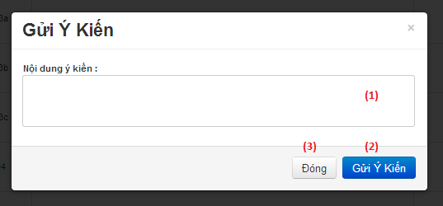

Figure 43: User – Send report

**Fields**

|  |  |  |  |  |  |  |  |
| --- | --- | --- | --- | --- | --- | --- | --- |
| **No** | **Field Name** | **Description** | **Read only** | **Mandatory** | **Control Type** | **Data Type** | **Length** |
| 1 | Report content | Enter report content to this field. | N | Y | Textbox | String | N/A |

**Button/ Hyperlink**

|  |  |  |  |  |
| --- | --- | --- | --- | --- |
| **No** | **Function** | **Description** | **Validation** | **Outcome** |
| 2 | Submit report | Click to send report. | No | Send report to server and close popup. |
| 3 | Close popup | Click to close popup | No | Popup close. |

### Admin Interface Design

#### Admin - Home Page

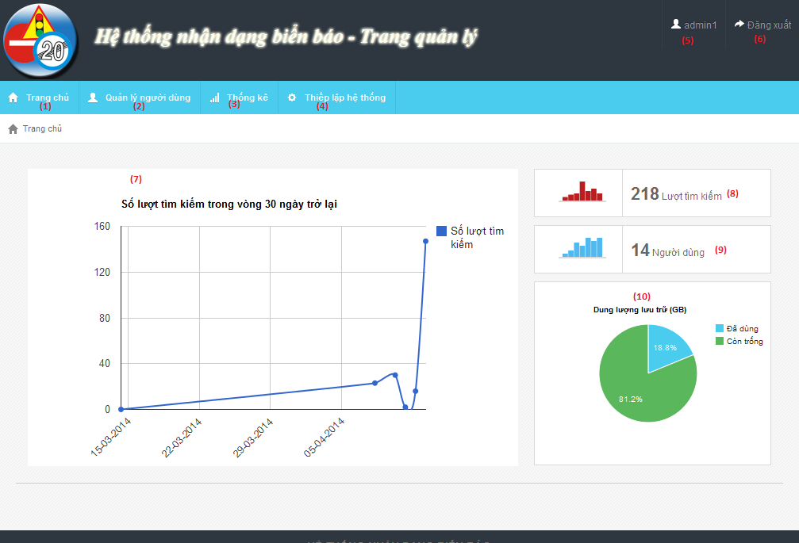

Figure 42: Admin - Home Page

**Fields**

|  |  |  |  |  |  |  |  |
| --- | --- | --- | --- | --- | --- | --- | --- |
| **No** | **Field Name** | **Description** | **Read only** | **Mand-atory** | **Control Type** | **Data Type** | **Length** |
| 5 | Username | username of user | Y | Y | Label | String | N/A |
| 7 | Statistic | Statistic of last 30 days search times | Y | Y | N/A | N/A | N/A |
| 8 | Total search times | Total search auto times | Y | Y | N/A | N/A | N/A |
| 9 | Total user | Total user registered in system | Y | Y | N/A | N/A | N/A |
| 10 | Space information | Disk space information of server | Y | Y | N/A | N/A | N/A |

**Button/ Hyperlink**

|  |  |  |  |  |
| --- | --- | --- | --- | --- |
| **No** | **Function** | **Description** | **Validation** | **Outcome** |
| 1 | Home page | Click to go to home page | No | Home page |
| 2 | Account manager page | Click to go to account manage page | No | Account manage page |
| 3 | Statistic page | Click to go to statistic page | No | Statistic page |
| 4 | Configure page | Click to go to configure page | No | Configure page |
| 6 | Log out button | Click to log out | No | Login page |

#### Admin - Account Manager Page

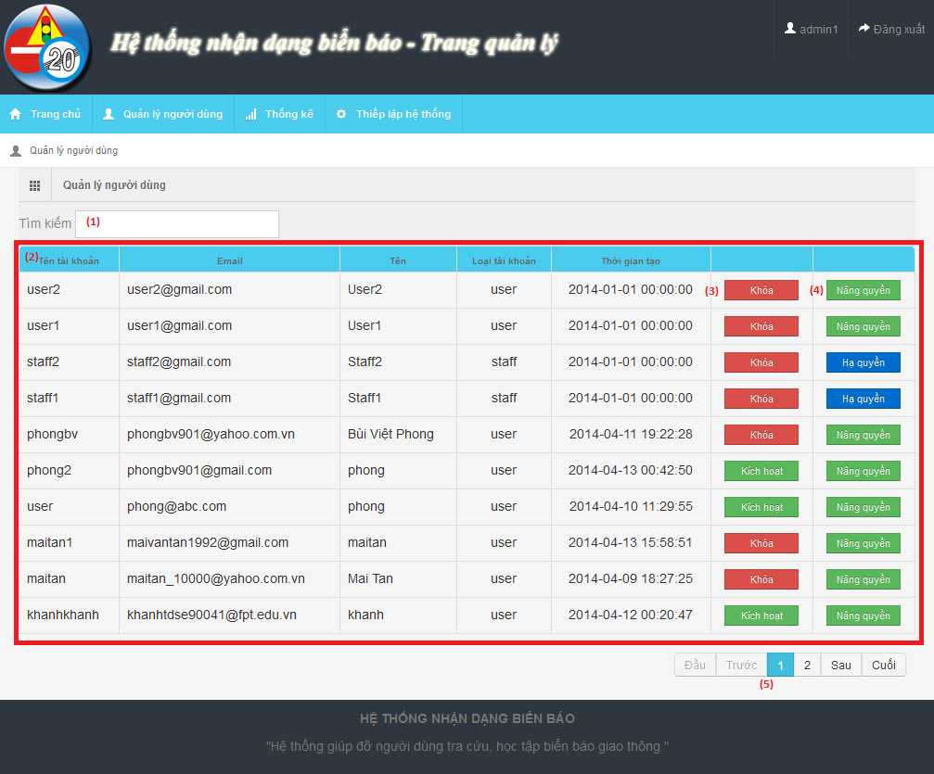

Figure 43: Admin - Account Manager Page

**Fields**

|  |  |  |  |  |  |  |  |
| --- | --- | --- | --- | --- | --- | --- | --- |
| **No** | **Field Name** | **Description** | **Read only** | **Mand-atory** | **Control Type** | **Data Type** | **Length** |
| 1 | Search field | Search textbox for the table | N | Y | Textbox | String | N/A |
| 2 | Account list | List account in system | Y | Y | Table | N/A | N/A |

**Button/ Hyperlink**

|  |  |  |  |  |
| --- | --- | --- | --- | --- |
| **No** | **Function** | **Description** | **Validation** | **Outcome** |
| 3 | Active/Deactivate | Active/deactivate account | No | Change text of button |
| 4 | Set/Unset staff role | Use to set or unset staff role | No | Change text of button |
| 5 | Paging | Paging area of the student table | No | Change page of the table |

**Table Account List includes**

|  |  |  |  |  |  |
| --- | --- | --- | --- | --- | --- |
| **Field Name** | **Description** | **Read only** | **Control Type** | **Data Type** | **Length** |
| UserID | UserID of account | Y | Label | String | N/A |
| Email | Email of account | Y | Label | String | N/A |
| Name | Name of account | Y | Label | String | N/A |
| Role | Role of account | Y | Label | String | N/A |
| Create date | Create date of account | Y | Label | String | N/A |
| Function | Active/Deactivate account | N | Button | N/A | N/A |
| Function | Set/Unset staff role | N | Button | N/A | N/A |

#### Admin - Statistic Page

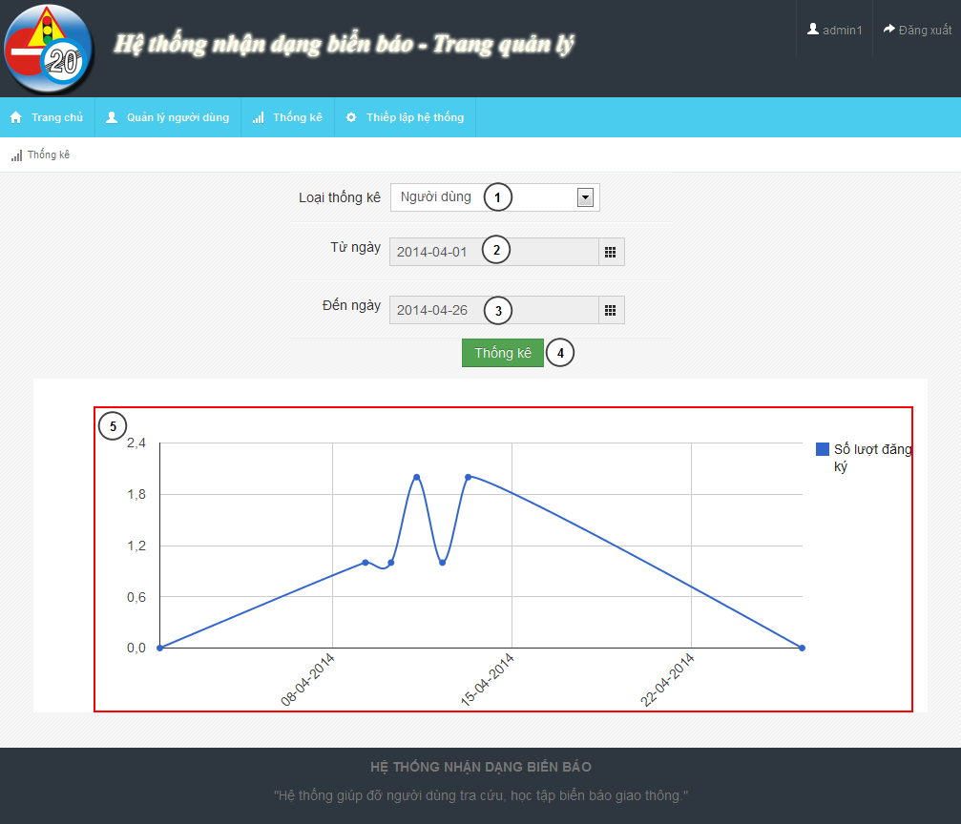

Figure 44: Admin - Statistic Page

**Fields**

|  |  |  |  |  |  |  |  |
| --- | --- | --- | --- | --- | --- | --- | --- |
| **No** | **Field Name** | **Description** | **Read only** | **Mand-atory** | **Control Type** | **Data Type** | **Length** |
| 1 | Statistic type | Type of statistic | N | Y | Dropdown-list | String | N/A |
| 2 | From date | From date to begin statistic | N | Y | Date picker | N/A | N/A |
| 3 | To date | To date to end of statistic | N | Y | Date picker | N/A | N/A |
| 5 | Chart field | Line chart description of the statistic information | N/A | Y | N/A | N/A | N/A |

**Button/ Hyperlink**

|  |  |  |  |  |
| --- | --- | --- | --- | --- |
| **No** | **Function** | **Description** | **Validation** | **Outcome** |
| 4 | Show statistic | Shot statistic information in chart field | From date and to date not empty, from date not after to date | Chart field |

#### Admin - Configure Page

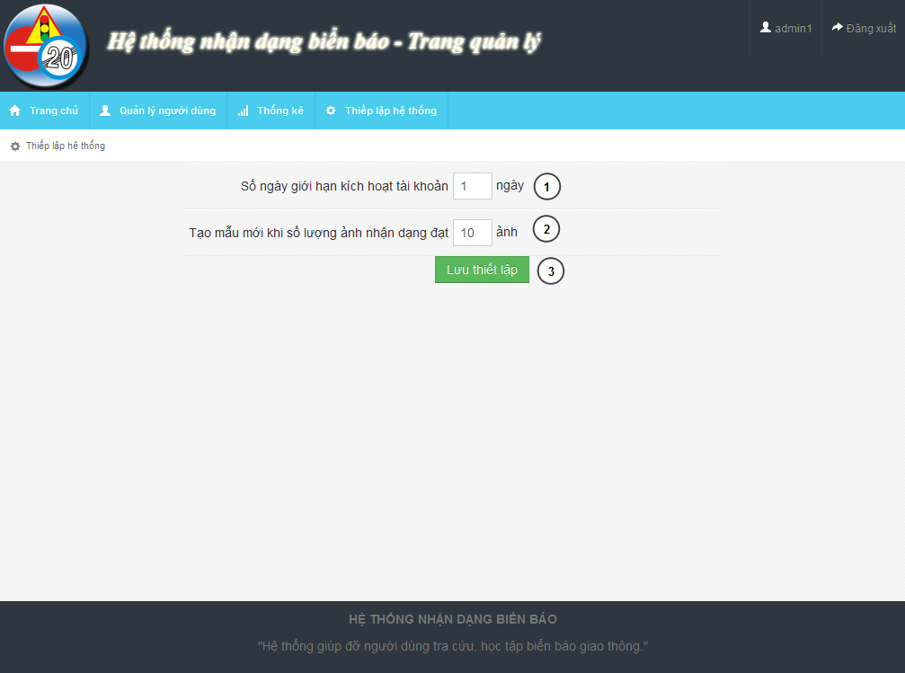

Figure 45: Admin - Configure Page

**Fields**

|  |  |  |  |  |  |  |  |
| --- | --- | --- | --- | --- | --- | --- | --- |
| **No** | **Field Name** | **Description** | **Read only** | **Mand-atory** | **Control Type** | **Data Type** | **Length** |
| 1 | Active day | The limit active day after register | N | Y | Textbox | Integer | [0..] |
| 2 | Retrain count | The train count limit after retrain model data | N |  | Textbox | Integer | [0..] |

**Button/ Hyperlink**

|  |  |  |  |  |
| --- | --- | --- | --- | --- |
| **No** | **Function** | **Description** | **Validation** | **Outcome** |
| 3 | Save configure | Save configure information | No | N/A |

### Staff Interface Design

#### Staff – Home Page

#### Staff – Traffic Sign Manager Page

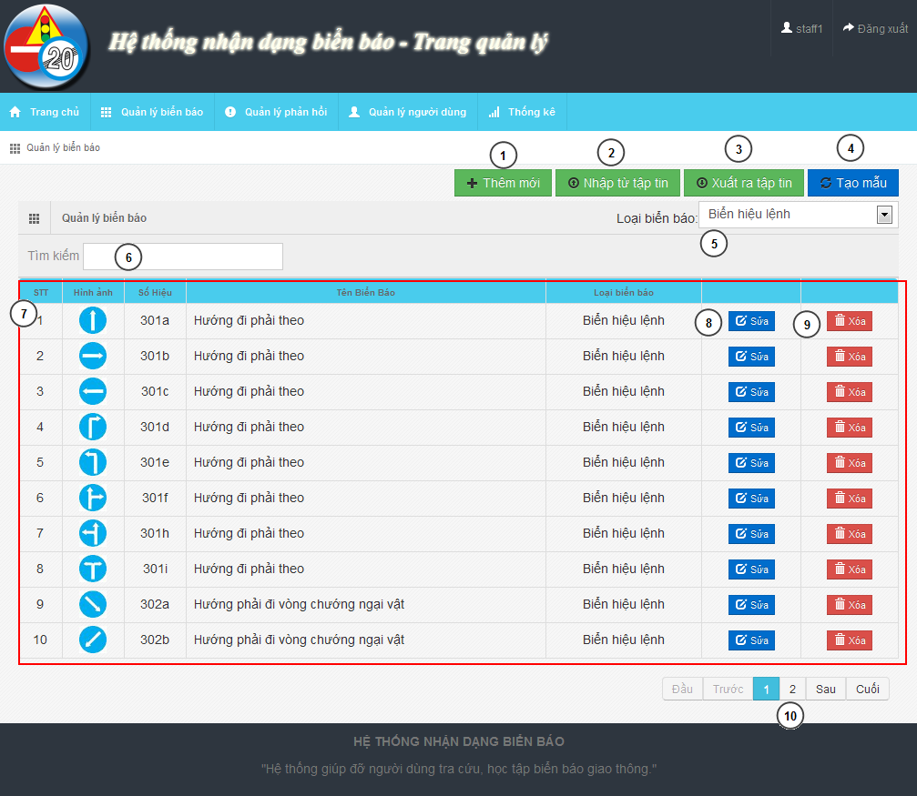

Figure 46: Staff – Traffic Sign Manager Page

**Fields**

|  |  |  |  |  |  |  |  |
| --- | --- | --- | --- | --- | --- | --- | --- |
| **No** | **Field Name** | **Description** | **Read only** | **Mand-atory** | **Control Type** | **Data Type** | **Length** |
| 5 | Traffic sign type | Filter traffic sign by type | N | Y | Dropdown-list | N/A | N/A |
| 6 | Search textbox | Search traffic sign | N | Y | Textbox | String | N/A |
| 7 | Traffic sign list | Traffic sign list | N/A | Y | Table | N/A | N/A |
| 10 | Paging | Paging for traffic sign table | N | Y | N/A | N/A | N/A |

**Button/ Hyperlink**

|  |  |  |  |  |
| --- | --- | --- | --- | --- |
| **No** | **Function** | **Description** | **Validation** | **Outcome** |
| 1 | Add new | Add new traffic sign | No | Traffic sign add new modal |
| 2 | Import data | Import data from file | No | Import data file modal |
| 3 | Export data | Export data to file | No | Zip file |
| 4 | Retrain model | Retrain model from data | No | New model create |
| 8 | Edit traffic sign | Edit traffic sign | No | Edit traffic sign modal |
| 9 | Delete traffic sign | Delete traffic sign | No | Refresh traffic table |

**Table Traffic Sign List includes**

|  |  |  |  |  |  |
| --- | --- | --- | --- | --- | --- |
| **Field Name** | **Description** | **Read only** | **Control Type** | **Data Type** | **Length** |
| No | Order of the row | Y | Label | Integer | N/A |
| Image | Image of traffic sign | Y | Image | Image | N/A |
| Label | Label of traffic sign | Y | Label | String | N/A |
| Name | Name of traffic sign | Y | Label | String | N/A |
| Type | Type of traffic sign | Y | Label | String | N/A |
| Function | Edit traffic sign | N | Button | N/A | N/A |
| Function | Delete traffic sign | N | Button | N/A | N/A |

#### Staff – Report Manager Page

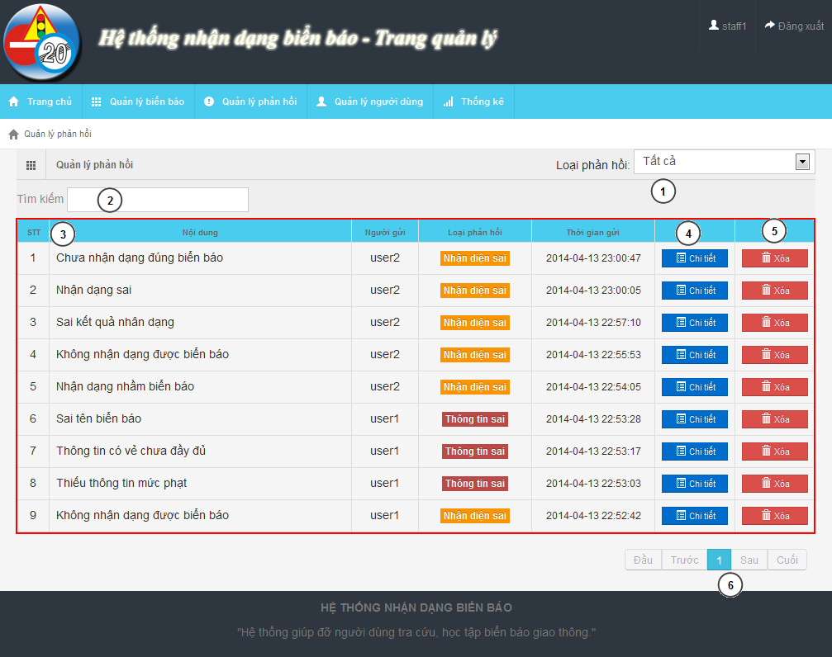

Figure 47: Staff – Report Manager Page

**Fields**

|  |  |  |  |  |  |  |  |
| --- | --- | --- | --- | --- | --- | --- | --- |
| **No** | **Field Name** | **Description** | **Read only** | **Mand-atory** | **Control Type** | **Data Type** | **Length** |
| 1 | Report type | Report type filter | N | Y | Dropdown-list | N/A | N/A |
| 2 | Search field | Search text box for report table | N | Y | Textbox | String | N/A |
| 3 | Report List | List of report | N | Y | Table | N/A | N/A |
| 6 | Paging | Paging for report list | N | Y | N/A | N/A | N/A |

**Button/ Hyperlink**

|  |  |  |  |  |
| --- | --- | --- | --- | --- |
| **No** | **Function** | **Description** | **Validation** | **Outcome** |
| 4 | View detail | View detail of report | No | Show detail report modal |
| 5 | Delete | Delete report | No | Refresh report table |

**Table Report List includes**

|  |  |  |  |  |  |
| --- | --- | --- | --- | --- | --- |
| **Field Name** | **Description** | **Read only** | **Control Type** | **Data Type** | **Length** |
| No | Order of the row | Y | Label | Integer | N/A |
| Content | Content of report | Y | Label | String | N/A |
| Creator | Creator of report | Y | Label | String | N/A |
| Type | Type of report | Y | Label | String | N/A |
| Create date | Create date of report | Y | Label | Date time | N/A |
| Function | View detail button | N | Button | String | N/A |
| Function | Delete button | N | Button | String | N/A |

#### Staff – Account Manager Page

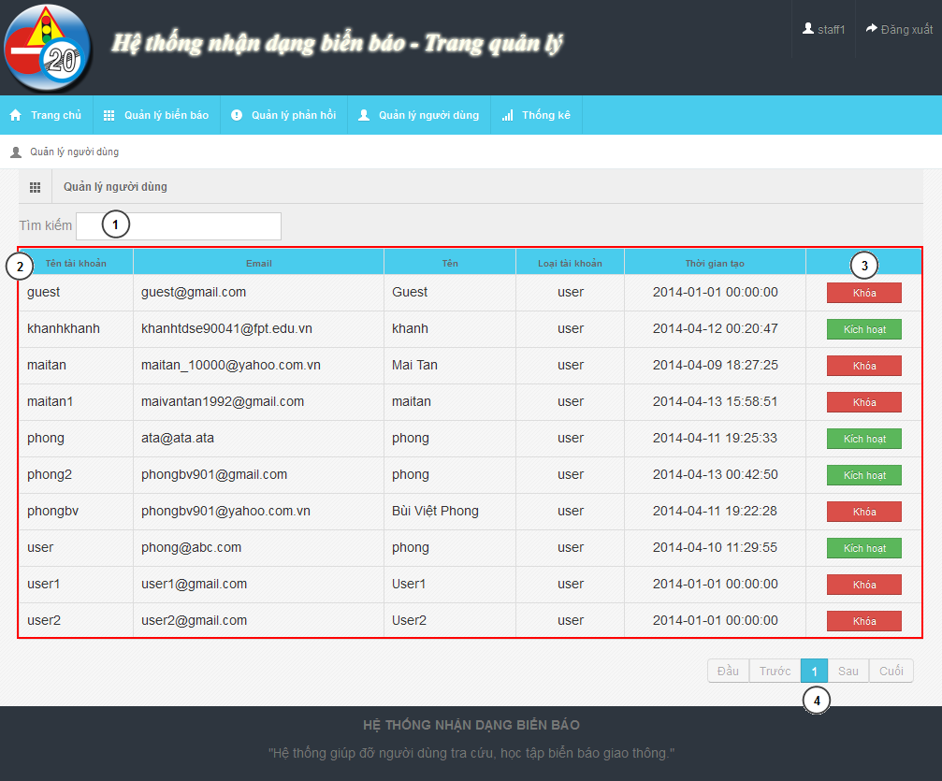

Figure 48: Staff – Account Manager Page

**Fields**

|  |  |  |  |  |  |  |  |
| --- | --- | --- | --- | --- | --- | --- | --- |
| **No** | **Field Name** | **Description** | **Read only** | **Mand-atory** | **Control Type** | **Data Type** | **Length** |
| 1 | Search field | Search textbox for the table | N | Y | Textbox | String | N/A |
| 2 | Account list | List account in system | Y | Y | Table | N/A | N/A |

**Button/ Hyperlink**

|  |  |  |  |  |
| --- | --- | --- | --- | --- |
| **No** | **Function** | **Description** | **Validation** | **Outcome** |
| 3 | Active/Deactivate | Active/deactivate account | No | Change text of button |
| 4 | Paging | Paging area of the student table | No | Change page of the table |

**Table Account List includes**

|  |  |  |  |  |  |
| --- | --- | --- | --- | --- | --- |
| **Field Name** | **Description** | **Read only** | **Control Type** | **Data Type** | **Length** |
| UserID | UserID of account | Y | Label | String | N/A |
| Email | Email of account | Y | Label | String | N/A |
| Name | Name of account | Y | Label | String | N/A |
| Role | Role of account | Y | Label | String | N/A |
| Create date | Create date of account | Y | Label | String | N/A |
| Function | Active/Deactivate account | N | Button | N/A | N/A |

#### Staff – Statistic Page

### Mobile Interface Design

#### Login Activity

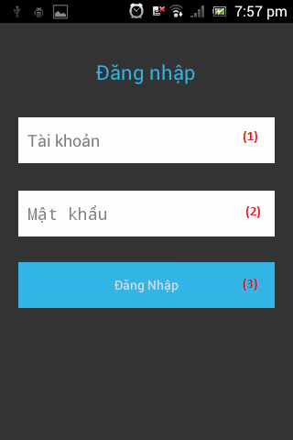

Figure 49: Login Activity

**Fields**

|  |  |  |  |  |  |  |  |
| --- | --- | --- | --- | --- | --- | --- | --- |
| **No** | **Field Name** | **Description** | **Read only** | **Mand-atory** | **Control Type** | **Data Type** | **Length** |
| 1 | Username | Fill user’s username | N | N | Textbox | String | [6, 30] |
| 2 | Password | Fill user’s password | N | N | Textbox | String | [6, 30] |

**Button/ Hyperlink**

|  |  |  |  |  |
| --- | --- | --- | --- | --- |
| **No** | **Function** | **Description** | **Validation** | **Outcome** |
| 3 | Login | Click to login the system | No | Transfer to Main activity |

#### Main Activity

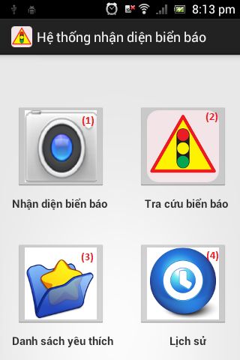

Figure 50: Main Activity

**Button/ Hyperlink**

|  |  |  |  |  |
| --- | --- | --- | --- | --- |
| **No** | **Function** | **Description** | **Validation** | **Outcome** |
| 1 | Search auto | Click transfer to camera activity | No | Transfer to Camera activity |
| 2 | Search manual | Click transfer to category activity | No | Transfer to Category activity |
| 3 | Show favorite list | Click transfer to favorite activity | No | Transfer to Favorite activity |
| 4 | Show history list | Click transfer to history activity | No | Transfer to History activity |

#### Camera Activity

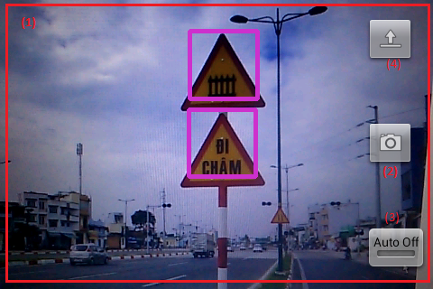

Figure 51: Camera Activity

**Fields**

|  |  |  |  |  |  |  |  |
| --- | --- | --- | --- | --- | --- | --- | --- |
| **No** | **Field Name** | **Description** | **Read only** | **Mandatory** | **Control Type** | **Data Type** | **Length** |
| 1 | Screen view | Show screen of camera on real time | Y | Y | Frame layout | N/A | N/A |

**Button/ Hyperlink**

|  |  |  |  |  |
| --- | --- | --- | --- | --- |
| **No** | **Function** | **Description** | **Validation** | **Outcome** |
| 2 | Capture | Click to capture image | No | Image on real time send to web service and transfer to List result activity |
| 3 | Turn on (off) auto capture mode | Click to turn on or off auto capture mode | No | Turn on (off) auto capture mode |
| 4 | Upload image | Click to select image for upload | No | Image on real time send to web service and transfer to List result activity |

#### List result Activity

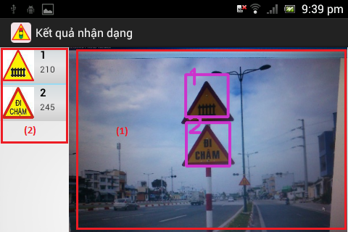

Figure 52: List result Activity

**Fields**

|  |  |  |  |  |  |  |  |
| --- | --- | --- | --- | --- | --- | --- | --- |
| **No** | **Field Name** | **Description** | **Read only** | **Mand-atory** | **Control Type** | **Date Type** | **Length** |
| 1 | Uploaded Image | Display image was uploaded by user. | Y | Y | Image view | N/A | N/A |

**Button/ Hyperlink**

|  |  |  |  |  |
| --- | --- | --- | --- | --- |
| **No** | **Function** | **Description** | **Validation** | **Outcome** |
| 2 | View traffic sign detail | Click one to view traffic sign detail | No | Transfer to Traffic sign detail activity |

**List result includes**

|  |  |  |  |  |  |  |
| --- | --- | --- | --- | --- | --- | --- |
| **Field Name** | **Description** | **Read only** | **Control Type** | **Color** | **Data Type** | **Length** |
| Position | Display position of result match with image. | Y | Textview | Black | String | N/A |
| Traffic ID | Display traffic’s ID number | Y | Textview | Black | String | N/A |
| Traffic image | Display traffic’s image | Y | Imageview | N/A | N/A | N/A |

#### Category Activity

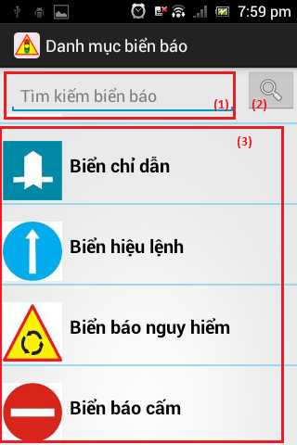

Figure 53: Category Activity

**Fields**

|  |  |  |  |  |  |  |  |
| --- | --- | --- | --- | --- | --- | --- | --- |
| **No** | **Field Name** | **Description** | **Read only** | **Mandatory** | **Control Type** | **Date Type** | **Length** |
| 1 | Search key | Key for search traffic sign by traffic’s name | N | N | Edit text | String | N/A |

**Button/ Hyperlink**

|  |  |  |  |  |
| --- | --- | --- | --- | --- |
| **No** | **Function** | **Description** | **Validation** | **Outcome** |
| 2 | Search traffic sign by name | Click to search traffic sign by traffic’s name | No | Search traffic sign then transfer to List traffic sign activity |
| 3 | Search traffic sign by category | Click to search traffic sign by category which was selected | No | Search traffic sign then transfer to List traffic sign activity |

**Category list includes**

|  |  |  |  |  |  |
| --- | --- | --- | --- | --- | --- |
| **Field Name** | **Description** | **Read only** | **Control Type** | **Data Type** | **Length** |
| Category image | Display category’s image | Y | Imageview | N/A | N/A |
| Category name | Display category’s name | Y | Textview | String | N/A |

#### List traffic sign Activity

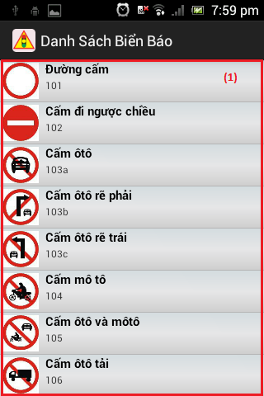

Figure 54: Category Activity

**Button/ Hyperlink**

|  |  |  |  |  |
| --- | --- | --- | --- | --- |
| **No** | **Function** | **Description** | **Validation** | **Outcome** |
| 1 | View traffic sign detail | Click view traffic sign detail | No | Transfer to Traffic sign detail activity |

**Traffic sign list includes**

|  |  |  |  |  |  |
| --- | --- | --- | --- | --- | --- |
| **Field Name** | **Description** | **Read only** | **Control Type** | **Data Type** | **Length** |
| Traffic sign image | Display traffic sign’s image | Y | Imageview | N/A | N/A |
| Traffic sign name | Display traffic sign’s name | Y | Textview | String | N/A |
| Traffic sign ID | Display traffic sign’s ID number | Y | Textview | String | N/A |

#### Traffic sign detail Activity

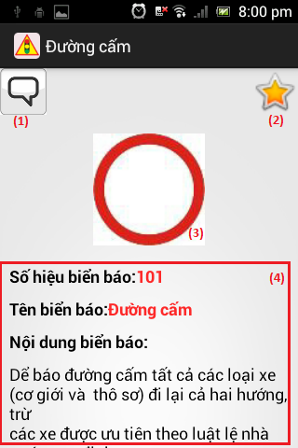

Figure 55: Traffic sign detail Activity

**Fields**

|  |  |  |  |  |  |  |  |
| --- | --- | --- | --- | --- | --- | --- | --- |
| **No** | **Field Name** | **Description** | **Read only** | **Mandatory** | **Control Type** | **Date Type** | **Length** |
| 3 | Traffic sign image | Display traffic sign’s image | Y | Y | Imageview | N/A | N/A |
| 4 | Traffic sign information | Display traffic sign’s detail information | Y | Y | Textview | String | N/A |

**Button/ Hyperlink**

|  |  |  |  |  |
| --- | --- | --- | --- | --- |
| **No** | **Function** | **Description** | **Validation** | **Outcome** |
| 1 | Send report | Click to transfer to report activity | No | Transfer to Report activity |
| 2 | Add/Remove favorite | Click to add or remove traffic sign to favorite list. | No | Send request to service for add/delete traffic sign to favorite list. |

#### Favorite Activity

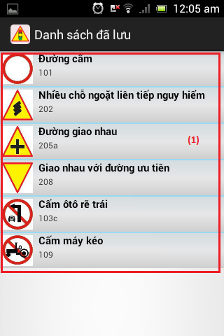

Figure 56: Favorite Activity

**Button/ Hyperlink**

|  |  |  |  |  |
| --- | --- | --- | --- | --- |
| **No** | **Function** | **Description** | **Validation** | **Outcome** |
| 1 | View traffic sign detail | Click to transfer to traffic sign detail activity | No | Transfer to Traffic sign detail activity |

**Favorite list includes**

|  |  |  |  |  |  |
| --- | --- | --- | --- | --- | --- |
| **Field Name** | **Description** | **Read only** | **Control Type** | **Data Type** | **Length** |
| Traffic sign image | Display traffic sign’s image | Y | Imageview | N/A | N/A |
| Traffic sign name | Display traffic sign’s name | Y | Textview | String | N/A |
| Traffic sign ID | Display traffic sign’s ID number | Y | Textview | String | N/A |

#### History Activity

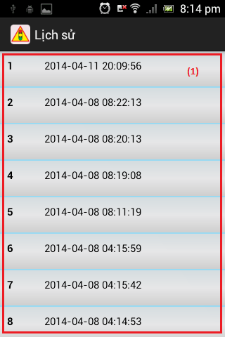

Figure 56: Favorite Activity

**Button/ Hyperlink**

|  |  |  |  |  |
| --- | --- | --- | --- | --- |
| **No** | **Function** | **Description** | **Validation** | **Outcome** |
| 1 | View history detail | Click to transfer to list result activity | No | Transfer to List result activity |

**History list includes**

|  |  |  |  |  |  |
| --- | --- | --- | --- | --- | --- |
| **Field Name** | **Description** | **Read only** | **Control Type** | **Data Type** | **Length** |
| Position | Display order number in the list | Y | Textview | String | N/A |
| Create date | Display history’s create date | Y | Textview | String | N/A |

## Database Design

### Entity Relationship Diagram

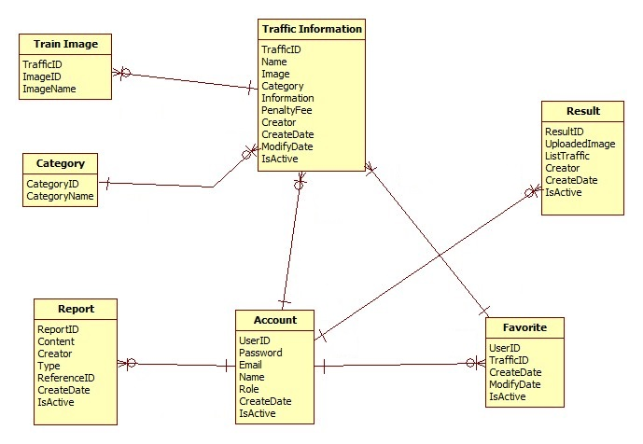

Figure 54: Entity Relationship Diagram

### Data Dictionary

|  |  |
| --- | --- |
| **Data dictionary: describe content of all entities** | |
| Name | Description |
| Traffic Information | Describe information about traffic sign |
| Train Image | Describe information about image use to train/recognize a traffic sign |
| Category | Describe all type of traffic sign |
| Report | Describe information about report of user. Contain wrong information report and wrong recognition report |
| Account | Describe all information about user in the system |
| Result | Describe information about search auto result |
| Favorite | Describe information about favorite traffic sign of user |

Table 39: Data Dictionary

|  |  |  |  |  |
| --- | --- | --- | --- | --- |
| **Name** | **Attributes** | **Description** | **Domain** | **Nulls** |
| trainimage | imageID {PK}  trafficID {FK}  imageName | ImageID of train image  Traffic ID of train image  Image name of train image | 255 nvar  11 nvar  255 nvar | No  No  No |
| category | categoryID {PK}  categoryName | Uniquely identifier  Name of category | Int  30 nvar | No  No |
| favorite | creator {PK, FK}  trafficID {PK, FK}  createDate  modifyDate  isActive | Creator of favorite  TrafficiD of favorite  Create date  Modify date  Status | 11 nvar  11 nvar  Date  Date  Bit | No  No  Yes  Yes  Yes |
| trafficinformation | trafficID {PK}  name  image  categoryID {FK}  information  penaltyfee  creator {FK}  createDate  modifyDate  isActive | Uniquely identifies, auto increment  Name of traffic sign  Image of traffic sign  Category ID of traffic sign  Information of traffic sign  Penalty fee of traffic sign  Creator  Create date  Modify date  Status | 11 nvar  255 nvar  255 nvar  Int  4000nvar  255 nvar  30 nvar  Date  Date  Bit | No  No  No  No  Yes  Yes  No  Yes  Yes  Yes |
| account | userID {PK}  password  email  name  role  createDate  isActive | Uniquely identifies, ID of user  Password of user in MD5 form  Email of user  Name of user  Role of user  Create date  Status | 30 nvar  255 nvar  30 nvar  30 nvar  10 nvar  Date  Bit | No  No  No  Yes  No  No  No |
| result | resuitlID {PK}  uploadedImage  listTraffic  creator  createDate  isActive | Uniquely identifies, auto increment  Image link  List contain trafficID and location in image  Create of result  Create date  Status | Int  255 nvar  4000nvar  30 nvar  Date  Bit | No  No  Yes  Yes  Yes  Yes |
| report | reportID {PK}  referenceID  content  creator {FK}  type  createDate  isActive | Uniquely identifies, auto increment  ReferenceID depend on type report  Report content  Creator  Type of report  Create date  Status | Int  11 nvar  4000nvar  30 nvar  Int  Date  Bit | No  No  Yes  No  No  Yes  Yes |

Table 40: Attribute Data Dictionary

## Algorithms

### Traffic sign detection

#### Definition

Traffic Sign Detection is a technology that determines the locations and sizes of traffic signs in images.

#### Different method for traffic sign detection

There are many ways to detect traffic sign in an image:

* Color-based detect method
* Shape-based detect method
* Machine learning method:

+ Artificial Neural Network

+ Word bag

+ Classifier cascade

+…

#### The method we chose

We chose the Viola-Jones method (a classifier cascade method). Reason:

* Already implemented in OpenCV (that support many platforms: Linux, Windows, Android…)
* Easy to extend base on train cascade file.
* Easy to use and handle in code.
* High accurate rate, good performance.

**Method Introduction**

The Viola-Jones (V-J) object detection framework is the first object detection framework to provide competitive object rates in real-time proposed. It can be trained to detect a variety of object classes. In OpenCV, it’s implemented as cvHaarDetectObjects() and the new method for multithread is cascadeClassifier()

Reference: <http://en.wikipedia.org/wiki/Viola%E2%80%93Jones_object_detection_framework>

Key ideas of Viola-Jones:

* Integral images for fast feature evaluation
* Boosting for feature selection
* Attentional cascade for fast rejection of non-object windows

Viola-Jones Technique:

* Feature extraction and feature evaluation
* Classifier training a feature selection using a method called AdaBoost.
* A degenerate decision tree of classifiers is formed.

**Feature extraction and feature evaluation:**

Feature extraction:

* Rectangle feature with four basic types. Value = sum( pixels in black area) – sum(pixels in white area)
* Each feature is related to a special location in the sub-window
* Each feature may have any size



Figure 55: Four basic types

Feature evaluation: using Integral Image for rapid computation of rectangular features.

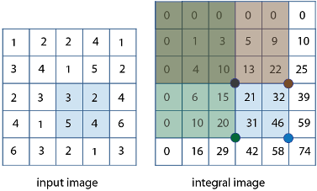

Figure 56: Integral Image

**Feature selection:** Using AdaBoost stands for “Adaptive” boost

* Constructs a “strong” classifier as a linear combination of weighted simple “weak” classifiers
* Features as weak classifiers: each single feature may be regarded as a simple weak classifier.
* An iterative algorithm: AdaBoost performs a series of trials, each time selecting a new weak classifier.
* Weights are being applied over the set of the example images: during each iteration, each example/image receives a weight determining it importance.

**Decision tree:** Attentional Cascade

* The reason the technique is fast.
* Quick rejection of sub windows.

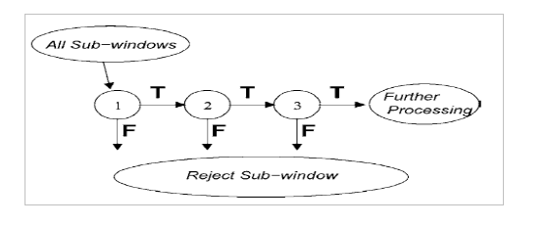

Figure 57: Attentional Cascade

**All Viola-Jones flow chart:**

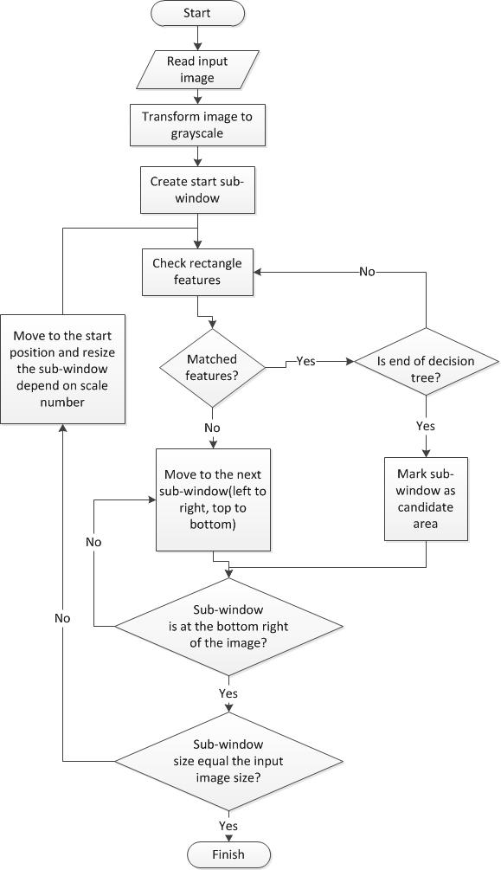

Figure 58: Viola-Jones flow chart

### Traffic sign recognition

#### Definition

* Traffic sign recognition is identify the name of traffic sign from detected area in an image.

#### Method for traffic sign recognition

**There are many way to recognize traffic sign from detect area in an image:**

* **Artificial neural network**
* **Nearest-Neighbor Classifiers**
* **Decision Trees**
* **…**

References: <http://sundog.stsci.edu/rick/SCMA/node2.html>

#### The Method we choose

**We chose SVM multi-class method, reason:**

* High accurate, good perform
* Implemented in many library
* Easy to handle in code

**Method Introduction**

**Support vector machine (SVMs) are supervised learning models with associated learning algorithms what analyze data and recognize pattern used for classification and regression analysis.**

**Basic SVM only support to classify 2 classes.**

**Multiclass SVM: assign labels to instances by using support vector machines, where the labels are drawn from a finite set of several elements.**

**This approach is extend of basic SVM (binary classification):**

**One-versus-all: Using binary classifiers with between one of the labels and the rest. The result calculate by winner-takes-all, in which the classifier with the highest output function assigns the class.**

**One-versus-one: between every pair of classes. The result calculate by max-wins voting strategy, in which every classifier assigns the instance to one of the two classes, then the vote for assigned class is increased by one vote, and finally the class with the most votes determines the instance classification.**

**In this project we use SVM multi-class with One-versus-all method.**

Reference:

<http://en.wikipedia.org/wiki/Support_Vector_Machine>

<http://www.cs.cornell.edu/people/tj/svm_light/svm_multiclass.html>

**Algorithm description:**

* Extract features of image
* Compare these features with the features of the model and get the best matched rate model (SVM multi-class One-versus-all)

**Extract feature of image**: Histogram of oriented gradients (HOG) features. The technique counts occurrences of gradient orientation in localized portions of an image.

Reference: <http://en.wikipedia.org/wiki/Histogram_of_oriented_gradients>



Figure 59: HOI features

**SVM classifier:** Base on features SVM classifier can calculate the rate that match with model and give the candidate model for object

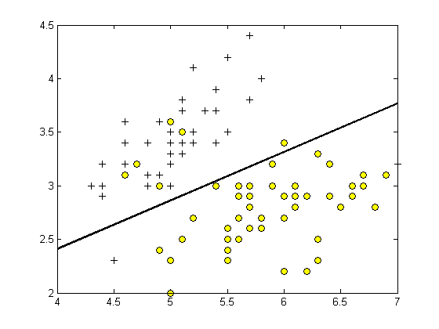

Figure 60: SVM classifier

**Classifier flow chart**

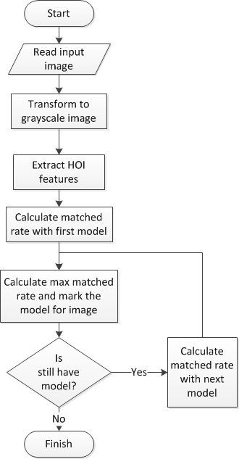

Figure 61: Classifier flow chart

# System Implementation & Test

## Introduction

### System Overview

This section provides in detail all necessary information about test plans, test cases, test result, test environments, pass/fail criteria and risks estimations as well as a checklist to cover all possible cases of TSRT.

### Test Approach

- Goal: To test the whole system based on the core workflow.

- Method: System Testing, Black-box Testing.

## Database Relationship Diagram

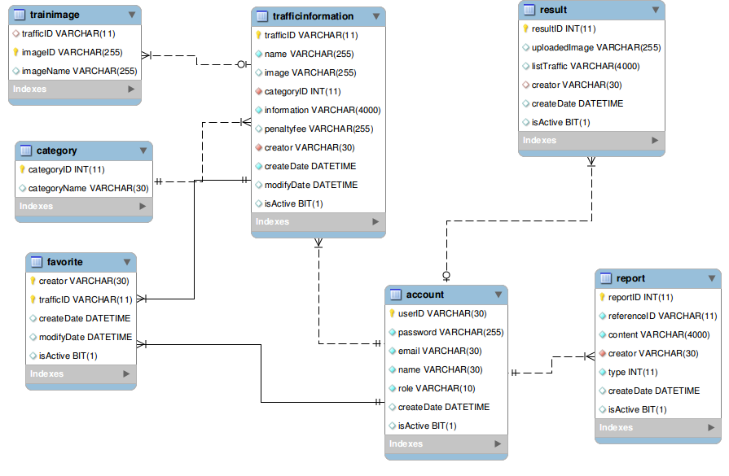

Figure 62: Database Relationship Diagram

## Performance measures

### Traffic Sign Detection Performance

With image resolution: 800x460px

Web module: Ubuntu 13.10 with core i3 M350 2.27GHz, 3GB Ram

* Average time to detect traffic sign:
* Best traffic sign detected result: 60/84 traffic sign. Percent: 71.4%
* Worst traffic sign detected result: 56/84 traffic sign. Percent 66.7%

Mobile module: Android 4.0 with 2 cores 1GHz, 512MB Ram

* Average time to detect traffic sign: 0.357s (2.8 FPS)

### Traffic Sign Recognition Performance

With image resolution: 800x460px

Web module: Ubuntu 13.10 with core i3 M350 2.27GHz, 3GB Ram

* Best time to run traffic sign recognition: 0.013s
* Worst time to run traffic sign recognition: 0.016s

Recognition accuracy (good condition):

Figure 63: Traffic Sign Recognition Accuracy

## Test Plan

The purpose of this section is to verify and ensure that TSRT meets its design specification and other requirements from user. The following part will describe which features to be tested and which will not.

### Features to be tested

We will test the entire system based on the following core workflow (Reference: **Figure 101: Core Workflow**).

Based on the workflow, all following features will be tested, which can include one or more functions. These features will be focused and tested thoroughly during the test phase.

* Manage Student Image: Add Images for Single Student/Many Students, Remove Student Images, Select Image From Log Images.
* Manage RollCall: Add/Edit Roll Call, Add/Remove Student in Roll Call.
* Face Detection & Recognition: Detect Face From Image, Recognize Face From Image (Read **FaceRecognizerTestingReport.docx**).
* Check Attendance: Show Current Roll Call, Check Attendance Auto (Mobile), Check Attendance Manual (Mobile, Web).

These remaining feature will be tested as individual module:

* Attendance Report: View Attendance Log, Get Excel Report
* ManageTeaching Calendar: View Teaching Calendar, Sync with Google Calendar
* Manage Study Session: Add RollCall Study Session, Change Session Date/Time/Instructor.
* Check own Attendance Rate

### Features not to be tested

* Register
* Login, Logout
* Forgot Password
* Admin - Manage Account, Configure System, Make statistic
* Staff – Manage Account, Make statistic, Import, Export file.

## System Testing Test Case



**Figure 64: Core Workflow**

|  |  |  |  |  |  |  |
| --- | --- | --- | --- | --- | --- | --- |
| **ID** | **Test Case Description** | **Test Case Procedure** | **Excpected output** | **Result** | **Test Date** | **Note** |
| ST01 | Admin add images info for a student.  (In actual use, admin must add images for all student in class) | 1 – Login into the system using an admin account  2 – On the admin home page, click “Student Images”, then click “Student List”.  3 – Click a button in cell “Images” of a student.  4 – Click “Select student's images”, select student’s image from computer.  5 – Press “Upload” button.  6 – Click the face region in images to select student face.  7 – Press “Submit Result” button. | - After step 3, the thumbnails of selected image will be shown below the “Select student’s images” button.  - After step 4, display the uploaded images. The images contains white regions on face detected.  - After step 6, redirect back to Single Student Page. | Passed | 30/10/2013 |  |
| ST02 | Staff create new Roll Call.  (Class of this Roll Call contains the student in test case ST01). | 1 – Login into the system using a staff account  2 – On the staff home page, click “Create Roll Call” link.  3 – Fill in Roll Call Info:   1. Semester 2. Begin Date 3. Major 4. Class 5. Subject 6. Begin Time 7. Instructor   4 – Press “Create” button. | - On the Create Roll Call Page, all the dropdownlist are disabled except semester.  - When staff select a value from dropdowlist, the following dropdownlist will be enable, with filtered info.  - After step 4, the new roll call is created. | Passed | 30/10/2013 |  |
| ST03 | Instructor login into Mobile App. | 1 – Touch the app icon from mobile.  2 – On login screen, input username and password of the instructor selected in test case STO2.  3 – Touch “Login” button. | - A message is displayed: “Hello, [teacher name].”  - All the instructor teaching roll call will be displayed with label contains teaching time.  - The “Take Attendance” button is disabled. | Passed | 30/10/2013 |  |
| ST04 | Instructor check attendance by taking picture | 1 – Set the server time to begin time of the roll call in ST02.  2 – Login again into the mobile app.  3- Touch “Take Attendance” button.  4 – Take a picture of class.  5 – Press Back button.  6 - Wait for the notification, slide from top to view.  7 – Touch the notification message. | - After step 2, the “Take Attendance” button is enabled.  - After step 6: A notification with sound and vibration will appear. A picture is saved as log on server.  - After step 7: Back to the home screen. | Passed | 30/10/2013 |  |
| ST05 | Instructor check attendance by taking picture again | After step 7 in test case ST04  1- Touch “Take Attendance” button.  2 – Take a picture of class.  3 – Press Back button. | - A notification with sound and vibration will appear. - - One more picture is saved as log on server.  - The attendance is update with more student. | Passed | 30/10/2013 |  |
| ST06 | Instructor view Roll Call Log | 1 – On the home screen after login, touch an roll call item.  2- Press “Attendance Log” button.  3 – Touch a log date. | - After Step 2, attendance log of today and yesterday (If exist) will be shown.  - After Step 3, a select list of present/absent will be shown | Passed | 30/10/2013 |  |
| ST07 | Instructor check attendance manually | 1 – On the home screen after login, touch an roll call item.  2- Press “Attendance Log” button.  3 – Touch a log date.  4 – Recheck the attendance.  5 – Presss “OK” button | - The checked attendance will be submit, the screen is refresh. | Passed | 30/10/2013 |  |
| ST08 | Instructor view Roll Call Log using Web.  (In case of mobile problem) | 1 – Login into the system using the instructor account in test case ST03.  2 – On the instructor home page, click on “Detail” link of a Roll Call  3 – On the “Log Attendance” table, click “Log Detail” button of a log (Log date must be before yesterday) | - After step 2, the Roll Call Info page will be shown, contains roll call info and student list and a list of attendance log.  - After step 3, a pop-up will be show, contains log images, the present/absent students. | Passed | 30/10/2013 |  |
| ST09 | Instructor check attendance manually using Web.  (In case of mobile problem) | 1 - Repeat step 1-3 of test case ST08.  2 – Recheck the attendance.  3 – Click “Submit Attendance” button. | - The attendance is submitted. | Passed | 30/10/2013 |  |
| ST10 | Instructor get attendance report | 1 – Login into the system using the instructor account in test case ST03.  2 – On the instructor home page, click on “Detail” link of a Roll Call.  3 – Click on the “Report” link in Log Attendance table. | - An excel file is downloaded. The file contains two sheets: Roll Call Book, Final Examl Student List. | Passed | 30/10/2013 |  |

**Table 41: Core Workflow Test Case**

## Module Test Case

### Manage RollCall

|  |  |  |  |  |  |  |  |
| --- | --- | --- | --- | --- | --- | --- | --- |
| **ID** | **Test Case Description** | **Test Case Procedure** | **Excpected output** | **Inter-test Case Dependence** | **Result** | **Test Date** | **Note** |
| MR01 | Staff view roll call list. | 1 – Login into the system using a staff account.  2 – Click the Manage Roll Call tab in menu sidebar. | - The Roll call list is showed base on current semester (from begins date to end date). |  | Passed | 15/10/2013 |  |
| MR02 | Create new roll call. | 1 – On the Manage Roll Call Page, click on “Create new roll call” link.  2 – Select information of roll call. Click on “Create” button. | - Dropdown list will show option is filter.  -Transfer to Manage Roll Call page after step 2. | MR01 | Passed | 15/10/2013 |  |
| MR03 | Staff filters the roll call by semester or date. | 1 – On Manage Roll Call page, staff select the semester in dropdown list or select a new begin date – end date.  2 – Click on “Select” button. | _All roll call in semester selected or from begin date to end date will be show in page. | MR01 | Passed | 15/10/2013 |  |
| MR04 | View attendance | 1 – On Manage Roll Call page, select an old semester. Click on “Select” button  2 – Click on “View attendance” link. | _The “View attendance” page will be show include: student list, attendance, absent... | MR01 | Passed | 16/10/2013 |  |
| MR05 | Edit roll call | 1 – On Manage Roll Call page. Click on “Edit” link.  2 – Click on “Save” button. | _The Edit page will be showed.  _After step 2, transfer to Manage roll call with new roll call, which have been update. | MR01 | Passed | 17/10/2013 |  |
| MR06 | Delete roll call | 1 – On Manage Roll Call page, select a new semester. Click on “Select” button.  2 – Click on “Delete” link. Select “Yes”. | _The confirm message will be showed.  _After step 2, transfer to Manage Roll Call page. | MR01 | Passed | 17/10/2013 |  |
| MR07 | Change schedule roll call. | 1– On Manage Roll Call page, click on “Change” link.  2 – Click on one date.  3 – Fill the new value and click on “Change” button. | _The calendar of roll call will be showed.  _After step 2, a pop-up will be showed.  _After step 3, the pop-up hide, and show calendar with new value. | MR01 | Passed | 18/10/2013 |  |
| MR08 | View student list. | 1 – On Manage Roll Call page, select a new semester. Click on “Select” button.  2 – Click on “Student list” link. | _The student list of class of roll call will be showed. | MR01 | Passed | 18/10/2013 |  |
| MR09 | Add new students to roll call | 1 – On Student list page,  Type or select student on select box.  2 – Click on “Add” button. | _The student list will be showed with new students. | MR01,MR08 | Passed | 18/10/2013 |  |
| MR10 | Remove a student from roll call | 1 – On Student list page, click on “Remove” link.  2 – Select “Yes” button. | _After step 1, a confirm message will be show.  _After step 2, the student list will be show with no student has been remove. | MR01, MR08 | Passed | 19/10/2013 |  |

**Table 42: Manage Roll Call Test Case**

### Manage Student Image

|  |  |  |  |  |  |  |  |
| --- | --- | --- | --- | --- | --- | --- | --- |
| **ID** | **Test Case Description** | **Test Case Procedure** | **Excpected output** | **Inter-test Case Dependence** | **Result** | **Test Date** | **Note** |
| MS01 | Admin view the list of all students | 1 – On the admin home page, click “Student Images”, then click “Student List”. | - All active students will be displayed, order descending by StudentID |  | Passed | 22/09/2013 |  |
| MS02 | Admin filter the student by class | 1 – On the admin home page, click “Student Images”, then click “Student List”.  2 – Select a class from the dropdownlist.  3 – Press “Select” button. | - All students of the selected class will be filtered and displayed | MS01 | Passed | 22/09/2013 |  |
| MS03 | Admin view student images data | 1 – On the admin home page, click “Student Images”, then click “Student List”.  2 – Click a button in cell “Images” of a student. | - Display all images of the selected student | MS01 | Passed | 24/09/2013 |  |
| MS04 | Admin add images for a student | 1 – On the admin home page, click “Student Images”, then click “Student List”.  2 – Click a button in cell “Images” of a student.  3 – Click “Select student's images”, select student’s image from computer.  4 – Press “Upload” button.  5 – Click the face region in images to select student face.  6 – Press “Submit Result” button. | - After step 3, the thumbnails of selected image will be shown below the “Select student’s images” button.  - After step 4, display the uploaded images. The images contains white regions on face detected.  - After step 6, redirect back to Single Student Page. | MS03 | Passed | 24/09/2013 |  |
| MS05 | Admin add images for a student (Image already in database) | 1 - Repeat Step 1-6 of case MS04.  2 – Click “Select student's images”, select the old image again.  4 – Press “Upload” button.  5 – Click the same region as first time.  6 – Press “Submit Result” button. | - Redirect back to Single Student Page. A warning show “Image already in database”. | MS03, MS04 | Passed | 24/09/2013 |  |
| MS06 | Admin Delete Images of a student | 1 – On the admin home page, click “Student Images”, then click “Student List.  2 – Click a button in cell “Images” of a student.  3 – Click the “X” mark on the top-right corner of an image.  4 – A confirm box is shown, click “Yes”. | - The image is deleted from database. A message is shown then hide. | MS03 | Passed | 25/09/2013 |  |
| MS07 | Admin add images for many students | 1 – On the admin home page, click “Student Images”, then click “Upload Images”.  2 – Click “Select student's images”, select students’s image from computer.  3 – Press “Upload” button.  4 – Hover the mouse over the face region, click the dropdownlist.  5 – Select the face’s owner from dropdownlist.  6 – Click “Submit Result” button | - After step 2, the thumbnails of selected image will be shown below the “Select student’s images” button.  - In step 3, the dropdownlist contains: image, student code, student name of all active students.  - After step 6, redirect back to Add Images Page, show the submitted result. |  | Passed | 27/09/2013 |  |
| MS08 | Admin view the attendance log images | 1 – On the admin home page, click “Student Images”, then click “Log Images”.  2 – Select the begin date to find.  3 – Select the end date to find.  4 – Click the “Find” button. | - On Log Images page, the default begin date is today, the default end date is set to tomorrow.  - After step 4, all log images between begin date and end date will be shown as thumbnail. |  | Passed | 05/10/2013 |  |
| MS09 | Admin view the attendance log images filtered by class | 1 – On the admin home page, click “Student Images”, then click “Log Images”.  2 – Select the begin date to find.  3 – Select the end date to find.  4 – Select a class from dropdownlist.  5 – Click the “Find” button. | - On Log Images page, the default begin date is today, the default end date is set to tomorrow.  - After step 5, all log images between begin date and end date of the selected class will be shown as thumbnail. | MS08 | Passed | 05/10/2013 |  |
| MS10 | Admin select learning data from log images | 1 – Repeat step 1-4 of test case MS08.  2 – Select the log images by clicking them.  3 – Click “Use selected images” button.  4 – Hover the mouse on face region to see student name.  5 – If the name is wrong, click the face region.  6 – Select the face’s owner using the dropdownlist.  7 – Press “Save Result” button. | - After step 5, a dropdownlist contains: image, student code, student name of all active students will be shown.  - After step 7, redirect to Log Images page, show the submited result | MS08 | Passed | 05/10/2013 |  |

**Table 43: Manage Student Image Test Case**

### Check Attendance

|  |  |  |  |  |  |  |  |
| --- | --- | --- | --- | --- | --- | --- | --- |
| **ID** | **Test Case Description** | **Test Case Procedure** | **Excpected output** | **Inter-test Case Dependence** | **Result** | **Test Date** | **Note** |
| CA01 | Instructor view teaching session (Web) | 1 – Create some roll calls for an instructor.  2 – Login into the system with that instructor account | - All the instructor teaching roll call will be displayed with label contains teaching time. | MR01 | Passed | 01/10/2013 |  |
| CA02 | Instructor view teaching session on Sunday (Web) | 1 – Create some roll calls for an instructor.  2 – Change server time to Sunday.  3 – Login into the system with that instructor account | - All the instructor teaching roll call will be displayed with red label contains “No Teaching Slot”. | MR01, CA01 | Passed | 01/10/2013 |  |
| CA03 | Instructor view Present Roll Call (Web) | 1 – On the instructor home page, click on “Present Roll Call” link | - The Roll Call Info page will be shown, contains roll call info and student list |  | Passed | 01/10/2013 |  |
| CA04 | Instructor view Roll Call Log  (Web) | 1 – On the instructor home page, click on “Detail” link of a roll call  2 – On the “Log Attendance” table, click “Log Detail” button of a log (Log date must be before yesterday) | - After step 1, the Roll Call Info page will be shown, contains roll call info and student list and a list of attendance log.  - After step 2, a pop-up will be show, contains log images, the present/absent students. | CA01 | Passed | 04/10/2013 |  |
| CA05 | Instructor check Attendance Manually (Web) | 1 – On the instructor home page, click on “Detail” link of a roll call  2 – On the “Log Attendance” table, click “Log Detail” button of a log (Log date must be yesterday or today)  3 – Recheck the attendance.  4 – Click “Submit Attendance” button. | The attendance is submitted. | CA01, CA04 | Passed | 06/10/2013 |  |
| CA06 | Instructor view teaching session (Mobile) | 1 – Create some roll calls for an instructor.  2 – Login into the system with that instructor account using mobile | - All the instructor teaching roll call will be displayed.  - The present roll call will be bigger, with red and orange text. | MR01 | Passed | 10/10/2013 |  |
| CA07 | Instructor view teaching session without present Roll Call (Mobile) | 1 – Create some roll calls for an instructor.  2 – Change server time to 11:00 pm  2 – Login into the system with that instructor account using mobile | - All the instructor teaching roll call will be displayed.  - The “Take Attendance” button will be disable | MR01, CA06 | Passed | 10/10/2013 |  |
| CA08 | Instructor check attendance by taking picture | 1 – On the home screen after login, touch “Take Attendance” button.  2 – Take a picture of class.  3 - Wait for the notification, slide from top to view.  4 – Touch the notification message.  5 – Continue to take a picture.  6 – Press Back button. | - After step 2: A notification with sound and vibration will appear. A picture is saved as log on server.  - After step 4: Show the home screen.  - After step 5: The notification appears agagin, 1 more picture is stored as log. |  | Passed | 13/10/2013 |  |
| CA08 | Instructor view Roll Call Detail (Mobile) | 1 – On the home screen after login, touch an roll call. | - All roll call info, include the student list will be shown at a new screen | CA06 | Passed | 13/10/2013 |  |
| CA09 | Instructor view Roll Call Log (Mobile) | 1 – On the home screen after login, touch an roll call item.  2- Press “Attendance Log” button.  3 – Touch a log date. | - After Step 2, attendance log of today and yesterday will be shown.  - After Step 3, a select list of present/absent will be shown | CA06, CA08 | Passed | 13/10/2013 |  |
| CA10 | Instructor check attendance manually | 1 – On the home screen after login, touch an roll call item.  2- Press “Attendance Log” button.  3 – Touch a log date.  4 – Recheck the attendance.  5 – Presss “OK” button | - The checked attendance will be submit, the screen is refresh. | CA06, CA09 | Passed | 15/10/2013 |  |

**Table 44: Check Attendance Test Case**

### Attendance Report

|  |  |  |  |  |  |  |  |
| --- | --- | --- | --- | --- | --- | --- | --- |
| **ID** | **Test Case Description** | **Test Case Procedure** | **Excpected output** | **Inter-test Case Dependence** | **Result** | **Test Date** | **Note** |
| AR01 | Instructor get Roll Call attendance report | 1 – Login into the system using an instructor account.  2 – On the instructor home page, click on “Detail” link of a Roll Call.  3 – Click on the “Report” link in Log Attendance table. | - An excel file is downloaded. The file contains two sheets: Roll Call Book, Final Exam Student List. |  | Passed | 25/10/2013 |  |
| AR02 | Staff get attendance report of Roll Calls | 1 – Login into the system using an instructor account.  2 – On the Roll Call Page, filter the Roll Call by select start date and end date  3 – Click “Get Attendance Rate” button. | - An excel file is downloaded. Each sheet contains the Roll Call Book with attendance rate of each Roll Call. |  | Passed | 25/10/2013 |  |
| AR03 | Staff get final exam’s student list of Roll Calls | 1 – Login into the system using an instructor account.  2 – On the Roll Call Page, filter the Roll Call by select start date and end date  3 – Click “Get Final Exam Student List” button. | - An excel file is downloaded. Each sheet contains the Final Exam Student List of each Roll Call. |  | Passed | 25/10/2013 |  |

**Table 45: Attendance Report Test Case**

### Manage Teaching Calendar

|  |  |  |  |  |  |  |  |
| --- | --- | --- | --- | --- | --- | --- | --- |
| **ID** | **Test Case Description** | **Test Case Procedure** | **Excpected output** | **Inter-test Case Dependence** | **Result** | **Test Date** | **Note** |
| MT01 | Instructor view teaching calendar | 1 – Create some roll calls for an instructor.  2 – Login into the system with that instructor account  3 - On the instructor home page, click on “Teaching Calendar” link | - A calendar will be shown, with the events are instructor teaching session. | MR01 | Passed | 04/11/2013 |  |
| MT02 | Instructor request Google API token | 1 – Repeat step 1-3 of case MT01  2- Click button “Sync with Google Calendar”.  3 – On the new page, click “Accept” button | - Redirect back to Calendar Page, with a message “Token received. Your calendar will be sync to Google Calendar later.”  - On the Calendar Page, there’re two button “Renew Token” and “Request Calendar Sync Now” | MT01 | Passed | 04/11/2013 |  |
| MT03 | Instructor request Google Calendar sync | 1 – Login with the instructor account used in MT02.  2 - On the instructor home page, click on “Teaching Calendar” link.  3 – Click “Request Calendar Sync Now” button.  4 – Login into Google Calendar account to check. | - Redirect back to Calendar Page, with a message “Your calendar was synced to Google Calendar at …”.  - The events are synced to Google Calendar | MT02 | Passed | 04/11/2013 |  |
| MT04 | Instructor request new token | 1 – Login with a new Google Calendar Account.  2 – Login with the instructor account used in MT02.  3 – Click “Renew Token” button.  4 – Click “Request Calendar Sync Now” button.  5 – Login into Google Calendar account to check. | - After step 3, redirect back to Calendar Page, with a message “Token received. Your calendar will be sync to Google Calendar later.”  - The events are synced to new Google Calendar account. | MT03 | Passed | 04/11/2013 |  |
| MT05 | Auto sync Google Calendar | 1 – At 02:00AM of everyday | - All the events begin from today will be synced for instructors who received Google API Token. | MT02 | Passed | 04/11/2013 |  |

**Table 46: Manage Teaching Calendar Test Case**

### Manage Study Session

|  |  |  |  |  |  |  |  |
| --- | --- | --- | --- | --- | --- | --- | --- |
| **ID** | **Test Case Description** | **Test Case Procedure** | **Excpected output** | **Inter-test Case Dependence** | **Result** | **Test Date** | **Note** |
| MS01 | Staff add more study session for roll call | 1 – Login into the system using a staff account.  2 – Click on “Roll Call” link.  3 – In the “Schedule” column, click the “Change” link.  4 – Click “Add new Session” button.  5 – Fill in information:   1. Date 2. Time 3. Instructor 4. Note   6 – Press “Add” button. | - After step 3, a calendar is shown, contains all study session of the roll call.  - After step 4, a pop-up is shown.  - After step 6, the created session is added to the calendar. |  | Passed | 25/10/2013 |  |
| MS02 | Staff change study session time (In past) | 1 – Login into the system using a staff account.  2 – Click on “Roll Call” link.  3 – In the “Schedule” column, click the “Change” link.  4 – Click on an gray event on calendar (Event in the past). | - The pop-up is not shown |  | Passed | 25/10/2013 |  |
| MS03 | Staff change study session time (In future) | 1 – Login into the system using a staff account.  2 – Click on “Roll Call” link.  3 – In the “Schedule” column, click the “Change” link.  4 – Click on an green event on calendar (Event in future).  5 – Select the date to change,  6 – Select time to changes.  7 – Enter reason into “Note”.  8 – Press “Save” button. | - After step 4, a pop-up is shown.  - After step 5, the time dropdownlist will be filled with avaible time.  - After step 8, the time of selected event is changed. |  | Passed | 25/10/2013 |  |
| MS04 | Staff change study session time without enter Note | 1 – Login into the system using a staff account.  2 – Click on “Roll Call” link.  3 – In the “Schedule” column, click the “Change” link.  4 – Click on an green event on calendar (Event in future).  5 – Press “Save” button. | - Alert “Enter reason for changing date”. |  | Passed | 26/10/2013 |  |
| MS05 | Staff change study session time with Note longer than 50 characters | 1 – Login into the system using a staff account.  2 – Click on “Roll Call” link.  3 – In the “Schedule” column, click the “Change” link.  4 – Click on an green event on calendar (Event in future).  5 – Enter note, longer than 50 characters  5 – Press “Save” button. | - Alert “Reason too long. Must be shorter than 50 characters”. |  | Passed | 26/10/2013 |  |
| MS06 | Staff change instructor of study session | 1 – Login into the system using a staff account.  2 – Click on “Roll Call” link.  3 – Click the “Change” link.  4 – Click “Change Instructor”.  5 – Choose the start date.  6 – Choose the end date.  7 – Choose instructor.  8 – Enter reason into “Note”.  9 – Press “Save” button. | - After step 4, a pop-up is shown.  - After step 6, the instructor dropdownlist will be filled with avaiable instructor.  - The instructor of selected study sessions will be changed. |  | Passed | 27/10/2013 |  |

**Table 47: Manage Study Session Test Case**

### Check own Attendance Rate

|  |  |  |  |  |  |  |  |
| --- | --- | --- | --- | --- | --- | --- | --- |
| **ID** | **Test Case Description** | **Test Case Procedure** | **Excpected output** | **Inter-test Case Dependence** | **Result** | **Test Date** | **Note** |
| CA01 | New student check own attendance | 1 – Using a staff account, create a new student  2 – Using an admin account, create the student account.  3 – Login into system, using the newly created student account. | - The Student Home Page is shown, with “No Learning Course” text. |  | Passed | 5/10/2013 |  |
| CA02 | Student check own attendance Rate | 1 – Login into the system using a student account.  2 – On the Roll Call Page, all the learning and learned course are shown.  3 – Click on the “Attendance” button of a course. | - A pop-up is shown, contains the absent rate, the log of present/absent of the student. |  | Passed | 6/10/2013 |  |

**Table 48: Check own Attendance Rate Test Case**

# Software User’s Manual

## Installation Guide

### Setting up environment at server site

The following software must be installed into the server machine:

#### Hardware requirements

VPS server to run the web and service

* CPU 1 Core 2.0GHz.
* 512MB of RAM.
* 20GB of hard disk.

A personal computer to access VPS server:

* CPU Core i3 2.0 GHz
* 4GB of Ram
* 300GB of hard disk

#### Software requirements

Software to run in VPS server:

* Java environment: Java 1.7.0_51
* Web Server: Tomcat 7.0
* Operation system: Linux 13.10
* Database management: Mysql 5.20
* Other library:
* OpenCV 2.4.8
* Jsoncpp 0.5.0

Software to run in personal computer to process the deployment:

* SSH Client to access VPS server
* FTP Client to upload file to VPS server

In this guide we can use Firefox with FireSSH and FireFTP addon.

#### Mobile Requirement

* Android 4.0
* Camera 5.0 Megapixel or above

### Deployment at server side

#### Prepare deployment package

* From personal computer access to VPS using FireFTP and FireSSH
* Upload deployment package to a folder on server, for example /home/deploy/deployment.zip
* Extract the deployment.zip
* Run the install.sh script to install the requirement software and library (this may take about 2h depend on your VPS internet connection). Flow the guide of script to complete the installation.
* Reboot VPS



**Figure 65: Prepare deployment package**

#### Deploy database

* Using SSH client, extract DB.sql script by command: mysql –u root –p
* Enter your mysql root password
* Then run command: DB.sql;

**Figure 66: Deploy database**

#### Deploy web application on server

* Run tomcat server by script: startup.sh

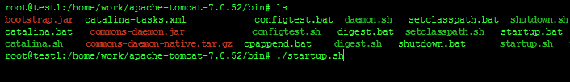

**Figure 67: Run tomcat server**

* Copy 2 War file TrafficService.war, TrafficWeb.war to webapps folder of tomcat and wait to tomcat auto deploy the war file.



**Figure 68: Copy war file to tomcat server**

* Final edit the console app path in config.properties file and restart tomcat server.



**Figure 69: Set console application path**

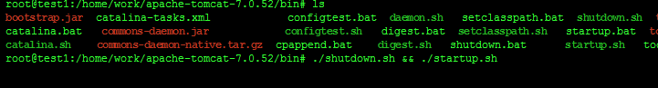

**Figure 70: Restart tomcat**

### Setting up the environment at client side

#### Setting up for computer

* The client devices need to have one of the following browsers to access the website:
* Google Chrome.
* Firefox.

#### Setting up for Android devices

* Change setting to install unknown source apk.
* Connect to the same network as the server



**Figure 71: Change Settings**

* Use browser and goto address 192.168.218.1:2987, download the apk file.



**Figure 72: Download app**

Click Install to install the app.



**Figure 73: Install App**

## User Guide

The user guide is based on the normal workflow of the system

### Login

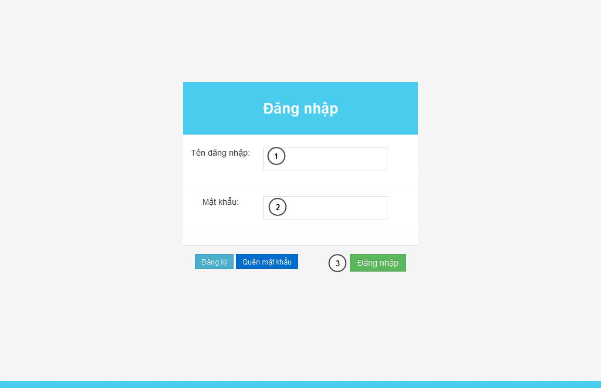

**Figure 74: Login Page**

|  |  |
| --- | --- |
| **Step** | **Description** |
| 1 | Fill UserID to “Tên đăng nhập” textbox |
| 2 | File password to “Mật khẩu” textbox |
| 3 | Press “Đăng nhập” button to login. |

**Table 49: Login Step**

### Admin

#### Set staff

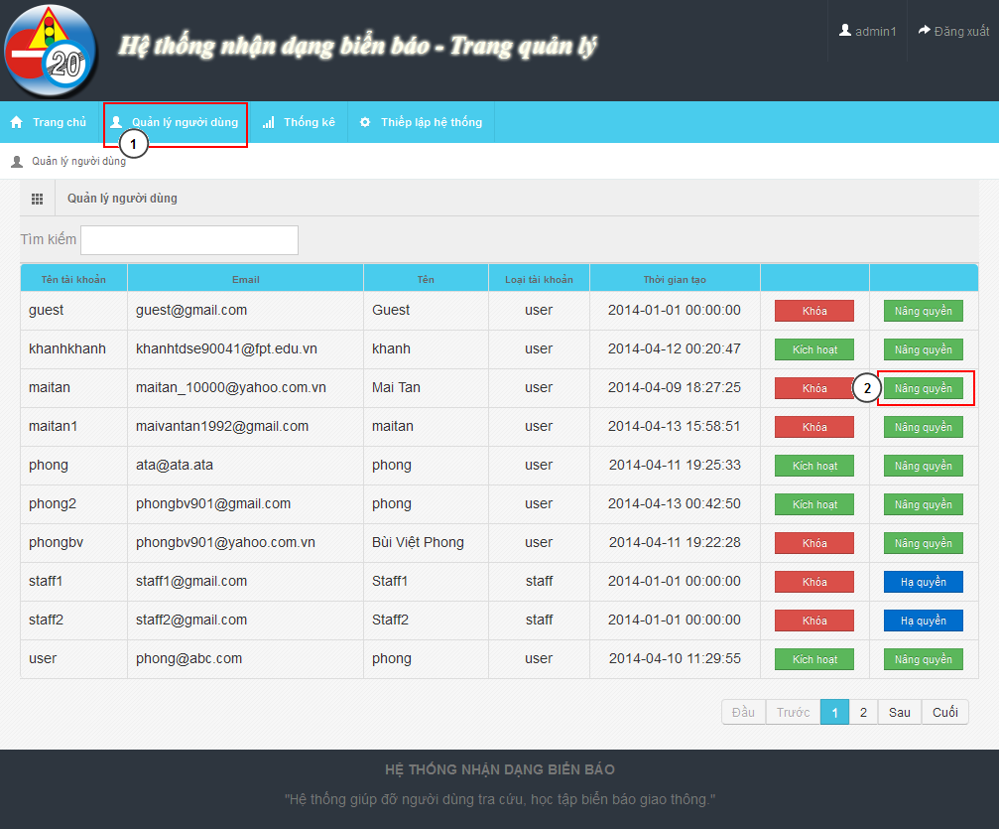

**Figure 75: Account Manage Page**

|  |  |
| --- | --- |
| **Step** | **Description** |
| 1 | “Quản lý người dùng” menu |
| 2 | Find user want to set staff. Click “Nâng quyền” |

**Table 50: Set staff**

### Staff

#### Add new traffic sign

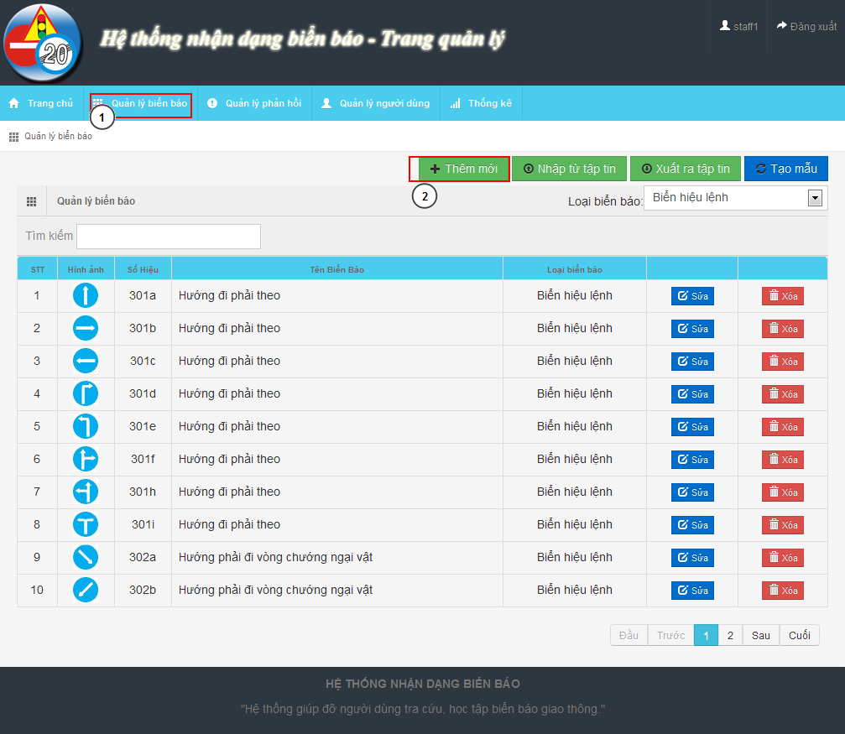

**Figure 76: Traffic Sign Manage Page**

|  |  |
| --- | --- |
| **Step** | **Description** |
| 1 | “Quản lý biển báo” menu |
| 2 | Click on “Thêm mới” button to show Add new modal |

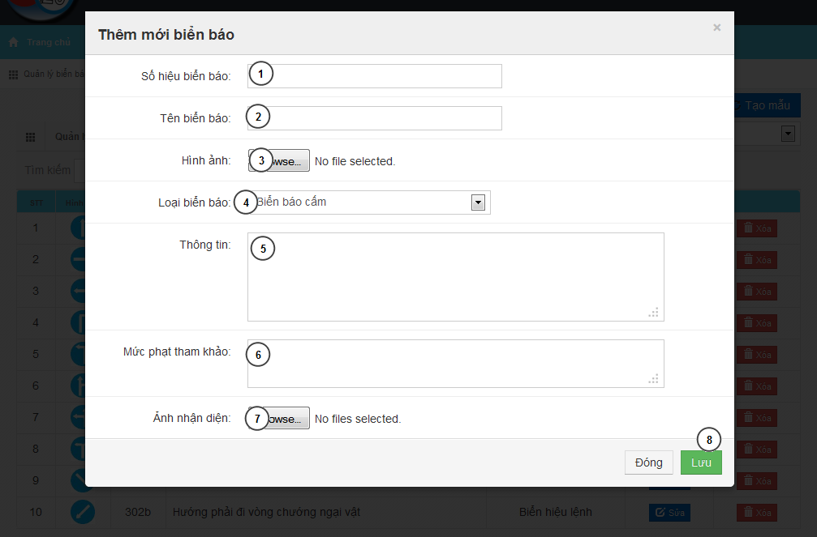

**Figure 77: Add New Traffic Sign Modal**

|  |  |
| --- | --- |
| **Step** | **Description** |
| 1 | Input traffic sign label |
| 2 | Input traffic name |
| 3 | Input traffic image |
| 4 | Select traffic type |
| 5 | Input traffic sign information |
| 6 | Input traffic sign penalty fee |
| 7 | Input train image for traffic sign |
| 8 | Press “Lưu” button to save traffic sign |

#### Fix wrong recognition from report

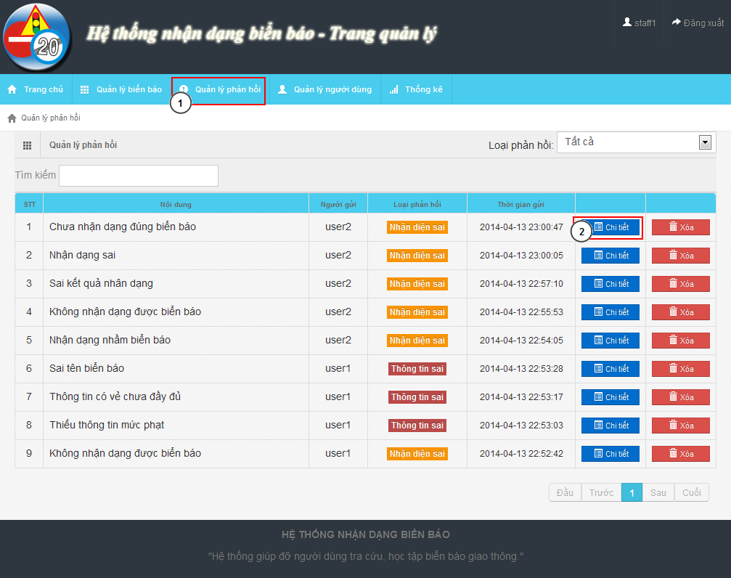

**Figure 78: Report Manage Page**

|  |  |
| --- | --- |
| **Step** | **Description** |
| 1 | “Quản lý phản hồi” menu |
| 2 | Find the report and click “Chi tiết” to show detail of report |

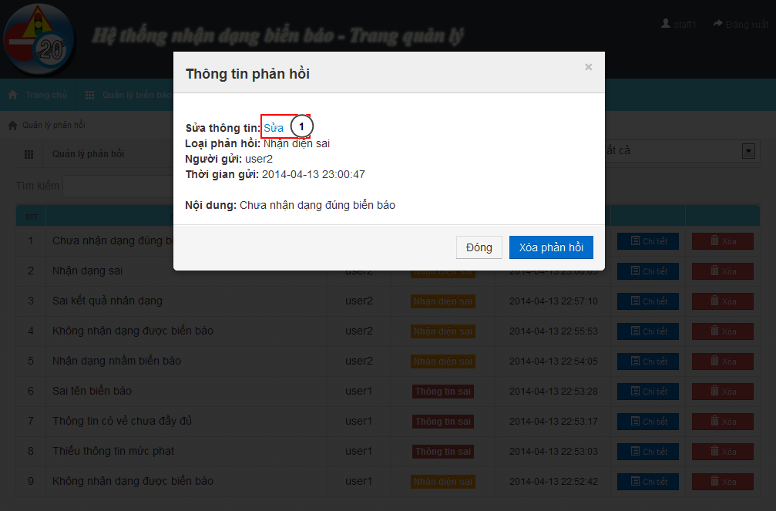

**Figure 79: Report Detail Modal**

|  |  |
| --- | --- |
| **Step** | **Description** |
| 1 | Click “Sửa” to edit the result |

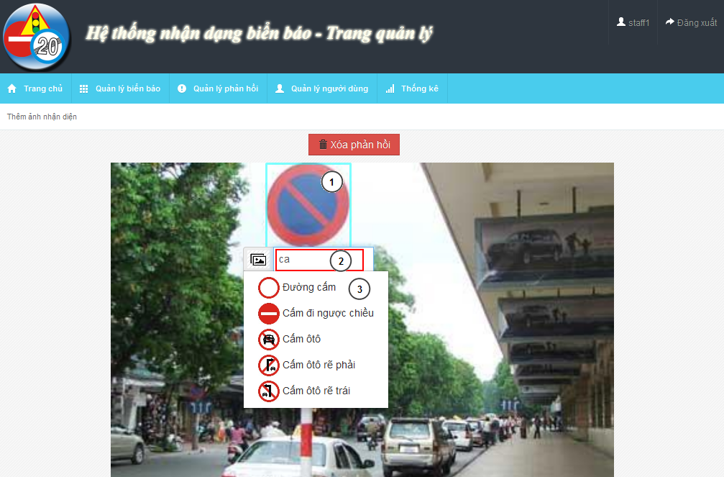

**Figure 80: Edit Wrong Recognition Page**

|  |  |
| --- | --- |
| **Step** | **Description** |
| 1 | Move mouse to the detected area |
| 2 | Input text to find the right traffic sign name |
| 3 | Select traffic sign name match with the image |

### User – Mobile

#### C:\Users\phongbv\Desktop\Do an\screen chot\login.pngLogin

**Figure 78: Login Screen**

|  |  |
| --- | --- |
| **Step** | **Description** |
| 1 | Fill Username. Example: phongbv |
| 2 | Fill Password. Example: 123456 |
| 3 | Click “Đăng nhập” button |

**Table 57: Login Step**

#### Register

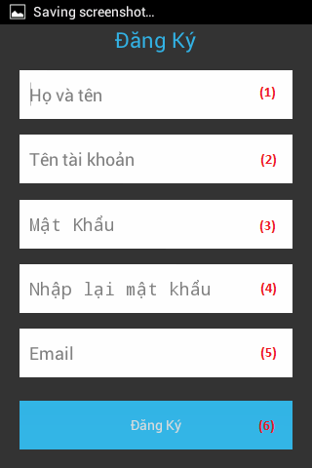

**Figure 79: Register Screen**

|  |  |
| --- | --- |
| **Step** | **Description** |
| 1 | Fill fullname. Example: Bùi Việt Phong |
| 2 | Fill account name. Example: phongbv |
| 3,4 | Fill password. Example: 123456 |
| 5 | Fill email. Format email: abc@example.com |
| 6 | Press “Đăng ký” button |

**Table 58: Register Step**

#### Search Auto

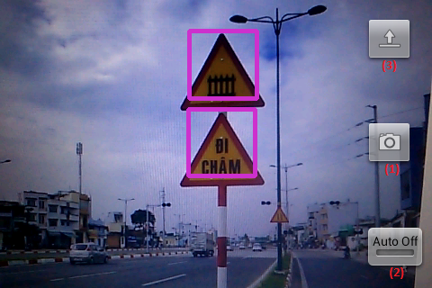

**Figure 80: Search Auto Screen**

|  |  |
| --- | --- |
| **Step** | **Description** |
| 1 | Press button to take picture and wait for result. |
| 2 | Click button switch on or off auto take picture mode. |
| 3 | Press button to select picture from mobile instead of take a picture by camera. |

**Table 59: Search auto step**

#### Search auto result



**Figure 81: Search auto result screen**

|  |  |
| --- | --- |
| **Step** | **Description** |
| 1 | Picture was taken by user before. |
| 2 | List result, position match with number in the image. Select one item to view traffic sign detail |

**Table 60: Search auto result step**

#### Search manual



**Figure 82: Search manual Screen**

|  |  |
| --- | --- |
| **Step** | **Description** |
| 1 | Fill search key. Example: “đường cấm”. |
| 2 | Click button to search by traffic sign’s name. |
| 3 | Select one category to view list traffic sign by category. |

**Table 61: Search manual step**

#### C:\Users\phongbv\Desktop\Do an\screen shot\list traffic.pngSearch manual result

**Figure 83: Search manual result Screen**

|  |  |
| --- | --- |
| **Step** | **Description** |
| 1 | Select one traffic sign to view detail. |

**Table 62: Search manual result Step**

#### View traffic detail



**Figure 84: View traffic detail screen**

|  |  |
| --- | --- |
| **Step** | **Description** |
| 1 | Press this button to report wrong information |
| 2 | Press this button to add or remove traffic sign to favorite |
| 3 | Traffic sign’s image |
| 4 | Traffic sign’s information |

**Table 63: View traffic detail step**

#### C:\Users\phongbv\Desktop\Do an\screen shot\favorite.pngView favorite

**Figure 85: View favorite screen**

|  |  |
| --- | --- |
| **Step** | **Description** |
| 1 | Select one traffic sign to view detail. (Or hold for 1 second, then select “Xóa” to delelte traffic sign from favorite list) |

**Table 64: View favorite step**

#### View history



**Figure 86: View history screen**

|  |  |
| --- | --- |
| **Step** | **Description** |
| 1 | Select one row to view search auto result detail. (Or hold for 1 second, then select “Xóa” to delelte result from history list) |

**Table 65: View history step**

#### C:\Users\phongbv\Desktop\Do an\screen shot\feedback.pngSend Report

**Figure 87: Send report screen**

|  |  |
| --- | --- |
| **Step** | **Description** |
| 1 | Enter report content. |
| 2 | Press this button to send report |

**Table 66: Send report step**

#### Setting

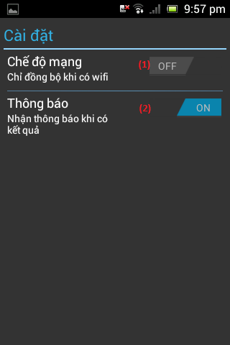

**Figure 88: Setting screen**

|  |  |
| --- | --- |
| **Step** | **Description** |
| 1 | Press this button to turn on or off “synchronize when on wifi only” mode. |
| 2 | Press this button to turn on or off notification when have search auto result. |

**Table 67: Setting step**

### User - Website

#### Search auto



**Figure 83: Search auto page**

|  |  |
| --- | --- |
| **Step** | **Description** |
| 1 | Click button “Chọn tệp tin” to select image for upload and wait for a few seconds. |
| 2 | List result, position match with number in the image. Select one item to view traffic sign detail |
| 3 | Picture was uploaded by user before |
| 4 | Click button “Sai kết quả” to report if the result is wrong. |

**Table 68: Search auto step**

#### Search manual

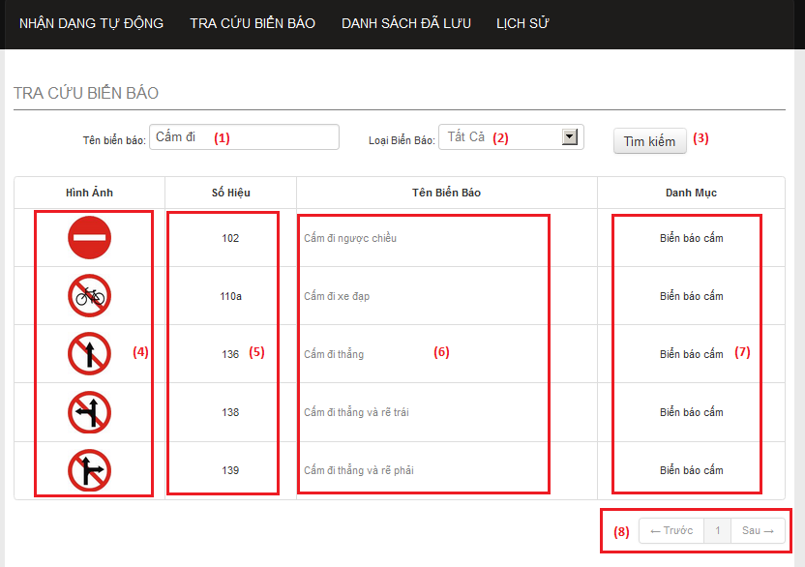

**Figure 90: Search manual page**

|  |  |
| --- | --- |
| **Step** | **Description** |
| 1 | Enter traffic sign’s name. Example: “cấm đi”. |
| 2 | Select one item to choose traffic sign category. |
| 3 | Click button “Tìm kiếm” to search traffic sign. |
| 4 | This column display traffic signs’ image. Click image to view traffic sign detail. |
| 5 | This column display traffic signs’ ID number. |
| 6 | This column display traffic signs’ name. Click traffic sign’s name to view traffic sign detail. |
| 7 | This column display traffic signs’ category. |
| 8 | Select number or “Trước”, “Sau” to view others records in the table. |

**Table 63: Search manual step**

#### View list favorite

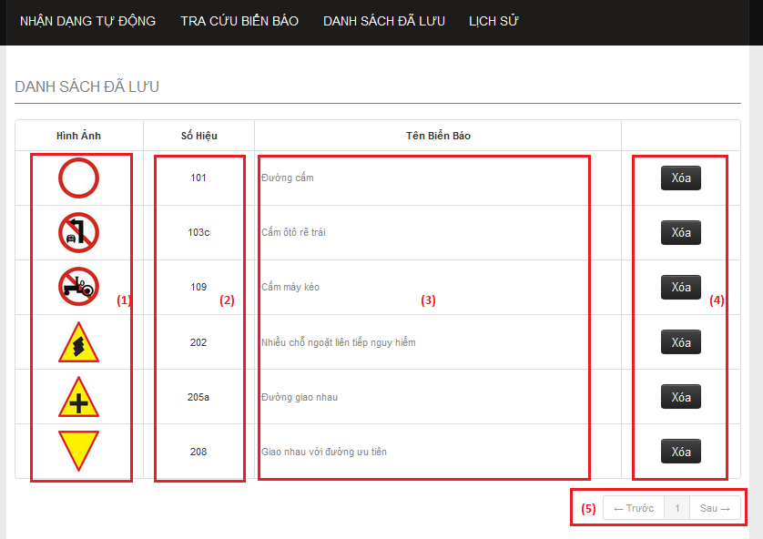

**Figure 91: Favorite page**

|  |  |
| --- | --- |
| **Step** | **Description** |
| 1 | This column display traffic signs’ image. Click image to view traffic sign detail. |
| 2 | This column display traffic signs’ ID number. |
| 3 | This column display traffic signs’ name. Click traffic sign’s name to view traffic sign detail. |
| 4 | Click button “Xóa” to remove one traffic sign from favorite list. |
| 5 | Select number or “Trước”, “Sau” to view others records in the table. |

**Table 70: View favorite step**

#### View list history

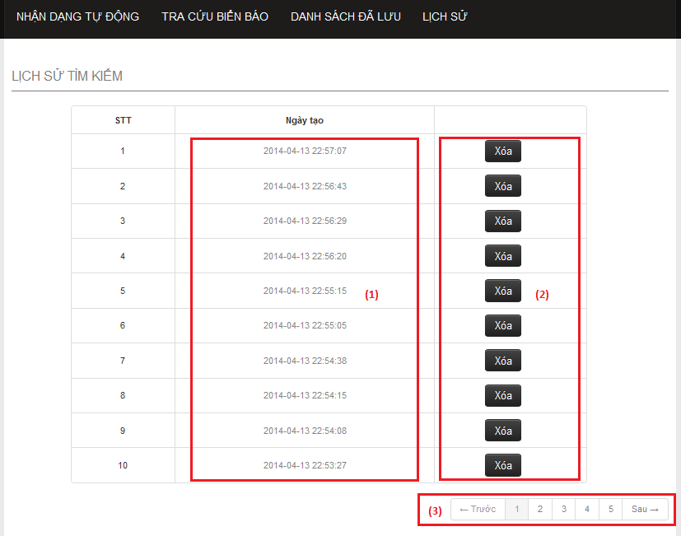

**Figure 92: History page**

|  |  |
| --- | --- |
| **Step** | **Description** |
| 1 | This column display the times when the history was created. Click link to view history detail. |
| 2 | Click button “Xóa” to remove one history from history list. |
| 3 | Select number or “Trước”, “Sau” to view others records in the table. |

**Table 71: View list history step**

#### View history detail

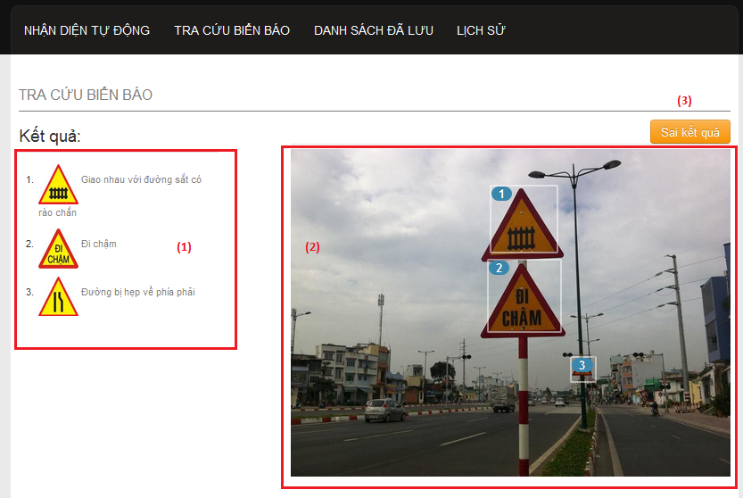

**Figure 93: History detail page**

|  |  |
| --- | --- |
| **Step** | **Description** |
| 1 | List result, position match with number in the image. Select one item to view traffic sign detail |
| 2 | Picture was uploaded by user before |
| 3 | Click button “Sai kết quả” to report if the result is wrong. |

**Table 72: View history detail step**

#### View traffic sign detail

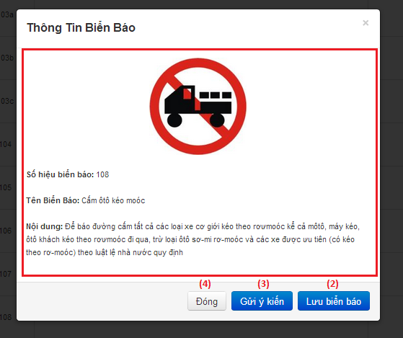

**Figure 94: Traffic sign detail popup**

|  |  |
| --- | --- |
| **Step** | **Description** |
| 1 | Traffic sign’s detail information. |
| 2 | Click “Lưu biển báo” to add traffic sign to favorite list. |
| 3 | Click button “Gửi ý kiến” to report if the information is wrong. |
| 4 | Click button “Đóng” to close popup. |

**Table 73: View traffic sign detail step**

#### Send report



**Figure 95: Send report popup**

|  |  |
| --- | --- |
| **Step** | **Description** |
| 1 | Enter report content. |
| 2 | Click button “Gửi ý kiến” to send report. |
| 3 | Click button “Đóng” to close popup. |

**Table 74: Send report step**

## User Notice

### Image Data Notice

* Each traffic sign should have at least 5 images for train image.
* The image should be in good condition, not have too much noise, or hide by another object.

Example of good image data:



Sample data of a traffic sign about 5-10 images:

* 60% taken from front of traffic sign.
* 40% taken from to side of traffic sign about 30 degrees side long.

Example of a good sample data set:



Avoid using not clear images like these:

### Take image to search

The below is recommend for the best image when search auto:

* Position and angle:
* The size of traffic sign in image:

By default the best size of traffic image is from 1/10 to ¼ the width of image.

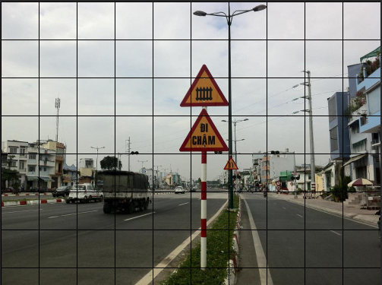

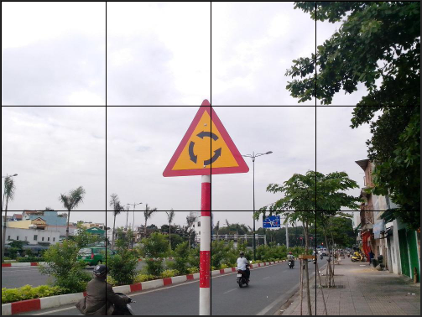

# Appendix

1. Face Detection Wikipedia: <http://en.wikipedia.org/wiki/Face_detection>
2. Face Detection Technicques: <http://www.facedetection.com/facedetection/techniques.htm>
3. Face Detection Viola-Johnes method: <http://cognotics.com/opencv/servo_2007_series/part_2/sidebar.html>
4. Face Recognition System Wiki: <http://en.wikipedia.org/wiki/Facial_recognition_system>
5. Face Recognition Technique: <http://www.biometricscatalog.org/NSTCSubcommittee>
6. Test Report: Eigenfaces, Fisherfaces error rates: [http://HYPERLINK "http://asp.eurasipjournals.com/content/2012/1/92" asp.eurasipjournals.com/content/2012/1/92](http://asp.eurasipjournals.com/content/2012/1/92)
7. Fisherfaces algorithm: <http://www.scholarpedia.org/article/Fisherfaces>
8. Fisherfaces algorithm: <http://www.bytefish.de/blog/fisherfaces/>